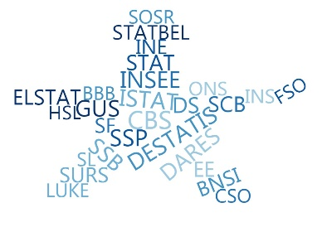

**ESSnet Big Data II**

**Grant Agreement Number: 847375-2018-NL-BIGDATA**

<https://webgate.ec.europa.eu/fpfis/mwikis/essnetbigdata>

[<https://ec.europa.eu/eurostat/cros/content/essnetbigdata_en>](https://ec.europa.eu/eurostat/cros/content/essnetbigdata_en)

**Workpackage WPB**

**Implementation – Online Job Vacancies**

**Report on the statistical output, required quality and definition of the necessary metadata at European and national level**

**Prepared by:**

Martina Rengers, Jakob de Lazzer, Galya Stateva, Francis Saucy, Dan Wu, Suad Elezović, Crt Grahonja, Jacek Maślankowski, Alexis Eidelman, Claire Dumesnil de Maricourt, Marian Necula, Ciprian Alexandru, Alberto Columbano, Sophie Schmassmann, Massimiliano Amarone,

Domenico Aprile, Diego Chianella, Annalisa Lucarelli, Marina Sorrentino

Tomaž Špeh (WP coordinator)

**Date of present version:**

Workpackage Leader:

Tomaž Špeh (SURS, SI)

e-mail address: tomaz.speh@gov.si

mobile phone: +38651672116

Contents

Summary 7

Main findings of CEDEFOP data analysis 11

Methodological aspects related to CEDEFOP data 11

Comparisons between OJAs and Job vacancy Statistics (JVS) 11

Improving the comparability of the two data sources 12

Understanding the OJAs business models 12

OJAs vs. OJAs in National Employment Agency 12

Vacancies by ISCO major groups 13

Duplicates 13

Lower rate of OJAs in some countries 13

Coverage of sources and sites 14

Data description 14

OJA versus country population size and GDP 17

Comparisons between OJAs and Job vacancy Statistics 22

Pseudo-stock transformation 25

Pseudo stocks by federal country 29

Industry sectors 29

Use cases of using OJA data in official statistics 31

Developing meaningful indicators based on OJA data 31

Labour Market Concentration Indicators using OJA 47

Supplementary indicators for official statistics from OJAs 51

Estimating labour market tightness using OJAs 61

Estimation of GDP components using OJA 64

Experimental statistics from OJA 67

Bulgarian National Statistical Institute 67

Romanian National Institute of Statistics 76

Statistics Poland 79

Swedish case: Experimental Online Job Vacancy index 82

Quality template ESQRS V 2.0 for OJAs outputs 86

Conclusions and recommendations for future developments 87

Major goals of collecting OJA in future years 87

Opportunities for further collaborative development 89

References 91

Annex 94

List of Figures:

Figure 1: Graphical representation of monthly OJA (absolute figures V2 before 25.03.2020; 15 months) 17

Figure 2: Scatterplots of relationships between OJA population size and GDP for V2 CEDEFOP datasets. Left: all countries; right : focus on smaller countries with populations size < 12 mio. or GDP < 700 billions USD) 18

Figure 3: Scatterplot of OJVs predicted (or fitted) by the model (vertical axis) against observed OJVs for the 13 countries of the V1 CEDFOP data (log scales) 19

Figure 4: Prediction model 19

Figure 5: OJVs predictions for the 19 countries for which no data are available in the V1 CEDEFOP dataset (monthly averages and 95% confidence intervals). Monthtly V2 observations from the V2 dataset have been added to the original table 20

Figure 6: Observed OJAs in the V2 CEDEFOP data set versus Predicted values from the regression model for countries without data in the V1 Dataset 21

Figure 7: Prediction map based on the NUTS1 model compared to observed OJA 21

Figure 8: The abline of slope 1 makes conspicuous two oulierrs (IE and CT) for which OJVs depart largely from the Eurostat JVS 23

Figure 9: Number of job ads per day 25

Figure 10: Pseudo-stock of active job ads at time T 26

Figure 11: Ads collected by source and month 27

Figure 12: Ads collected from the 3 largest sources 28

Figure 13: CEDEFOP‐OJAs vs. JVS vs. 28

Figure 14: Pseudostocs of CEDEFOP-OJAs by validity period 29

Figure 15: Map of job ad pseudo‐stocks Q1 2019 29

Figure 16: CEDEFOP‐OJA vs. JVS: relative share of job ads by industry sector 30

Figure 17: OJAs used in labour market reporting by public-law / non-profit institutions (selection) – part 1 34

Figure 18: OJAs used in labour market reporting by public-law / non-profit institutions (selection) – part 2 36

Figure 19: OJAs (commercially) collected and analysed by private companies (selection) 38

Figure 20: Australia: First page of the monthly report of Internet Vacancy Index (IVI) 38

Figure 21: USA: First page of the monthly report of Help Wanted Online (HWOL) Index 39

Figure 22: Burningglass US: Free access to timely data in the situation of Covid-19 41

Figure 23: Indeed Hiring Lab: Free access to timely data in the situation of Covid-19 (first page) 42

Figure 24: LinkedIn: How COVID-19 is impacting hiring around the world 43

Figure 25: Textkernel: Free access to timely graphs in the situation of Covid-19 44

Figure 26: Germany: how to interpret the different OJA indicators from selected private companies using the example of Covid-19 45

Figure 27: LMC index 072018 - 032019 average over occupations and quarters 50

Figure 28: OJAs vs JV rates: Italy, Total Economy (NACE Rev. 2 economic activity sections from B to S, excluding O) 53

Figure 29: OJAs vs JV rates: Italy, Industry (NACE Rev. 2 economic activity sections from B to F) 54

Figure 30: OJAs vs JV rates: Italy, Industry (NACE Rev. 2 economic activity sections from G to S, excluding O) 54

Figure 31: OJAs daily distribution during the four quarters of 2019: the Italian case, first quarter 2019 55

Figure 32: OJAs daily distribution during the four quarters of 2019: the Italian case, second quarter 2019 56

Figure 33: OJAs daily distribution during the four quarters of 2019: the Italian case, third quarter 2019 56

Figure 34: OJAs daily distribution during the four quarters of 2019: the Italian case, fourth quarter 2019 56

Figure 35: From a quarterly to a monthly basis job vacancies rate estimates: the Italian case 57

Figure 36: Mean tightness by occupation groups, including OJAs 63

Figure 37: Tightness distribution among qualification groups 64

Figure 38: The job portals and economic indicators data 65

Figure 39: Linear regression and ARIMAX models graphs 65

Figure 40: Linear regression and ARIMAX estimations with lagged MD data 66

Figure 41: Number of OJAs and change by Educational level (flow) 74

Figure 42: Registered unemployed and OJAs during COVID outbreak 75

Figure 43: Number of OJA by educational level 78

Figure 44: Number of OJA by experience years 78

Figure 45: Results of the text mining use for occupation classification 81

Figure 46: Processing Online job advertisements from Swedish Employment Service to SCB…………. 83 Figure 47: SCB:s Experimental Index Online Job Vacancies (I-OLT): Seasonally adjusted, trend- and unadjusted index values (Jan 2008=100) ……………………………………………………………………………………….. 84

List of Tables:

Table 1: Structure of CEDEFOP data 16

Table 2: Attempt to extract monthly OJAs coresponding to quarterly JVS for period 2018Q3 to 2019Q1. 24

Table 3: Summary of concentration index 49

Table 4: Year on year change in the job vacancy rate (percentage points difference): the Italian case 58

Table 5: Percentage distribution of employees by Isco level 1 and quarter 58

Table 6: Italian OJAs quarterly rate by Isco level 1 59

Table 7: Italian OJAr year on year differences, by Isco level 1 60

Table 8: Percentage distribution of employees by geographical area and quarter 60

Table 9: Italian OJAs quarterly rate by geographical area and quarter 61

Table 10: Italian OJAs quarterly rate by geographical area and quarter 61

Table 11: Number of OJVs and main proportions (in ‰) for the period May - July 2019 69

Table 11: Number of OJVs and main proportions (in ‰) for the period May - July 2019 71

Table 12: Distribution of OJAs by Educational level and NUTS 3 72

Table 13: Distribution of OJAs by NUTS 3 and NACE Level 1 for the period May-July 2019 73

Table 14: OJA by weeks and NUTS3 and % change during the COVID period in Bulgaria 74

Table 15: Ratio of OJAs to registered unemployed by weeks 75

Table 16: Year-by-year comparison in the number of job offers among different data sources 79

Table 17: The comparison between official statistics and Big Data sources 80

Table 18: Comparison between CEDEFOP and home data (Big Data - one source) 82

Table 19: SCB:s Experimental Index Online Job Vacancies (I-OLT)- total: Seasonally adjusted, trend- and unadjusted index values (percentage changes) ………………………………………………………………………. 84 Table 20: SCB:s Experimental Index Online Job Vacancies (I-OLT)- total and by industrial classifications: Seasonally adjusted figures- percentage changes ………………………………………………….. 85

# Summary

The aims of implementing this work package were to produce statistical estimates on the topic of online job adverts and to identify statistical production processes and capabilities that may be affected at the national level and to define the conceptual production processes at the national level and at the level of the ESS. Suitable techniques and specific methodologies were developed during the pilot phase of the project ESSNet Big Data 2016-2018 on Web Scraping for Job Vacancy Statistics. The implementation phase was based on work carried out to establish the conditions under which web scraping techniques can be used and to evaluate the quality of the scraped data. This report summarises the results made within the Big Data ESSNet WPB 2018-2020 on online job vacancies implementation work package.

Using OJA has a number of advantages. They can be used successfully for the needs of official statistics for completing and estimating the number and characteristics of the job vacancies. Their main advantages are their accessibility, timeliness, comparatively low cost of producing them and lack of or minimal burden for the respondents. Most OJA contain information not only for the vacant position but also for the required qualifications and skills, including the so-called soft skills, for degree and kind of the graduate education and professional experience necessary for the potential applicants for taking it. Often they also contain information on the employer (sector of the economy, size of the enterprise, kind of ownership, etc.). Estimates could be made for labour demand by economy sectors, professions, specific skills and qualifications, and regions. A comparison could also be made for which job vacancies similar education, qualification and specific skills are required. However, using OJA as an alternative information source for statistical surveys is always accompanied by challenges:

* Defining the scope of the survey. OJA data refer only to part of the actual job vacancies and not all workplaces are announced online regardless of the kind of channels. Some positions are more likely to be advertised on the Internet and the received estimates will contain deviations connected with the professions and qualification. As a rule, workplaces are announced on the Internet to a much greater extent in the high-tech economy sectors, as well as in such requiring higher education degree and specific qualification.
* There is not a certain information source for job vacancies and sometimes they are published simultaneously on different Internet channels – on specialized websites for publishing job vacancies ads, on recruitment agencies’ websites, enterprises’ websites, on social media, etc. Often some websites republish ads from other ones. This raises the issue of constructing methods for avoiding the so-called duplication of one and the same ad in one and the same Internet source or in different Internet sources and solving this issue is among the main challenges of using big data for monitoring job vacancies. OJAs often contain both structured and unstructured elements. In the texts of the ads in unstructured form education, qualification and skills are usually required, which should be turned into structured elements through special procedures. This requires using of specific classification algorithms adjusted for the respective language used by the published ad. However, the data received through these algorithms often contain inaccuracies and errors.
* The job vacancy ad does not always correspond to the statistical unit job vacancy.
* In the various job ads the information about the vacancies is with different extent of details.
* Most often, the ads of the recruitment agencies do not contain employer data. This leads to the impossibility of collecting data for the enterprise sector, as well as of connecting big data to the data from the official statistical sources.

Since CEDEFOP is developing a pan-European system for collecting and processing, ESSNet collaborated with CEDEFOP on using their data with the focus on facilitating the integration of these data in official statistics.

A good understanding of the “business models” underlying the development of job portals, as well as of the market of OJA is crucial. Understanding of their mechanisms is a key issue to understand the data collected and processed by CEDEFOP system and identify the best fit model to use them for statistical purposes, direct on JVS or in correlation with other socio-economic indicators. Beware of that simple aspect, the Online job portals have not been developed to produce statistics or indicators of the job market. Their goal is different from a portal to portal, some of them are focused on human resource aspects, in finding the right person for a specific job, but other portals are focused only in making money from promoted adverts on their web pages.

The quality issues are such that it is not clear if these data could be integrated in a way that would enable them to meet the standards expected of official statistics. On the other hand, OJA data can provide many insights that official estimates cannot. Statistics based on OJA data can be published in a very timely and frequent manner, allowing for short-term tracking of labour market conditions and flash-estimates of labour demand. Because of the larger data pool available, OJA data also allow for more granular analysis by subgroups or geographical regions. Additionally, OJA data might allow for the provision of completely new (to official statistics) labour market insights: for instance, indicators of labour market power by employers[1]. There is, however, further need to address the challenges how OJA data should be interpreted and used together with official estimates.

One area that shows some promise is to use the time series properties of OJA data to improve existing statistics. The analysis showed modest success in predicting job vacancy survey values using OJA data, so these data could be used for producing flash estimates of labour demand. It may also be possible to use these time series properties to produce more frequent estimates, or even reduce the frequency of the survey. An important limiting factor of current CEDEFOP data is that this system holds data from 2018 onwards, so it will take several years at least to collect a reasonable time series.

CEDEFOP data demonstrate a strong relationship between OJAs and socio-economic variables such as national and regional population sizes and GDPs. These relationships can be modelled with promising outputs. Such models may potentially be used for predictive purposes. For instance, since OJAs are potentially instantly available, they might offer a data source for developing flash estimates of national and regional GDPs. The models and choice of variables should of course be studied in more detail and improved. The models also indicate that they offer the potential of predicting OJAs for countries without data for OJAs on the basis of their socio-economic variables. Such cases without CEDFOP OJAs data offer an interesting opportunity to test the models.

With a monthly index on the (economic) development of online job advertisements, the potential of real-time information from job portals can be analysed and processed in real time. Additional regional differentiations as well as job-group specific evaluations of the online job market provide new short-term indicators that show current and policy-relevant developments with regard to changes in the demand for labour. For example, early warnings of threatening bottlenecks or overcapacities are conceivable. In this way, information can be provided that goes beyond the established labour demand statistics.

Integrating OJA in the production of JVS and replacing JVS by OJA may be major goals of collecting OJA in future years. Such an approach would significantly alleviate the survey burden on enterprises and would have important consequences on survey designs, with classical sampling surveys being replaced by censuses.

Three levels of integration are foreseen:

* Use OJA as a complementary data source to help filling non-response items
* Replace the classical data collection using OJA in a classical sampling approach
* Replace both the survey data collection and the sampling approach by a census approach

Starting from the interests and building strengths of all parties (Member States and Eurostat), there is a ground for collaborative development of a shared system for producing official from OJA.

Eurostat has undertaken further initiatives like the development and maintenance of a flexible software solution freely available and identification of best practice for Data access Arrangements (DA), the use of Web Scraping (WS), Data from the IoT/Smart devices (DI), Natural Language Processing (NLP), Machine Learning (ML) and Production process Automation (PA) to produce Official Statistics. Web Intelligence is an important element of the Smart Trust Statistics that will play a pivotal role in the new official statistics business architecture[2]. Eurostat and CEDEFOP signed a MoU to further development and maintenance of software solution for collecting OJA data developed by CEDEFOP.

The member states should consider an active role and bring their experience in the joint development of common solutions; further exploration of the potential of new types of OJA sources, assessment of quality of the data collected and perform methodological developments.

All these challenges necessitate careful searching for ways and approaches for estimating the job vacancies via information from online ads.

The document contains three parts. The first part, **main findings of CEDEFOP data analysis**, describes describe the methodological aspects, at the conceptual and practical level, regarding the use of data produced by CEDEFOP as an input for producing statistical indicators in the area of OJA, starting from pre-processed data. It addresses key conceptual, methodological, and technical aspects in using CEDEFOP data in OJA statistics. In the second part, **use cases of using OJA data in official statistics**, we present a few examples of using OJA for producing statistical outputs of mainly experimental nature. These are not ready to be used as tools for decision making, and rather serve as proof-of-concepts illustrating some of the paths that are possible to follow in the future for creating statistical outputs based on OJA data. The last part, **conclusions and** **recommendations for future developments**, describes major goals of collecting OJA in future years to alleviate the survey burden on enterprises and would have important consequences on survey designs, with classical sampling surveys being replaced by censuses. In this section we try to propose tentative sketches of integrating OJA in the process of JVS production, identify necessary requirements needed to assure standards of quality and identify pitfalls to avoid and issues to address.

# Main findings of CEDEFOP data analysis

## Methodological aspects related to CEDEFOP data

The purpose of this material is to describe the methodological aspects, at the conceptual and practical level, regarding the use of data produced by CEDEFOP as an input for producing statistical indicators in the area of online job adverts (OJA), starting from pre-processed data. It addresses key conceptual, methodological, and technical aspects in using CEDEFOP data in OJA statistics.

Methodological considerations from this material consider the results obtained by the countries members of WPB ESSnet Big data II, in the implementation of using the CEDEFOP data for producing job vacancies statistics based on OJA.

The Work Package B, Implementation - Online Job Vacancies, has established a close working relationship with the European Centre for the Development of Vocational Training (CEDEFOP) in order to use the collected or/and processed data as a source for producing statistical estimates.

CEDEFOP is creating the infrastructure to gather information from the most important online job vacancy portals (OJV portals) in real time across the EU, into the project Real-time labour market information on skill requirements: setting up the EU system for online vacancy analysis [1].

The CEDEFOP data were presented in June 2019, at the physical meeting in Thessaloniki, and all countries have started to use these data and the first results have come during the month of July, August, and September 2019.

The document focus primarily on:

* Analysis of CEDEFOP and home OJA
* Statistical products and experimental statistics from OJA
* Investigation and selection of potential use cases in the field of job vacancies statistics.
* Investigation of the methodology for the calculation of statistical indicators.
* Comparisons and linking of OJA and Job Vacancy Statistics
* Investigation of other possible statistics beyond job vacancies statistics which could be produced with OJA
* Investigation of issues around data quality and timeliness
* Quality assessment of statistical outputs.

### Comparisons between OJAs and Job vacancy Statistics (JVS)

A major issue when dealing with OJAs is to understand how OJAs are connected to actual job vacancies, in particular to the official Job Vacancy Statistics. For this purpose, CEDEFOP data are in a first step compared to the Eurostat JVS downloaded from: <https://ec.europa.eu/eurostat/databrowser/view/tps00172/default/table?lang=en>.

Rescaling the data: In an attempt to bring the data on a common basis allowing to compare the two sources, the total amount of CEDEFOP OJAs (a cumulated sum over a *n* months period) are transformed to monthly averages, as follows:

m_oja = total CEDEFOP OJAs / *n*

On the contrary, the quarterly Eurostat JVS correspond to a snapshot taken at the reference day (the last day of the quarter). For the same period, we have data of *q* quarters. The absolute amount of JVS are averaged as follows:

m_jvs = (JVSQ1 + JVSQ2 + ... + JVSQn) / *q*

Regarding the CEDEFOP data, due to the availability of daily online job vacancies in each month, the daily average number of online job vacancies should be considered in each month, as it was a data collection on a continuous basis. As technical approach, the data ingestion is developed as sequential process, on daily snapshot of web scraping, crawling and API collected data. This must take into consideration if we want to compare the OJAs data with JVS on a reference day, because on that specific day data will be collected only for certain websites.

### Improving the comparability of the two data sources

The comparability of the two data sources, OJAs resulting from OJAs CEDEFOP data and the JVS, may be improved in several ways [2]:

1. subsetting the OJAs to the corresponding months for which JVS results are available
2. subsetting the OJAs data to job advertisements still open for the JVS reference days
3. subsetting the OJAs to job advertisements corresponding to the NACE2 categories covered by the official Eurostat JVS (sections B-C), or to the NACE2 branches actually covered for each country individually
4. comparing the monthly OJAs (as above subsetted) data with the corresponding month of the quarterly JVS

### Understanding the OJAs business models

A good understanding of the “business models” underlying the development of job portals, as well as of the market of OJA is crucial [2]. Understanding of their mechanisms is a key issue to understand the data collected and processed by CEDEFOP system and identify the best fit model to use them for statistical purposes, direct on JVS or in correlation with other socio-economic indicators. Beware of that simple aspect, the Online job portals have not been developed to produce statistics or indicators of the job market. Their goal is different from a portal to portal, some of them are focused on human resource aspects, in finding the right person for a specific job, but other portals are focused only in making money from promoted adverts on their web pages.

### OJAs vs. OJAs in National Employment Agency

The web portals of the National Employment Agencies are well structured and contains verified information declared by the companies, and most important, with official classifications, like NACE and ESCO. For some countries there quite big difference between the CEDEFOP data collected from National Employment Agencies and the data obtained directly from these agencies, some possible reasons could be [3]:

* the basic concept is a job vacancy (Employment Agency), not job advertisement
* depends on the country’s legislation, if the JVs that employers submit to the Employment Agency are declared voluntary (i.e.: BG situation) or as a request of the law (i.e.: RO situation); employers prefer to advertise their job vacancies mostly in online job portals, as it is faster and more convenient for them.
* from the moment of the declaration of the job vacancy in the Regional Labor Office until it’s actual publication on the Employment Agency's Internet portal, there is a certain lag of time (i.e. we can't say that these JVs are actual in real time)

### Vacancies by ISCO major groups

The share of the total amount of online job vacancies according to ISCO major groups differs in the CEDEFOP-data from data collected by countries, from web scraping or from data in JVS. The differences may be related to the difficulties in de-duplicating. Occupations with the lower skill levels are often published on multiple job portals, problems with de-duplicating can therefore be expected to become more apparent.

As a future development of the CEDEFOP system, could be take into consideration, to add a new variable with the value of the ingestion source: web scraping, crawling or API collected data.

### Duplicates

Duplicates occur when advertisements are taken from another job portal with identical values. For duplicated jobs, the ‘general_id’ have the same value. Sometimes, duplicated rows are identical and sometimes, duplicated rows indicate the same job announcement coming from different sources. In this case, in order to identify and eliminate duplicated records should be used ‘general_id’ variable.

### Lower rate of OJAs in some countries

There is a bias or an artefact in the collected data: only a part of the OJAs have been screened and the main issues could be:

1. The OJAs channel is not yet much developed in some countries
2. The difference reflects a peculiarity of the labour market in these countries
3. Other issues

Suggestions for testing those potential explanations[3]:

a) Bias or artefact:

* plotting time series for all countries to detect anomalies
* compare the proportion of the scraped sources over time
* search for duplicates

b) OJAs channel:

* time series might display an increase in OJAs with time
* comparisons with other indicators of IT technologies and internet development among countries

c) labour market:

* comparisons
* with employment,
* unemployment,
* activity rates (proportion of persons in employment in the population)
* Job vacancy rates

### Coverage of sources and sites

Some consistency issues were identified between variables (source country and source), coverage of sources and sites in data collection and missing information (location, contract, source, etc.). Of particular importance for the construction of labour market indicators is the question whether CEDEFOP data represent the flow or stock of OJA. In the case of flow data, we would see a large initial stock on which to base the flows of ads. In the case of stocks, we would expect to observe similar stocks of observations for every day. Analyses indicate that it is neither. Therefore, steps has been undertaken to calculate or approximate the stock of OJA, for instance by using pseudo-stocks.

Some important variables are not available, such as the organization ID, visiting address of organization, title of ads and description of ads. There are other important variables for deriving variables, such as work unit and NACE. These variables are important because of the comparison between online job ads and JVS data.

In some cases, differing data patterns were identified when comparing CEDEFOP data with collected home OJA data due to the different approaches and methods in data pre-processing phases.

### Data description

The final processed data are presented in structured mode, as a table with 49 variables, accessible by CEDEFOP Data LAB (Table 1). The Data Lab environments are deployed in the EC (European Commission) Data Platform. In order to authenticate, the users receive a EC Data Platform account, which they will be able to use in any environment deployed in that platform. In this environment there are more options available for exploring the data: R and Python scripts, and Jupyter notebooks.

| variable | type | example values |
| --- | --- | --- |
| general_id | numeric | 157361354, 157355438, 157460283 |
| grab_date | date | 17891, 17892, 17893 |
| year_grab_date | numeric | 2018, 2018, 2018 |
| month_grab_date | numeric | 12, 12, 12 |
| day_grab_date | numeric | 26, 27, 28 |
| expire_date | date | 18011, 18012, 18013 |
| year_expire_date | numeric | 2019, 2019, 2019 |
| month_expire_date | numeric | 4, 4, 4 |
| day_expire_date | numeric | 25, 26, 27 |
| lang | character | ro, en, lu |
| idesco_level_4 | character | 4321, 8322, 7126 |
| esco_level_4 | character | Stock clerks; Car, taxi and van drivers; Plumbers and pipe fitters |
| idesco_level_3 | character | 432, 832, 712 |
| esco_level_3 | character | Material-recording and transport clerks; Car, van and motorcycle drivers; Building finishers and related trades workers |
| idesco_level_2 | character | 43, 83, 71 |
| esco_level_2 | character | Numerical and material recording clerks; Drivers and mobile plant operators; Building and related trades workers, excluding electricians |
| idesco_level_1 | character | 4, 8, 7 |
| esco_level_1 | character | Clerical support workers; Plant and machine operators, and assemblers; Craft and related trades workers |
| idcity | character | NA, 179132, 95060 |
| city | character | NA, Municipiul Bucureşti, Municipiul Iaşi |
| idprovince | character | RO424, RO226, RO414 |
| province | character | Timiş, Vrancea, Olt |
| idregion | character | RO42, RO22, RO41 |
| region | character | Vest, Sud-Est, Sud-Vest Oltenia |
| idmacro_region | character | RO4, RO2, RO4 |
| macro_region | character | MACROREGIUNEA PATRU; MACROREGIUNEA DOI; MACROREGIUNEA PATRU |
| idcountry | character | RO |
| country | character | ROMÂNIA |
| idcontract | character | 1, 2, 3, 4 |
| contract | character | Internship; Permanent; Self Employment; Temporary |
| ideducational_level | character | 1, 2, 3, 4, 5, 6, 7, 8 |
| educational_level | character | Primary education; Lower secondary education; Post-secondary non-tertiary education; Upper secondary education; Short-cycle tertiary education; Bachelor or equivalent; Master or equivalent; Doctoral or equivalent |
| idsector | character | 1,..., 97, A,..., U |
| sector | character | Accommodation and food service activities (General); Activities auxiliary to financial services and insurance activities; ... |
| idmacro_sector | character | A,..., U |
| macro_sector | character | Manufacturing; Other service activities, ... |
| idcategory_sector | character | 1, 2, 3 |
| category_sector | character | Agriculture; Manufacturing; Services |
| idsalary | character | 1,..., 13 |
| salary | character | 0 - 6.000 EUR; ...; > 90.001 EUR |
| idworking_hours | character | 1, 2 |
| working_hours | character | Part time; Full time |
| idexperience | character | 1,..., 8 |
| experience | character | No experience; ..., Over 10 years |
| source_category | character | Classified ads portal; Company; Education; Employers organization; Employment agency; Employment website; Job search engine; Online newspaper; Public employment service |
| sourcecountry | character | FR, RO, US |
| source | character | ADECCO; ADZUNA; AT_AMS; AT_CAREERJET;... |
| site | character | academics; accenture; accesa; ... |
| companyname | character | cms careers; cmv; cn group; ... |

Table 1: Structure of CEDEFOP data

Dataset V1 was available in June 2019 covered the period July 2018- March 2019. The dataset encompasses 64.3 millions of records. After exclusion of duplicate cases (query: SELECT COUNTRY, COUNT(DISTINCT GENERAL_ID) as num_job_vacancy), the dataset displays 55.5 millions of unique records, or “Online job vacancy” (OJV) advertisements covering the period July 2018 - March 2019 and 13 countries.

Dataset V2 was available during the second half of March 2020 covered the period July 2018- September 2019, i.e. a period of 15 months or 5 quarters for all 28 EU countries and encompasses 107.83 millions of records (V1: 64.3; +43.5 millions; +67.6%). After exclusion of duplicate cases (query: SELECT COUNTRY, COUNT(DISTINCT GENERAL_ID) as num_job_vacancy), the V2 dataset displays 92.4 millions of unique records, or “OJAs = Online job advertisements” (V1: 55.5 millions; +36.9 millions; + 66.5%)[4].

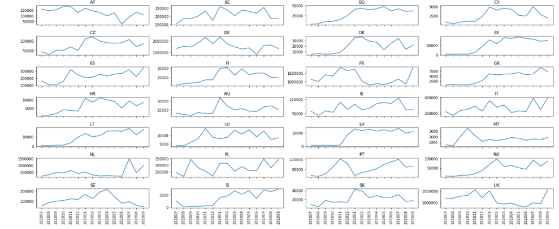

Figure 1: Graphical representation of monthly OJA (absolute figures V2 before 25.03.2020; 15 months)

## OJA versus country population size and GDP

Clear relationship between OJA and population size and GDP has been found with two subsets of countries. Figure 2 presents the results for the V2 dataset. The same pattern appears with RO and several small countries (mostly from Eastern Europe, but also FI, DK and PT) joining the group of Poland, Spain and Italy with relatively lower rates of OJAs relative to population size.

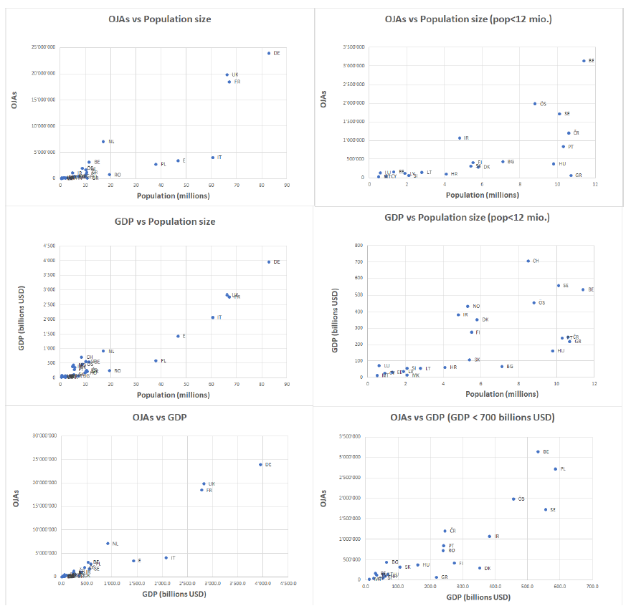

Figure 2: Scatterplots of relationships between OJA population size and GDP for V2 CEDEFOP datasets. Left: all countries; right : focus on smaller countries with populations size < 12 mio. or GDP < 700 billions USD)

This relationship has been first tested using V1 dataset in a modelling approach by regression of OJVs against these two variables using the following results:

a) the regression of OJVs against Population size shows a significant relationship with an adjusted squared R of 0.66 indicating that population size explains 66% of the variance of OJVs (adj. R2=0.78 for log transformed data).

b) the regression of OJVs against GDP returns an even stronger relationship : adj. R2=0.85 (adj. R2 =0.90 for log transformed data).

c) the regression of OJVs against Population size and GDP returns an adj. R2 of 0.87 ((adj. R2=0.88 for log transformed data).

Figure 3 displays graphically the relationship between observed and fitted OJVs for the 13 countries for which CEDEFOP data are available. The graph shows that the data for all countries are aligned on a straight line (log scale) with dots for CR, PL, E and IT no more forming a particular cluster. Predictions for E and IT seem to be slightly overcorrected. Perhaps additional variables might help improving the fit for these countries.

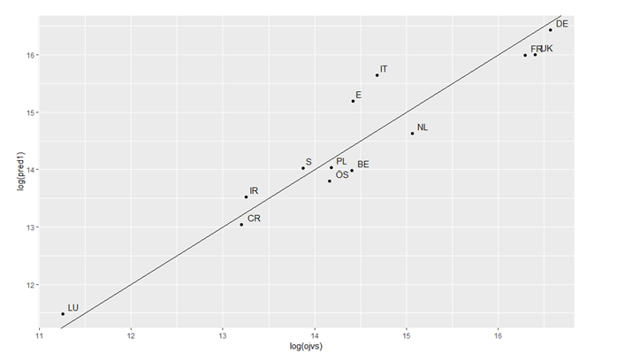

Figure 3: Scatterplot of OJVs predicted (or fitted) by the model (vertical axis) against observed OJVs for the 13 countries of the V1 CEDFOP data (log scales)

Predictions for the 19 remaining countries without CEDEFOP data were estimated. The results (Figure 4) of predicted OJA (vertical axis) against GDP (horizontal axis) show a similar pattern of predictions for the 19 remaining EU countries (Figure 4b), as compared to the predictions for the 13 countries with CEDEFOP data (Figure 4a).

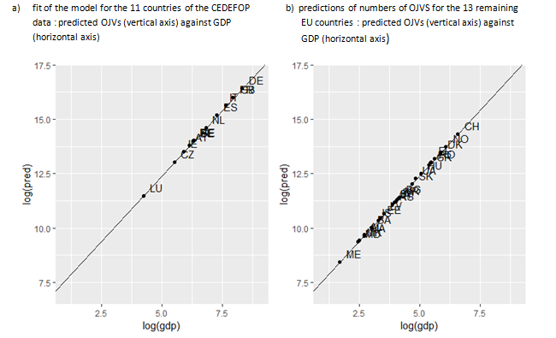

Figure 4: Prediction model

In order to assess the adequacy of the model, the predicted OJVs for the 19 countries of Figure 4b has been tested against actual data for those countries in CEDEFOP dataset V2. The results are shown in Figure 5 in which observed OJAs from the V2 version have been reported.

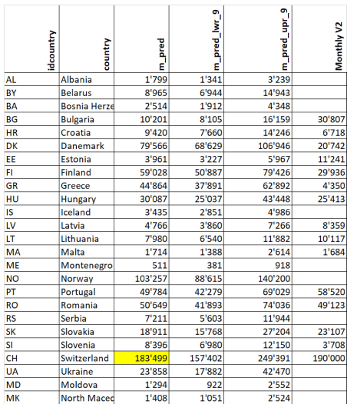

Figure 5: OJVs predictions for the 19 countries for which no data are available in the V1 CEDEFOP dataset (monthly averages and 95% confidence intervals). Monthtly V2 observations from the V2 dataset have been added to the original table

The same data are also displayed graphically in Figure 6. It appears that in most cases the observed OJAs are encompassed in the range (95% confidence interval) of the predicted values. There are nevertheless spectacular exceptions for FI, DK and GR with significantly less observed OJAs than predicted by the model, as well as for BG with more reported OJAs as predicted. Running the model with V2 data only slightly affects the parameters, which does not modify the general conclusions drawn from V1 data. While the economic conjuncture during the last decade may account for the low observed OJAs for Greece, the cases of Finland and Denmark remain to be explained.

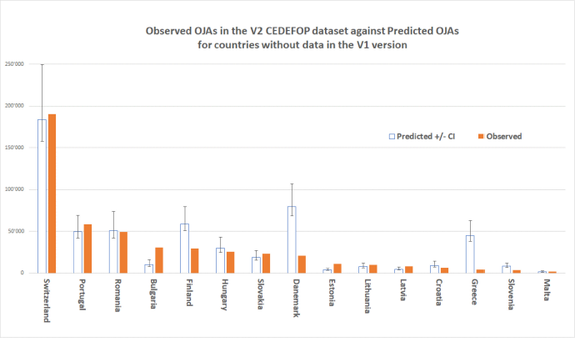

Figure 6: Observed OJAs in the V2 CEDEFOP data set versus Predicted values from the regression model for countries without data in the V1 Dataset

The prediction map (Figure 7b) drawn from the V1 dataset (Figure 7a) is displayed below against the map drawn from actual data for the period July 2018 to March 2019 (Figure 7c). It shows a good agreement between predictions of the model and actual observations for the additional countries which were absent from the first dataset.

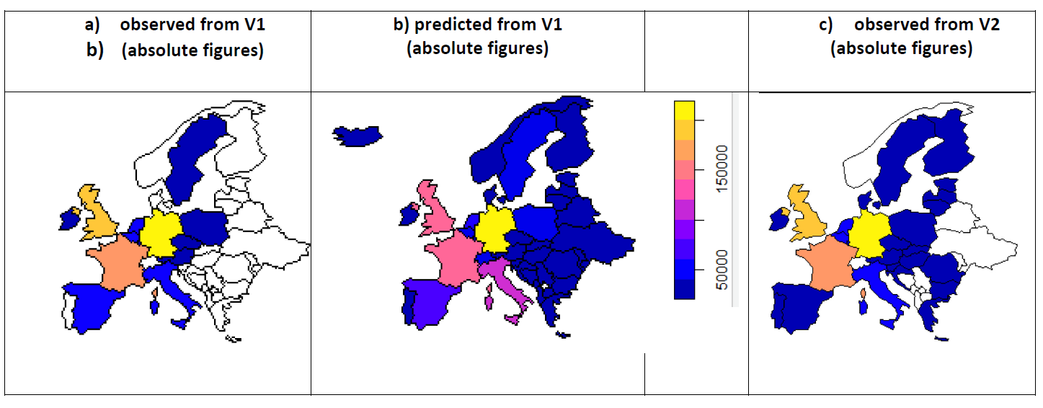

Figure 7: Prediction map based on the NUTS1 model compared to observed OJA

The replication with the second CEDEFOP dataset confirms the major results and conclusions reached through the analyses using the first CEDEFOP dataset at the country level. The good agreement obtained suggests that the conclusions also apply at the NUT2 level.

The following conclusions can be drawn from the modelling exercise at the national level:

a) A strong relationship exists between OJVs, country size (population) and national economic activity expressed as GDP

b) The CEDEFOP data collected as the European scale seem to offer a promising basis for developing pertinent economic indicators

c) Model predictions have been drawn which could be compared to actual observations for the 19 remaining countries for which no CEDEFOP data are available

d) On log scale GDP and population size offer a reasonable predictive power for OJVs

e) On the same basis OJVs could offer a tool for developing flash estimates of GDP among EU countries

Similar conclusions can be drawn from analysis of the data at the regional level as compared to the national level. The model could be improved using a robustification approach to handle outliers.

CEDEFOP data investigated clearly demonstrate a strong relationship between OJVs and socio-economic variables such as national and regional population sizes and GDPs. These relationships can be modelled with promising outputs. Such models may potentially be used for predictive purposes. For instance, since OJVs are potentially instantly available, they might offer a data source for developing Flash estimates of national and regional GDPs. The models and choice of variables should of course be studied in more detail and improved. The models also indicate that the offer the potential of predicting OJVs for countries without data for OJVs based on their socio-economic variables. Such cases without CEDFOP OJVs data, offer an interesting opportunity to test the models (blind approach).

## Comparisons between OJAs and Job vacancy Statistics

As discussed in the previous work by the Big Data ESSnet WP1[5], there are fundamental methodological issues around the quality of online job advertisements (OJAs). These issues need to be analysed in order to use these data to produce supplementary indicators for official statistics In particular, the main ones regard what the OJAs represent and cover and how they can be compared with official estimates produced from the official job vacancy survey.

The OJAs cannot be considered similar to the JVS as defined in the EU Regulations[6]. There are differences between the measures, which derive from the definition used by the European official surveys, and what can be practically measured from on-line job advertisements.

A major issue when dealing with OJAs is to understand how Online Job advertisements are connected to actual job vacancies, in particular to the official Job Vacancy Statistics. For this purpose, CEDEFOP data are in a first step compared to the Eurostat JVS downloaded from <https://ec.europa.eu/eurostat/databrowser/view/tps00172/default/table?lang=en>.

In an attempt to bring the data on a common basis allowing to compare the two sources, the total amount of CEDEFOP OJAs (a cumulated sum over a 9 months period : July2018-March2019) are transformed to monthly averages, as follows: m_ojv=total CEDEFOP OJVs/9. On the contrary, the quarterly Eurostat JVS correspond to a snapshot taken at the reference day (the last day of the quarter). For the same period, we have data of three quarters (2018Q3, 2018Q4 and 2019Q3). The absolute amount of JVS is averaged as follows: m_jvs= (JVS183 + JVS184 + JVS191)/3.

Figure 8 presents the CEDEFOP OJAs (9-months averages of total number of OJAs for the period July 2008 to March 2019) in comparison with absolute figures of the official published JVS of Eurostat (3-quarters averages) for the 13 countries with CEDEFOP data. Note that no data are not available for two large countries (FR and IT). We are therefore left with 11 cases for comparisons. Apart for CZ and IE for which figures diverge largely, monthly OJAs are of the same order of magnitude with JVS exceeding JVS from 10 to 61% (Figure 8). Note the very close agreement between the two indicators for Sweden.

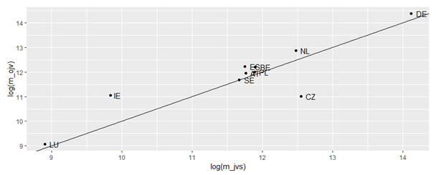

Figure 8: The abline of slope 1 makes conspicuous two oulierrs (IE and CT) for which OJVs depart largely from the Eurostat JVS

Although the results (Figure 8) are based on rough estimates (averages of total numbers of OJAs), they suggest a consistent relationship between OJAs and JVS and leave some hope that JVS may be approached using OJAs. Table 2 provide preliminary results supporting this hypothesis for the 11 countries for which CEDEFOP and JVS data are available. In the first three columns, official Eurostat JVS figures are reported for quarters 2018Q3, 2018Q4 and 2019Q1. A selection of OJVs with similar orders of magnitude is given in the next three columns, and ratios in percentage are given in the last three columns. OJVs have been selected as follows:

a) For each quarter, we selected the OJVs open during a window of 30 days corresponding to the last month of the quarter which were still open at the reference day have been counted (i.e 1-30. September 2018, 1-31 December 2018 and 1-31 March 2019 using the variables grab_date and expire_date)

b) For each country we retained only the OJVs corresponding to a given country and advertised in this country

c) We only retained OJVs for NACE B to S

d) We excluded advertisements from sources coming from an agency abroad the country (for instance, a job advertisement from a source like the one CZ_GIGAJOB in Czech Republic for a job in Ireland was rejected)

e) When the OJVs figures differed too much from the JVS, a closer agreement was searched playing with the time window



Table 2: Attempt to extract monthly OJAs coresponding to quarterly JVS for period 2018Q3 to 2019Q1.

Results of Table 2 indicate that a reasonable agreement can be reached in most cases with a 30-days time window corresponding to the last month of the quarter. In the case of Ireland the window was reduced to 15 days, while it has to be increased to 2 or 3 months for LU and BE. A closer analysis of the data indicates that the raw data may be very heterogeneous within a source, with missing data or large numbers of collected OJVs among months within the same source. Much work is still needed to better understand the data at this level of detail, as well as to validate/invalidate the approach of data selection attempted here.

This issue also enhances an important point. Online job portals have not been developed in order to produce statistics or indicators of the job market. Nor have they been invented for altruistic purposes. Their goal is different. They have been developed on economic grounds and for business reasons, crudely said “to make money” in a way or another. Therefore, a good understanding of the “business models” underlying the development of job portals, as well as of the market of online job advertisements is crucial. A good understanding of their mechanisms is a key issue to understand the data and find convincing ways to use them for statistical purposes.

For more details and detailed analysis of particular cases, see reports provided by Swiss Federal Statistical Office [7].

## Pseudo-stock transformation

In order to evaluate total labour demand based on OJA, we need to know if OJA data refers to the stock of vacancies at a point in time or to the inflow of new vacancies relative to the previous period. However, CEDEFOP data represent neither the flow nor the stock of online job vacancies. If it was flow data, we would see a large initial stock on which to base the flows of ads. This is not the case, as evident from Figure 9, which shows the daily frequency counts of job ads collected in Germany. If it were stocks, we would expect to observe similar stocks of observations every day, with gradual changes. This is also not the case, as there are large day-to-day fluctuations in the numbers of ads collected. 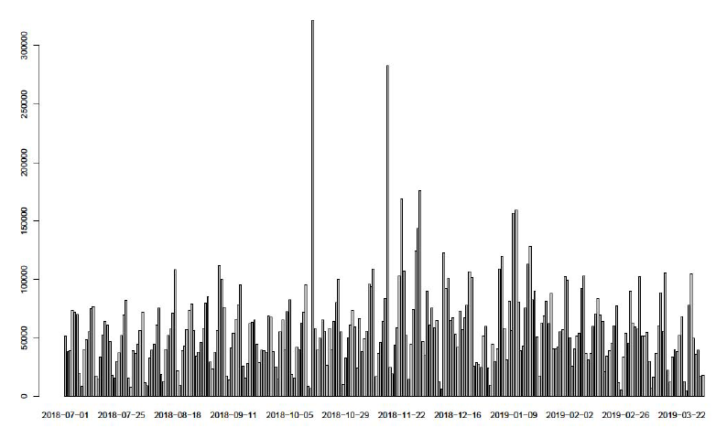

Figure 9: Number of job ads per day

If it were stocks, we would expect to observe similar stocks of observations every day, with gradual changes. This is also not the case, as there are large day-to-day fluctuations in the numbers of ads collected.

The data layout and descriptive material from CEDEFOP hint at an unstructured approach to collecting OJA data by scraping new ads whenever there happen to be resources available. Therefore, the counts of job ads cannot be directly compared with other measures of labour demand. CEDEFOP job ads cannot be interpreted as a time-series unless converted to stock data.

In order to address this issue, we explore the possibility of generating pseudo-stocks from CEDEFOP data, which approximate the underlying stock of job ads. The idea behind pseudo-stocks is the following:

The idea behind pseudo-stocks is the following: At a given point in time (T), we consider a job ad to be valid if it has not expired yet and was posted a maximum number of days before T. Expiration of a job ad is determined by the variable expire_date. Preliminary analysis of other sources indicates that job ads stay relevant for roughly 30 days on average. [8] The number of all job ads, which are considered at time T, is the pseudo-stock of active job ads at time T. Figure 10 illustrates this approach.

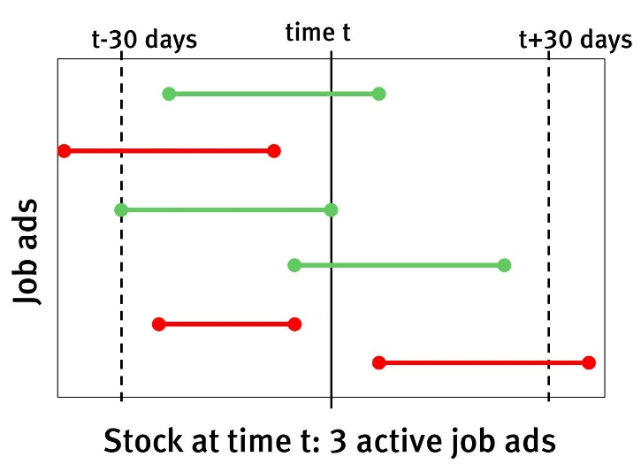

Figure 10: Pseudo-stock of active job ads at time T

This approach has the advantage that it can account for gaps in scraping coverage as long as the missing ads are scraped at some point within the assumed validity period.

One drawback of this approach is that for the length of the first validity period in the observed timeframe too few valid vacancies are available. Therefore, assuming 30 days of validity, pseudo-stocks are only useful from the 01.08.2018 onward.

In order to ease the comparison with JVS, we take the average of pseudo-stocks over the last month of each quarter. In any given quarter, the pseudostock of job ads is much lower.

The German JVS quantifies two types of vacancies, general vacancies which are to be filled at some indeterminate point in the future and urgent vacancies which are to be filled immediately.

The number of pseudo-stock job ads lies substantially below general vacancies in the JVS. This is also the case if we only consider JVS vacancies, which are to be filled immediately. We consider urgent vacancies to be a better equivalent to OJV ads than general vacancies, since the publication of OJV ads indicates that the recruitment process has started and the position is to be filled within a fixed timeframe.

OJAs capture only a subset of all vacancies, therefore we expect accurately measured OJV stocks to be lower than JVS vacancies, which is borne out by the results.

However, there is a substantial divergence in the development over time between OJA data and JVS vacancies. While JVS vacancies are relatively stable throughout the year 2019, this is not true for the pseudostocks of CEDEFOP OJAs. Those rise from 54-thousand in the third quarter of 2018, to 85-thousand at the start of 2019. An increase of more than 50% over 9 months. After a sharp drop in the second quarter of 2019, pseudostocks remain at a relatively low level until the start of 2020.

It needs to be stated clearly that the seven quarters for which CEDEFOP data is available is too short a timeframe to compare long-term trends in CEDEFOP and JVS results. However, it is clear that quarter-to-quarter variations are vastly different for both data sources. Three explanations for the observed differences are possible.

First, CEDEFOP OJA data is about job ads, while the JVS represents vacancies. If the number of vacancies per job ad was fluctuating strongly over time, discrepancies between OJA and JVS could be caused by this factor. However, research by the University of Zürich indicates that the average number of vacancies per online job ad is stable over time, at roughly 1.2.[9]

Second, the online job market may be more volatile than the numbers of vacancies reported in the JVS. While increased volatility is likely, there is also huge volatility in webscraping coverage of sources. It is therefore not possible, at the moment, to disentangle volatility in data collection from volatility in the underlying job market.

Which leads to the third possible reason for the observed discrepancies. Webscraping coverage of job ad sources in CEDEFOP data is spotty and unreliable, as illustrated by Figure 11 and Figure 12. Which might lead to strong quarter-to-quarter variations in pseudostock levels.

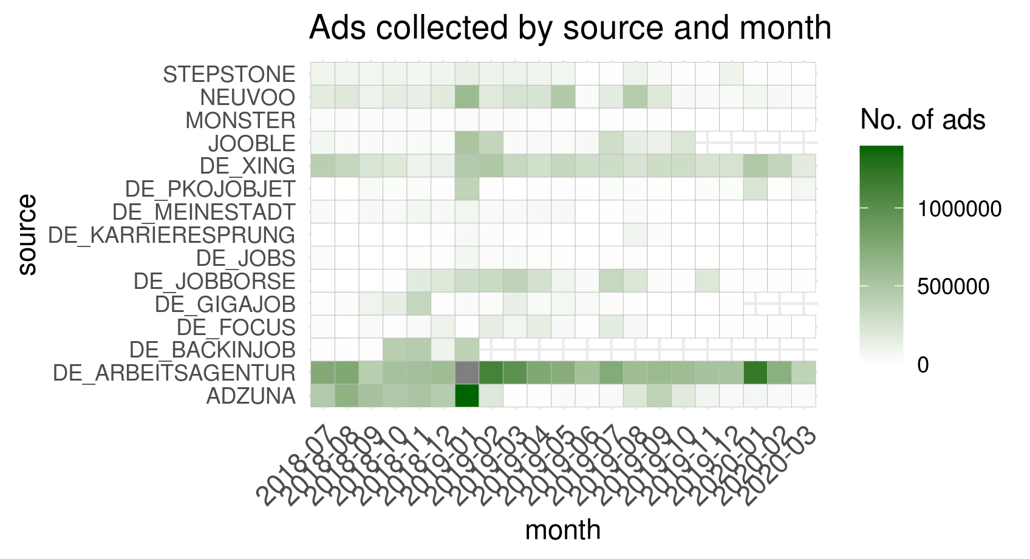

Figure 11: Ads collected by source and month

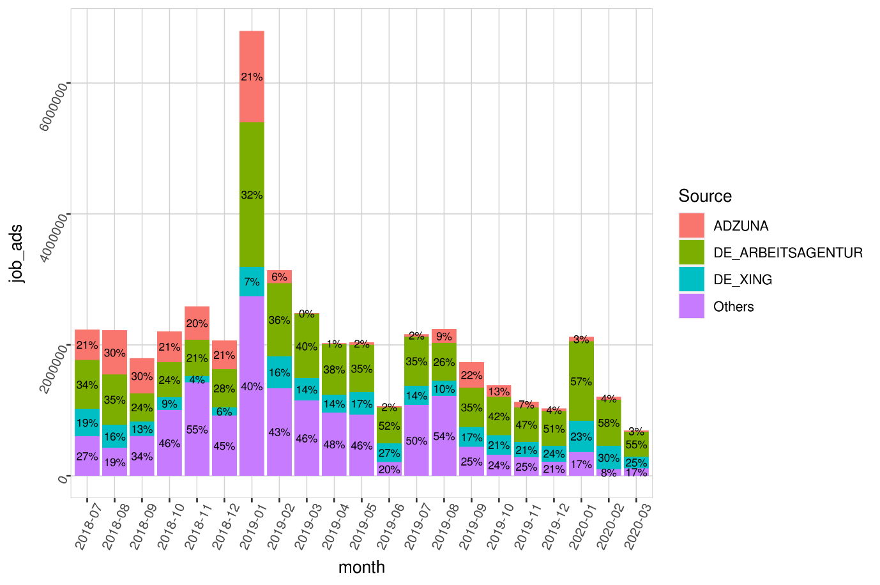

Figure 12: Ads collected from the 3 largest sources

Additionally, removal of duplicate observations is likely not perfect, which means that the share of duplicates will, to some extent, increase with the number of sources. Because the number of sources which are scraped effectively by CEDEFOP varies over time, the share of duplicates also varies in a similar way.

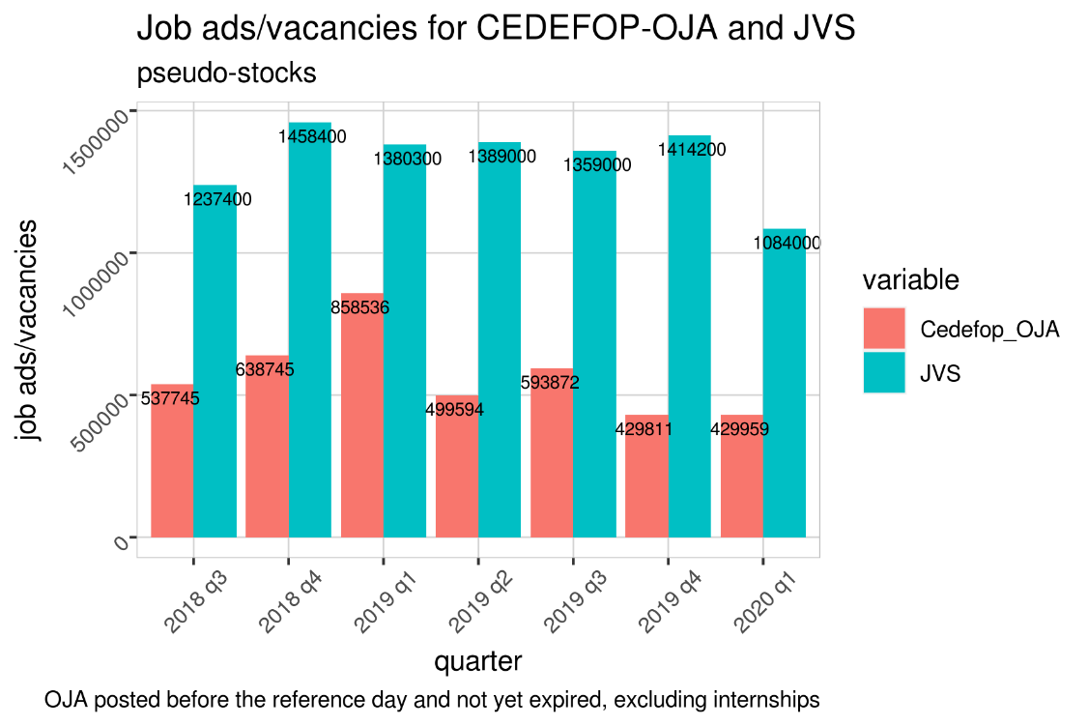

Figure 13: CEDEFOP‐OJAs vs. JVS vs.

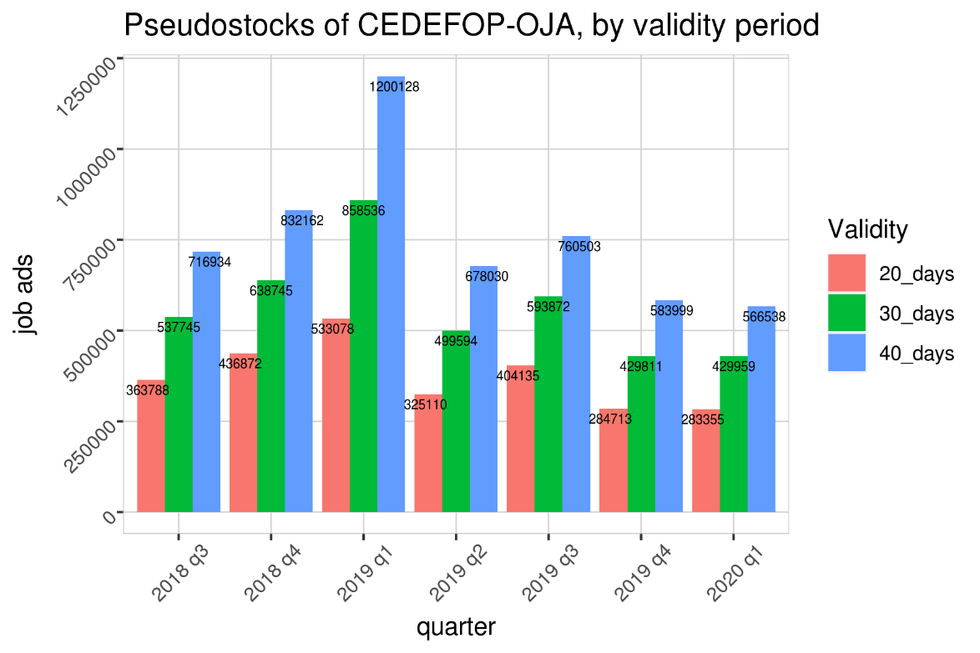

Figure 14: Pseudostocs of CEDEFOP-OJAs by validity period

### Pseudo stocks by federal country

The following figures plot the geographical distribution of OJA pseudo stocks by federal country for the three quarters of the observed time‐period. We observe large differences in OJA intensity across federal countries, with job ads primarily concentrated in highly populated areas. For comparison, Figure 15 plots the population distribution across federal countries. In fact, the geographic distribution of ads closely mimics the geographic distribution of individuals. The relative shares of job ads by federal country are quite stable over time. While total numbers of job ads vary between the quarters of the observed timeframe, they do so evenly across regions.

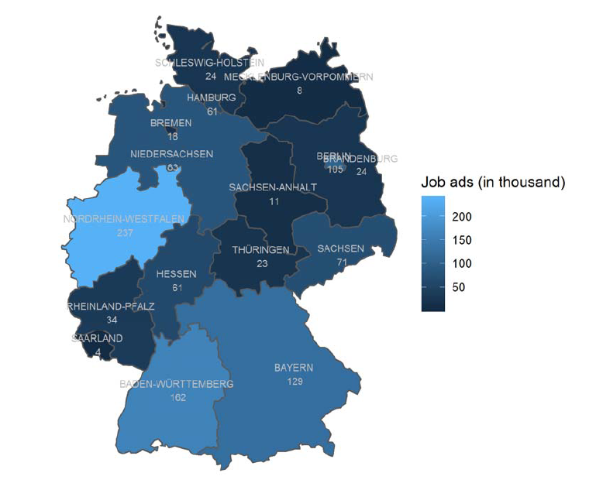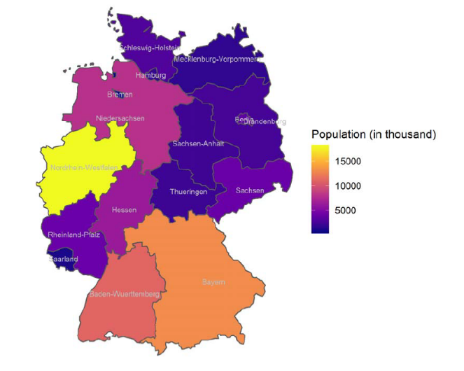

Figure 15: Map of job ad pseudo‐stocks Q1 2019

### Industry sectors

As an additional plausibility check, we compare the relative shares of industry sectors (by NACE categories) in OJA and JVS (Figure 16). Deviations from the industry shares in the JVS can be caused by uneven coverage in the web‐scraping process, by sector differences in online job‐portal use and by sector specific variations in the efficiency of the CEDEFOP deduplication process.

We see an overrepresentation of the manufacturing, IT and corporate services sectors in the CEDEFOP data, compared with the JVS. On the other hand, retail, construction and other services are under‐represented in CEDEFOP. The imbalance between corporate and other services might be caused by differences in classification of specific services between the two datasets.

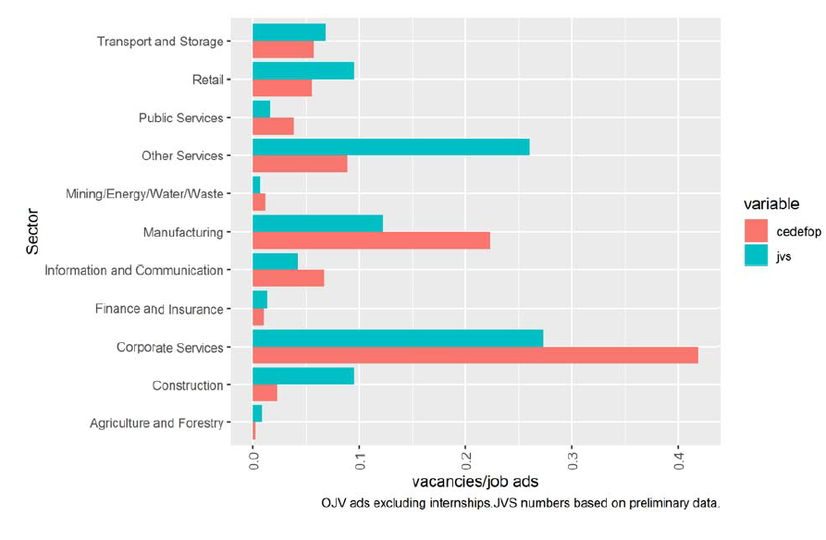

Figure 16: CEDEFOP‐OJA vs. JVS: relative share of job ads by industry sector

For more details and detailed analysis of particular cases, see reports provided by DESTATIS [10].

# Use cases of using OJA data in official statistics

In this section, we present examples of using OJA for producing statistical outputs of mainly experimental nature. These are not ready to be used as tools for decision making, and rather serve as proof-of-concepts illustrating some of the paths that are possible to follow in the future for creating statistical outputs based on OJA data.

## Developing meaningful indicators based on OJA data

##### Examples of institutions and companies dealing with OJAs

Figure 17 shows a selection of indicators based on OJA data used in labour market reporting separated by public-law or other non-profit institutions. It gives an overview regarding the answer to the question „what do the others do in the world“, and provides first ideas about meaningful indicators based on OJA data.

For example, the Australian government publishes an index of monthly online job advertisements. The database is based on the three largest job portals in Australia (SEEK, CareerOne and Australian Job Search). Figure 20 shows the first page of this monthly report of Internet Vacancy Index (IVI). Its development is presented from 2006 onwards. Not only an index value is calculated (index: January 2006 = 100), but also monthly absolute figures on the new job ads received within a month are shown. Additional information is the percentage change of the previous month and previous year. A differentiation is also made according to occupations, qualification requirements and 37 regions.

In the United States the member driven think tank The Conference Board uses data collected from online job sources including traditional job boards, corporate boards, and social media sites. Results are published on a monthly basis as shown in Figure 21. However, not evident at first sight, the reference period is defined as mid-month of previous month to mid-month of reference month that means data is aggregated from the 14th of the previous month to the 13th of the current month. The reason for this is the comparison of this labour demand with the labour supply based on unemployment figures of the Bureau of Labor Statistics (BLS). The latter one are collected with the so-called Current Population Survey which is a monthly survey that uses as reference period in general the calendar week (Sunday through Saturday) that includes the 12th day of the month (mid-month survey) [11].

The most recent important development is the so-called real time economic tracker from Opportunity Insights, an American organisation based at Harvard University (see Figure 18). This tracker has many different indicators and is more or less an immediate consequence of the COVID-19 pandemic, which has significantly increased the already existing pressure to use alterna¬tive new digital data sources. Chetty et al. build „a new, freely accessible platform that tracks economic activity at a high-frequency, granular level using anonymized and aggregated data from private companies. […] We report these statistics in real time using an automated pipe¬line that ingests data from businesses and reports statistics publicly on the data visualization platform, typically less than seven days after the relevant transactions occur.“ [12]

One can get further ideas from exploring private companies, which collect and analyse OJAs. Figure 19 lists the six most famous companies: Burning Glass, Haver Analytics, Gartner Inc., Indeed Hiring Lab, LinkedIn and Textkernel. Not mentioned in Figure 19 is the Swiss company x28 AG as it only covers one European country, the Switzerland itself. Furthermore, publications regarding their Jobradar[13] are only available after contact details have been entered.

|  |  |  |  |
| --- | --- | --- | --- |
| **Country** | **Institution** | **Indicators** | **Data basis** |
| **Australia** | Australian government  [*http://www.ga.gov.au/*](http://www.ga.gov.au/) | **Name:**  Internet Vacancy Index (IVI) <https://data.gov.au/dataset/internet-vacancy-index>  and  <http://lmip.gov.au/default.aspx?LMIP/VacancyReport>  **Periodicity**:  monthly press releases  (see Figure 4)  **Timelag:**  22 days after the end of e.g. corona month March 2020 | 3 biggest job portals (SEEK, CareerOne and Australian JobSearch);  Data provision by Department of Jobs and Small Business <https://www.jobs.gov.au/> |
| **Austria** | Austrian Public Employment Service (AMS) , a public service provider [*http://www.ams.at/*](http://www.ams.at/%20) *\** | **Name:**  Qualifikationsbarometer [*http://bis.ams.or.at/ qualibarometer/*](http://bis.ams.or.at/qualibarometer/)  not very prominent subdomain of [www.ams.at](http://www.ams.at)  **Periodicity:**  half a year (mostly) / yearly | Until reporting year 2015 job ads from print media – no ads from online job portals;  From reporting year 2016 onwards job ads from online job portals; automated data collection and data processing by using the big data platform **Jobfeed** powered by the company Textkernel [*https://www.jobfeed.com/at/home.php*](https://www.jobfeed.com/at/home.php)  See also: [*https://www.textkernel.com/hr-software/jobfeed/*](https://www.textkernel.com/hr-software/jobfeed/%20) |
| **Europe** | CEDEFOP  [*https://www.cedefop.europa.eu*](https://www.cedefop.europa.eu) | * **OVATE** (Online vacancy analysis tool for Europe) data presentation platform <https://www.cedefop.europa.eu/en/data-visualisations/skills-online-vacancies> * **Skills Panorama** data presentation platform <https://skillspanorama.cedefop.europa.eu/en/indicators/skills-online-vacancies> | Job advertisements from different job portals in Europe collected by web scraping, crawling or API.  For more details see CEDEFOP (2019), CEDEFOP (2018a). Country-specific reports are available at: <https://www.cedefop.europa.eu/en/publications-and-resources/country-reports/online-job-vacancy-market> (e.g. CEDEFOP 2018b). |
|  | EUROSTAT  [*https://ec.europa.eu/eurostat/web/main*](https://ec.europa.eu/eurostat/web/main) | Future plans. | Future plans:  Online platform “Data science lab” created as joint system together with CEDEFOP.  See the paper from Descy et al. (2018) presented at the DGINS Conference "The European path towards Trusted Smart Statistics" in Bucharest 2018. |
|  | European Central Bank ECB  [*https://www.ecb.europa.eu*](https://www.ecb.europa.eu) | **Name:** High-frequency data developments in the euro area labour market:   * Indeed job postings indicator * LinkedIn hiring rate indicator * nowcasting of unemployment rate during Covid-19 based on two above mentioned timely data sources   **Periodicity:**  Irregular**  **Time lag:**  Approximately 20 days after last observation day | Daily job postings from Indeed in the period from 2017 till 20 June 2020 for DE, FR, IT, ES, NL  Beyond pure job posting data they used additional information from the jobportal LinkedIn, in this case the so called LinkedIn hiring rate indicator calculated as the percentage of LinkedIn members who started  a job on a given day of the month and added a new employer to their profile in that month, divided by the total number of LinkedIn members in the five countries considered (DE, FR, IT, ES, NL).  See ECB (2020). |

* Not available in English

**These publications are a result of the urgent high frequency data needs to assess the impact of Covid-19 (see also Chapter 2).

Source: Translated, updated and expanded from Rengers (2018).

Figure 17: OJAs used in labour market reporting by public-law / non-profit institutions (selection) – part 1

|  |  |  |  |
| --- | --- | --- | --- |
| **Country** | **Institution** | **Indicators** | **Data basis** |
| **Germany** | Ifo Institute,  a registered non-profit association  [*https://www.ifo.de*](https://www.ifo.de) | **Name:** Press release June 16th 2020 based on findings of a joint evaluation by the ifo Institute and the LinkedIn social network  [*https://www.ifo.de/en/node/56091*](https://www.ifo.de/en/node/56091)  **Periodicity:**  Irregular** | Change in the number of job ads in different industries in the period from March-May 2019 to March-May 2020 measured as a proportion of all job ads on LinkedIn.  See Ifo Institute (2020). |
| **Switzer-land** | Swiss Job Market Monitor University of Zurich  [*https://www.stellenmarkt monitor.uzh.ch/en.html*](https://www.stellenmarktmonitor.uzh.ch/en/indices/combined.html%20) | Adecco Swiss Job Market Index (ASJMI)  [*https://www.stellenmarktmonitor.uzh.ch/de/indices/asjmi.html*](https://www.stellenmarktmonitor.uzh.ch/de/indices/asjmi.html)*  or  [*https://adeccogroup.ch/de/studien/job-index/*](https://adeccogroup.ch/de/studien/job-index/)  **Periodicity:** quarterly | The index is made up of three sub-indices that provide information on the change in job offers in the press, on company websites and on Internet job portals.  Regarding the job portals, those cross-industry and cross-professional Internet portals are taken into account which are most frequently used by companies for job advertisements. The identification of these most frequently used job portals is based on an annual company survey.  See Sacchi (2008). |
|  |  | Combined print-online index [*https://www.stellenmarktmonitor.uzh.ch/en/indices/combined.html*](https://www.stellenmarktmonitor.uzh.ch/en/indices/combined.html%20)  **Periodicity:** annual; last reference year 2014 | The combined print-online index shows the long-term development of demand for staff in Switzerland since 1950.  Web scraping of 12 job portals and 1,350 enterprise websites (for more details see Sacchi 2014*) |
| **USA** | Opportunity Insights,  an organization based at Harvard University  <https://opportunityinsights.org/> | **Name:** Oportunity Insights Economic Tracker  (real time economic tracker with a lot of different indicators)[*https://tracktherecovery.org/*](https://tracktherecovery.org/)  Regarding OJA:  Change in weekly unique job postings indexed to January 4-31 2020 (see Appendix Figure 11)  **Reference Period:**  a week ending Friday  **Periodicity:** weekly  **Timelag:**  3-5 days after end of working week | Data on job postings from 2007 to present from Burning Glass Technologies. Data from approximately 40,000 online job boards in the United States were collected and aggregated from Burning Glass.  See Chetty et al. (2020), especially chapter II.D. |
|  | The Conference Board,  a member-driven think tank  [*https://www.conference-board.org/*](https://www.conference-board.org/%20) | **Name:**  The Conference Board Help Wanted OnLine (HWOL) [*https://www.conference-board. org/data/helpwantedonline.cfm*](https://www.conference-board.org/data/helpwantedonline.cfm)  **Periodicity:**  monthly press releases (see Figure 5)  **Reference period:**  14th of previous month to 13th of following reference month  **Timelag:**  27-37 days after the end of a reference period , e.g. | Help Wanted Advertising Index (HWI) of print ads was published for over 55 years and discontinued in 2008; since 2005 indexmeasures changes over time in advertised online job vacancies Help Wanted OnLine (HWOL);  Situation in August 2018: More than 16,000 online sources;  Since December 2018: revised HWOL index based on 28,000 different online job boards including traditional job boards, corporate boards, social media sites, and smaller job sites that serve niche markets and smaller geographic areas AND since December 2018 release of experimental HWOL Index  Data delivery from the company Haver Analytics [*http://www.haver.com*](http://www.haver.com); cooperation with Wanted Analytics *www.wantedanalytics.com* which belongs to the American Company CEB *www.cebglobal.com* since November 2015; CEB itself was taken over by Gartner, Inc. *www.gartner.com* in April 2017.  Changes since 2019: Burning Glass Technologies |
|  | US State California:  EDD Employment Development Department  <https://edd.ca.gov> | HWOL statistics  <http://www.labormarketinfo.edd.ca.gov/data/help-wanted-online%28hwol%29/> | See descriptions in the row above regarding the conference board. |

* Not available in English

**These publications are a result of the urgent high frequency data needs to assess the impact of Covid-19 (see also next chapter).

Source: Translated, updated and expanded from Rengers (2018).

Figure 18: OJAs used in labour market reporting by public-law / non-profit institutions (selection) – part 2

|  |  |  |  |  |
| --- | --- | --- | --- | --- |
| **ompany** | **URL/ registered office** | **Observed country** | | **Product names** |
| **Burning Glass** | <https://www.burning-glass.com/>  Boston, USA    <https://www.burning-glass.com/uk/>  Edinburgh, United Kingdom    <https://www.burning-glass.com/au/>  Christchurch, New Zealand | In principle, this analysis tool can be used for any country. For the time being, the following case studies are available:     * Australia and Asia * USA: Missouri Economic Research Information Center * USA: Northeastern University * USA: University of Maryland, Baltimore County * United Kingdom: Company Active Informatics as official sales partner of Burning Glass | | * Labour Insight TM   For free:  Some news and results from labour market (OJAs) are available online; see Chapter 2 |
| **Haver Analytics** | [http://www.haver.com](http://www.haver.com/)  New York, USA | * Australia * Canada * China * Europe | * Japan * New Zealand * United Kingdom * USA |  |
| **Gartner, Inc.** | [www.gartner.com](http://www.gartner.com/)  Headquarter in Stamford (Connecticut), USA    German locations in Munich, Düsseldorf and Frankfurt am Main | * worldwide active | | * Gartner TalentNeuron TM (previous: Wanted Analytics) |
| **Indeed Hiring Lab** | <https://www.hiringlab.org/>  Indeed, Inc.  Austin, USA | * Australia * Canada * France | * Germany * Ireland * United Kingdom * USA | * analyses based on indeed’s own job portal   For free:  Some news and results from labour market (OJAs) are available online see Chapter 2 |
| **LinkedIn** | <https://economicgraph.linkedin.com>  https://www.linkedin.com/news/daily-rundown/ | * Europe *(new; coverage unclear)* * India * United Kingdom * USA | | * Economic graph   For free: monthly LinkedIn Workforce Report; monthly report on hiring, skills, and migration trends in the U.S., the U.K., and India. Also updated news as irregular web population;  see Chapter 2. |
| **Textkernel** | [https://www.textkernel.com](https://www.textkernel.com/)  Amsterdam, Netherlands  London, UK  Düsseldorf, DE  Paris, FR | Data for Europe and North America:   * Austria * Belgium * Canada * France * Germany | * Italy * Netherlands * Spain * United Kingdom * **USA** | * Jobfeed   DE: <https://www.jobfeed.de>  US: <https://us.jobfeed.com>  …  For free: weekly update of OJAs development for the most countries mentioned in the left column in graphs (see Chapter 2)  Apart from that:  No press releases with results from jobfeed (only demo versions can be requested) |

Source: Translated, updated and expanded from Rengers (2018).

Figure 19: OJAs (commercially) collected and analysed by private companies (selection)

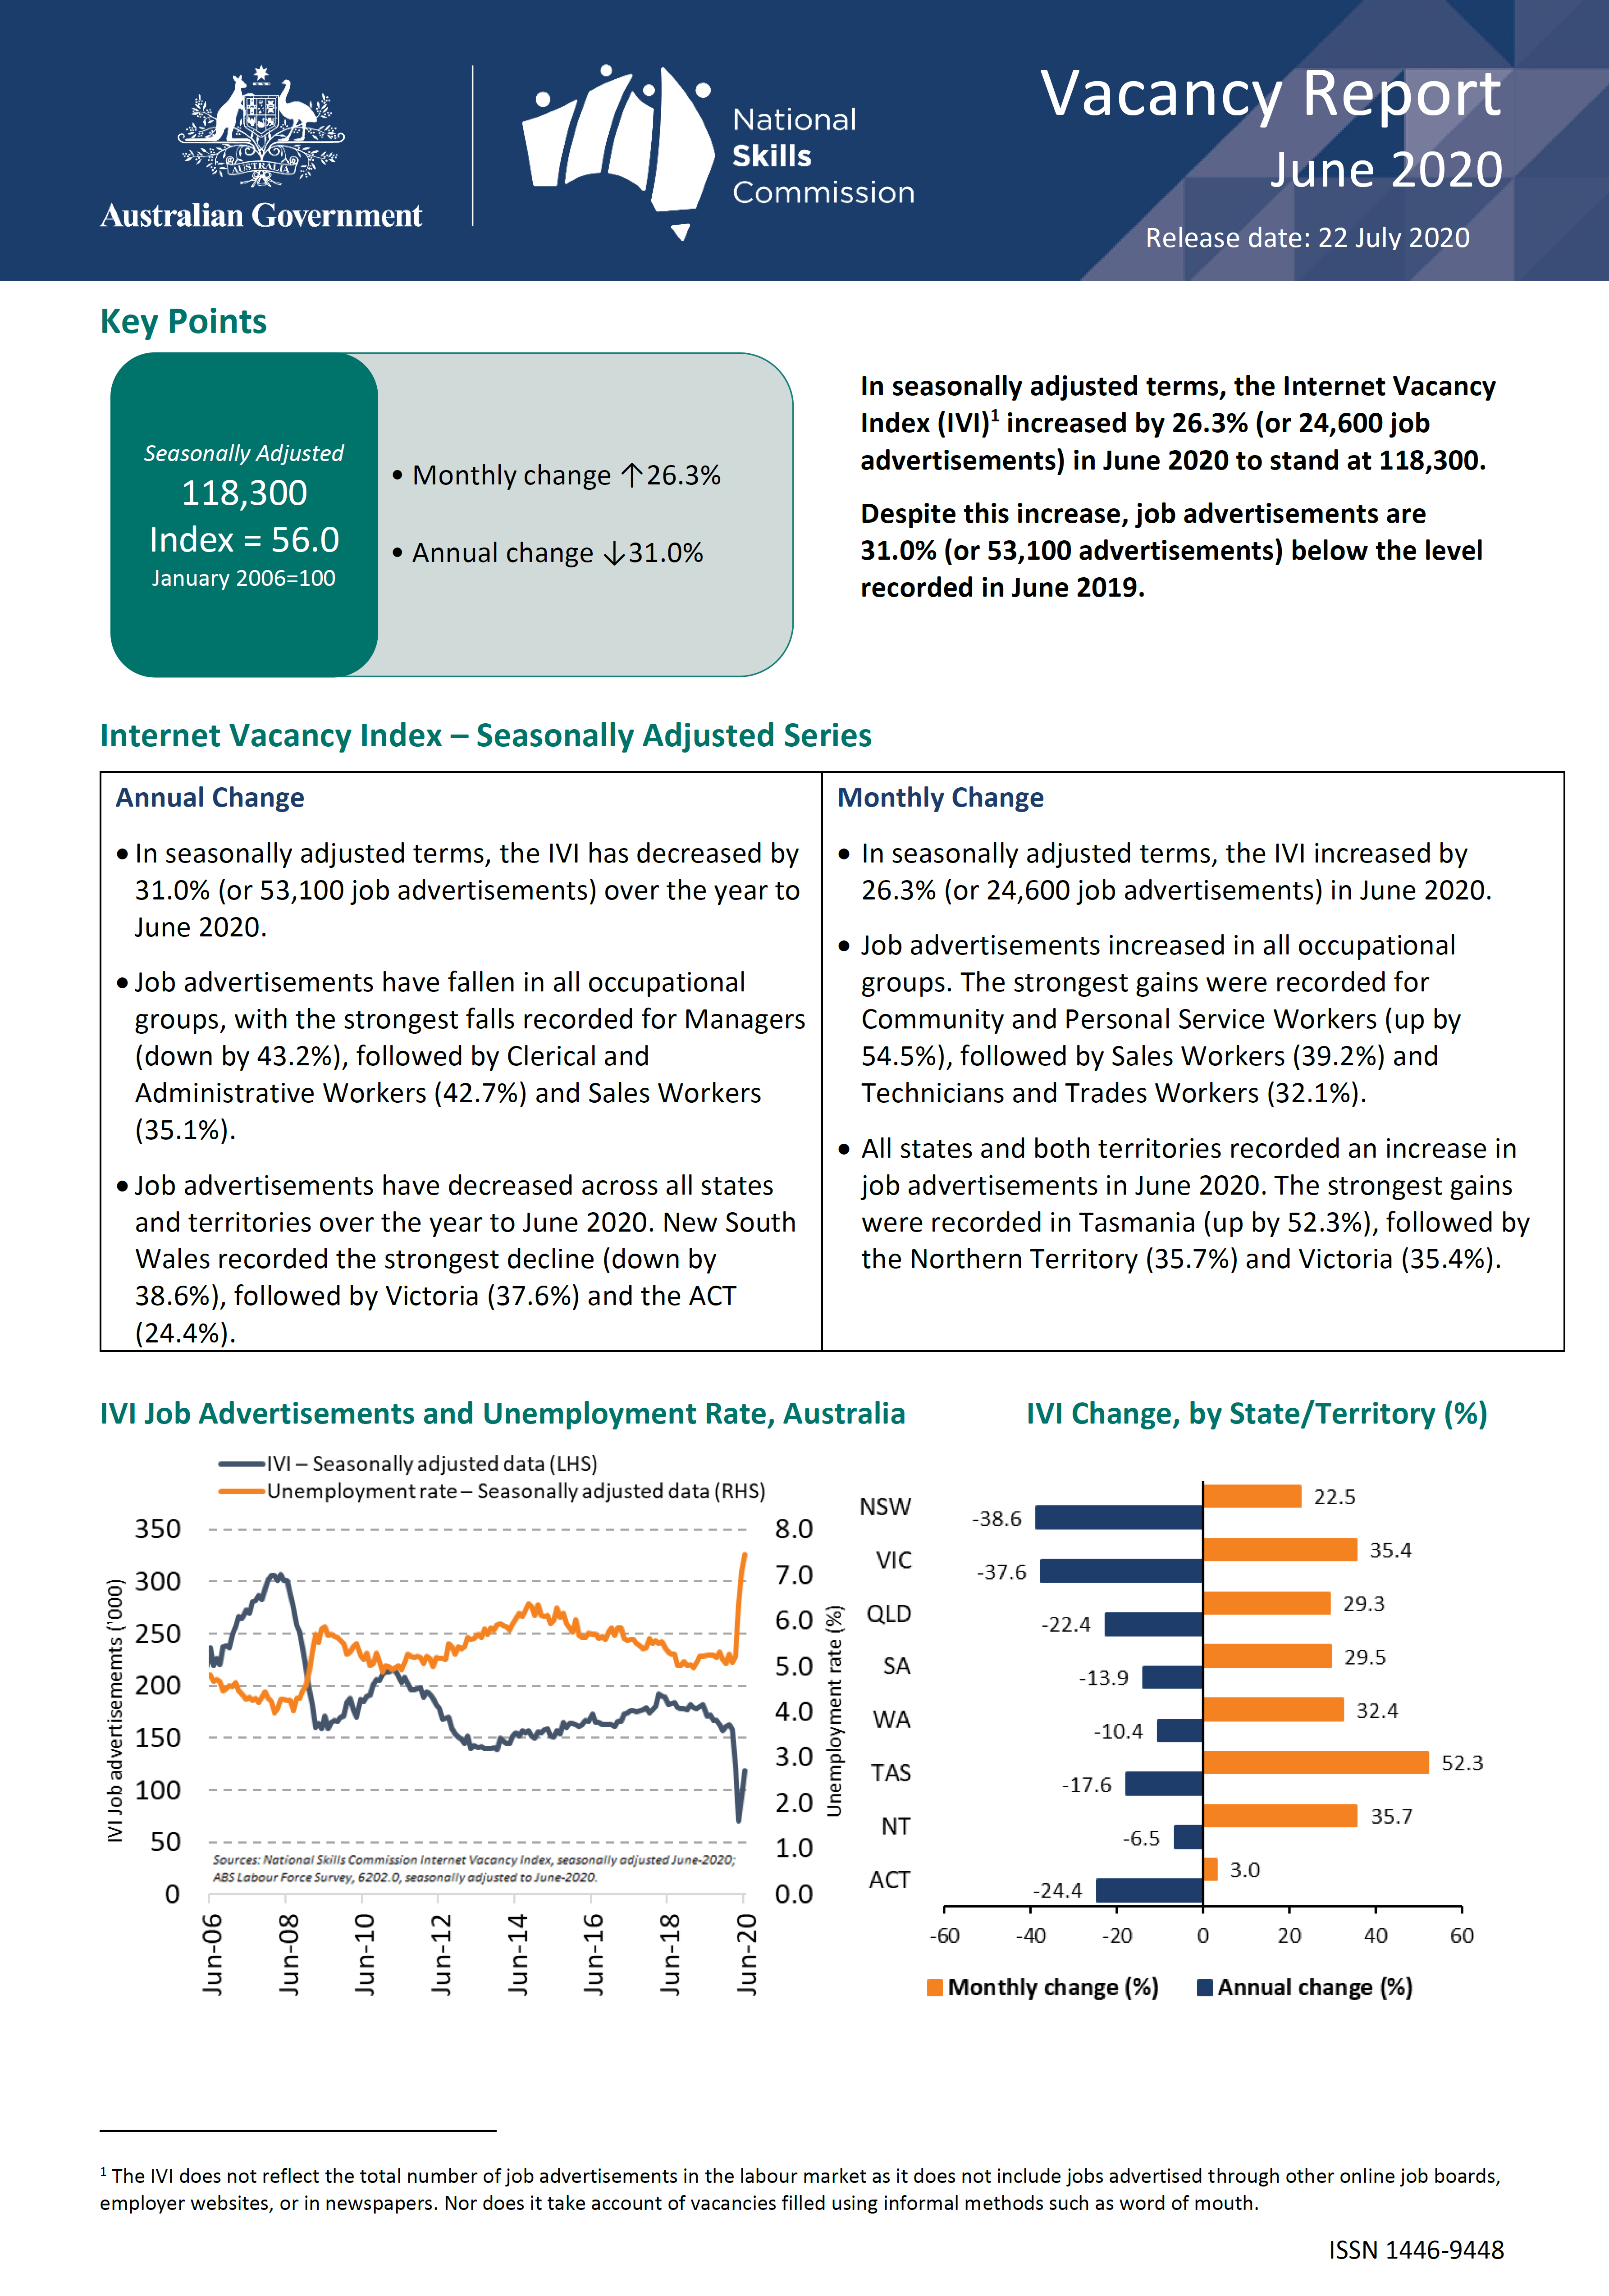

Source: Australian Government (2020); pdf document of the website <https://lmip.gov.au/default.aspx?LMIP/GainInsights/VacancyReport> (state of date: 18 August 2020).

Figure 20: Australia: First page of the monthly report of Internet Vacancy Index (IVI)

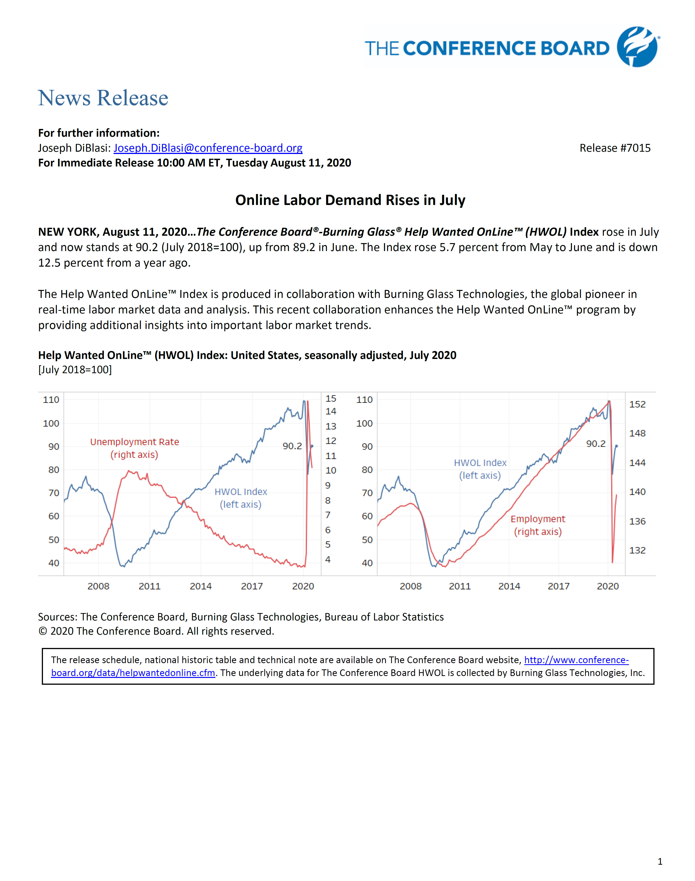

Source: <https://conference-board.org/pdf_free/press/7015%20-%20HWOL%20July%202020.pdf> (state of date: 18 August 2020)

Figure 21: USA: First page of the monthly report of Help Wanted Online (HWOL) Index

##### Timeliness, short-term development, early detection of turning points: the case of COVID-19 outbreak and initial OJA figures for March 2020

With a monthly index on the (economic) development of online job advertisements, the potential of real-time information from job portals can be analysed and processed in real time. Additional regional differentiations as well as job-group specific evaluations of the online job market provide new short-term indicators that show current and policy-relevant developments with regard to changes in the demand for labour. For example, early warnings of threatening bottlenecks or overcapacities are conceivable. In this way, information can be provided that goes beyond the established labour demand statistics.

In the following, the importance of real-time information from online job portals will be discussed in light of the current extraordinary COVID-19 crisis. Companies like Burningglass, Indeed, LinkedIn, and Textkernel react with very timely publications and information on special online sites. The earliest of these was Burningglass US, which, just four days after the end of a reporting week, provided calendar-week-specific changes to online job advertisements in an Excel file for download on a COVID-19 special page for all states of America (see Figure 22). They promote this with the following words: “The coronavirus pandemic has had an unprecedented impact on the world economy. Burning Glass Technologies is using its database of more than a billion current and historical job postings to measure this economic shock and how it affects the job market. We’ll be updating this page frequently with the latest data.” Corresponding COVID-19 special pages from Indeed, LinkedIn, and Textkernel are shown in Figure 23, Figure 24 and Figure 25.

Timeliness and punctuality are one side of the coin, but what about data quality (e.g. coverage problem and problem of duplicates) and how to interpret the different OJA indices? In Figure 26 latest OJA data for Germany published by Textkernel and by Indeed are compared with each other. Textkernel’s product Jobjeed offers an overview of new job vacancies appearing on the Internet – at least that’s how the company describes it. But how exactly are "new job vacancies" defined? What is the reference period? Regarding the first graph of Figure 26 one can assume that the reference period is one calendar week. This indicator from Textkernel shows more or less a decline from March 01 to April 01 of around –40%. Unfortunately, there are no figures available for free but regarding the graph one can assume for calendar week 9 (including first of March 2020) an amount of 270K new jobs and for calendar week 14 (including first of April 2020) round about 160K. On the other side, the Indeed Index (measured as 7 day moving average of job postings on Indeed job portal) fell by 12% from March 1 to April 1.

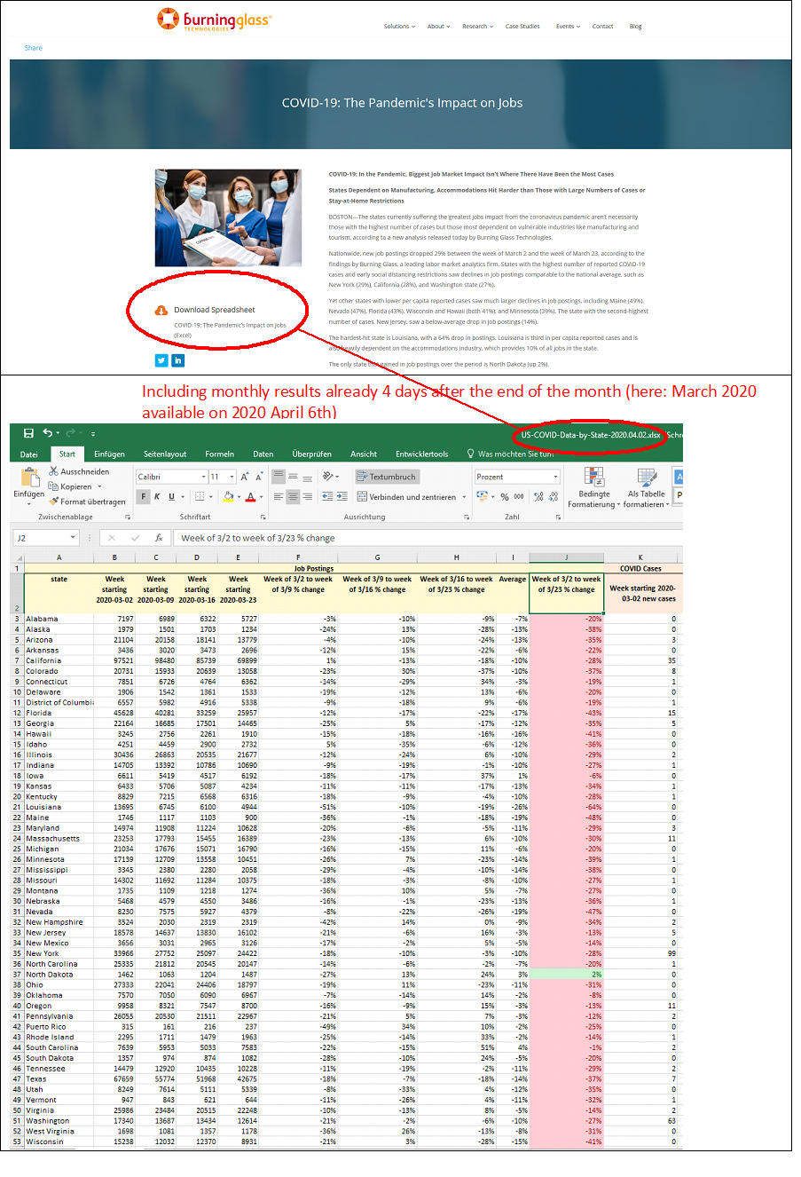 Source: <https://www.burning-glass.com/research-project/covid-19/> (state of date 02 April 2020)

Figure 22: Burningglass US: Free access to timely data in the situation of Covid-19

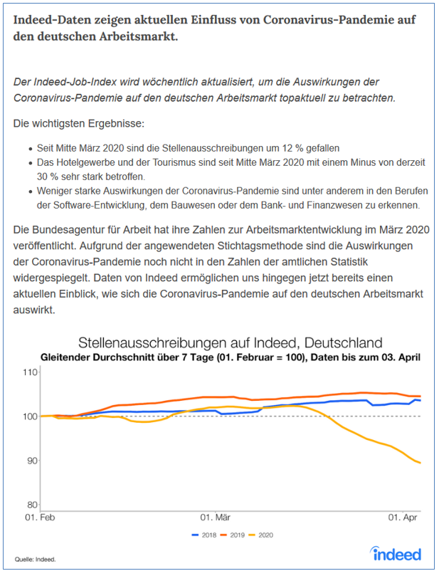

Source: <https://www.hiringlab.org/de/blog/2020/04/08/coronavirus-arbeitsmarkt-stellenausschreibungen/> (state of date 9th April 2020)

Figure 23: Indeed Hiring Lab: Free access to timely data in the situation of Covid-19 (first page)

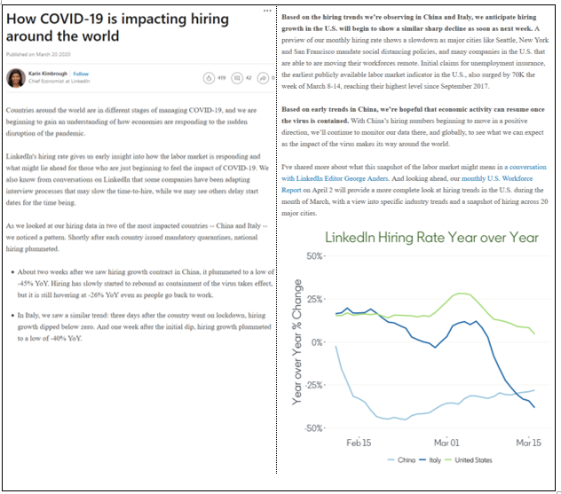

Source: <https://www.linkedin.com/pulse/how-covid-19-impacting-hiring-around-world-karin-kimbrough/?src=direct%2Fnone&veh=direct%2Fnone%7Cdirect%2Fnone>

Figure 24: LinkedIn: How COVID-19 is impacting hiring around the world

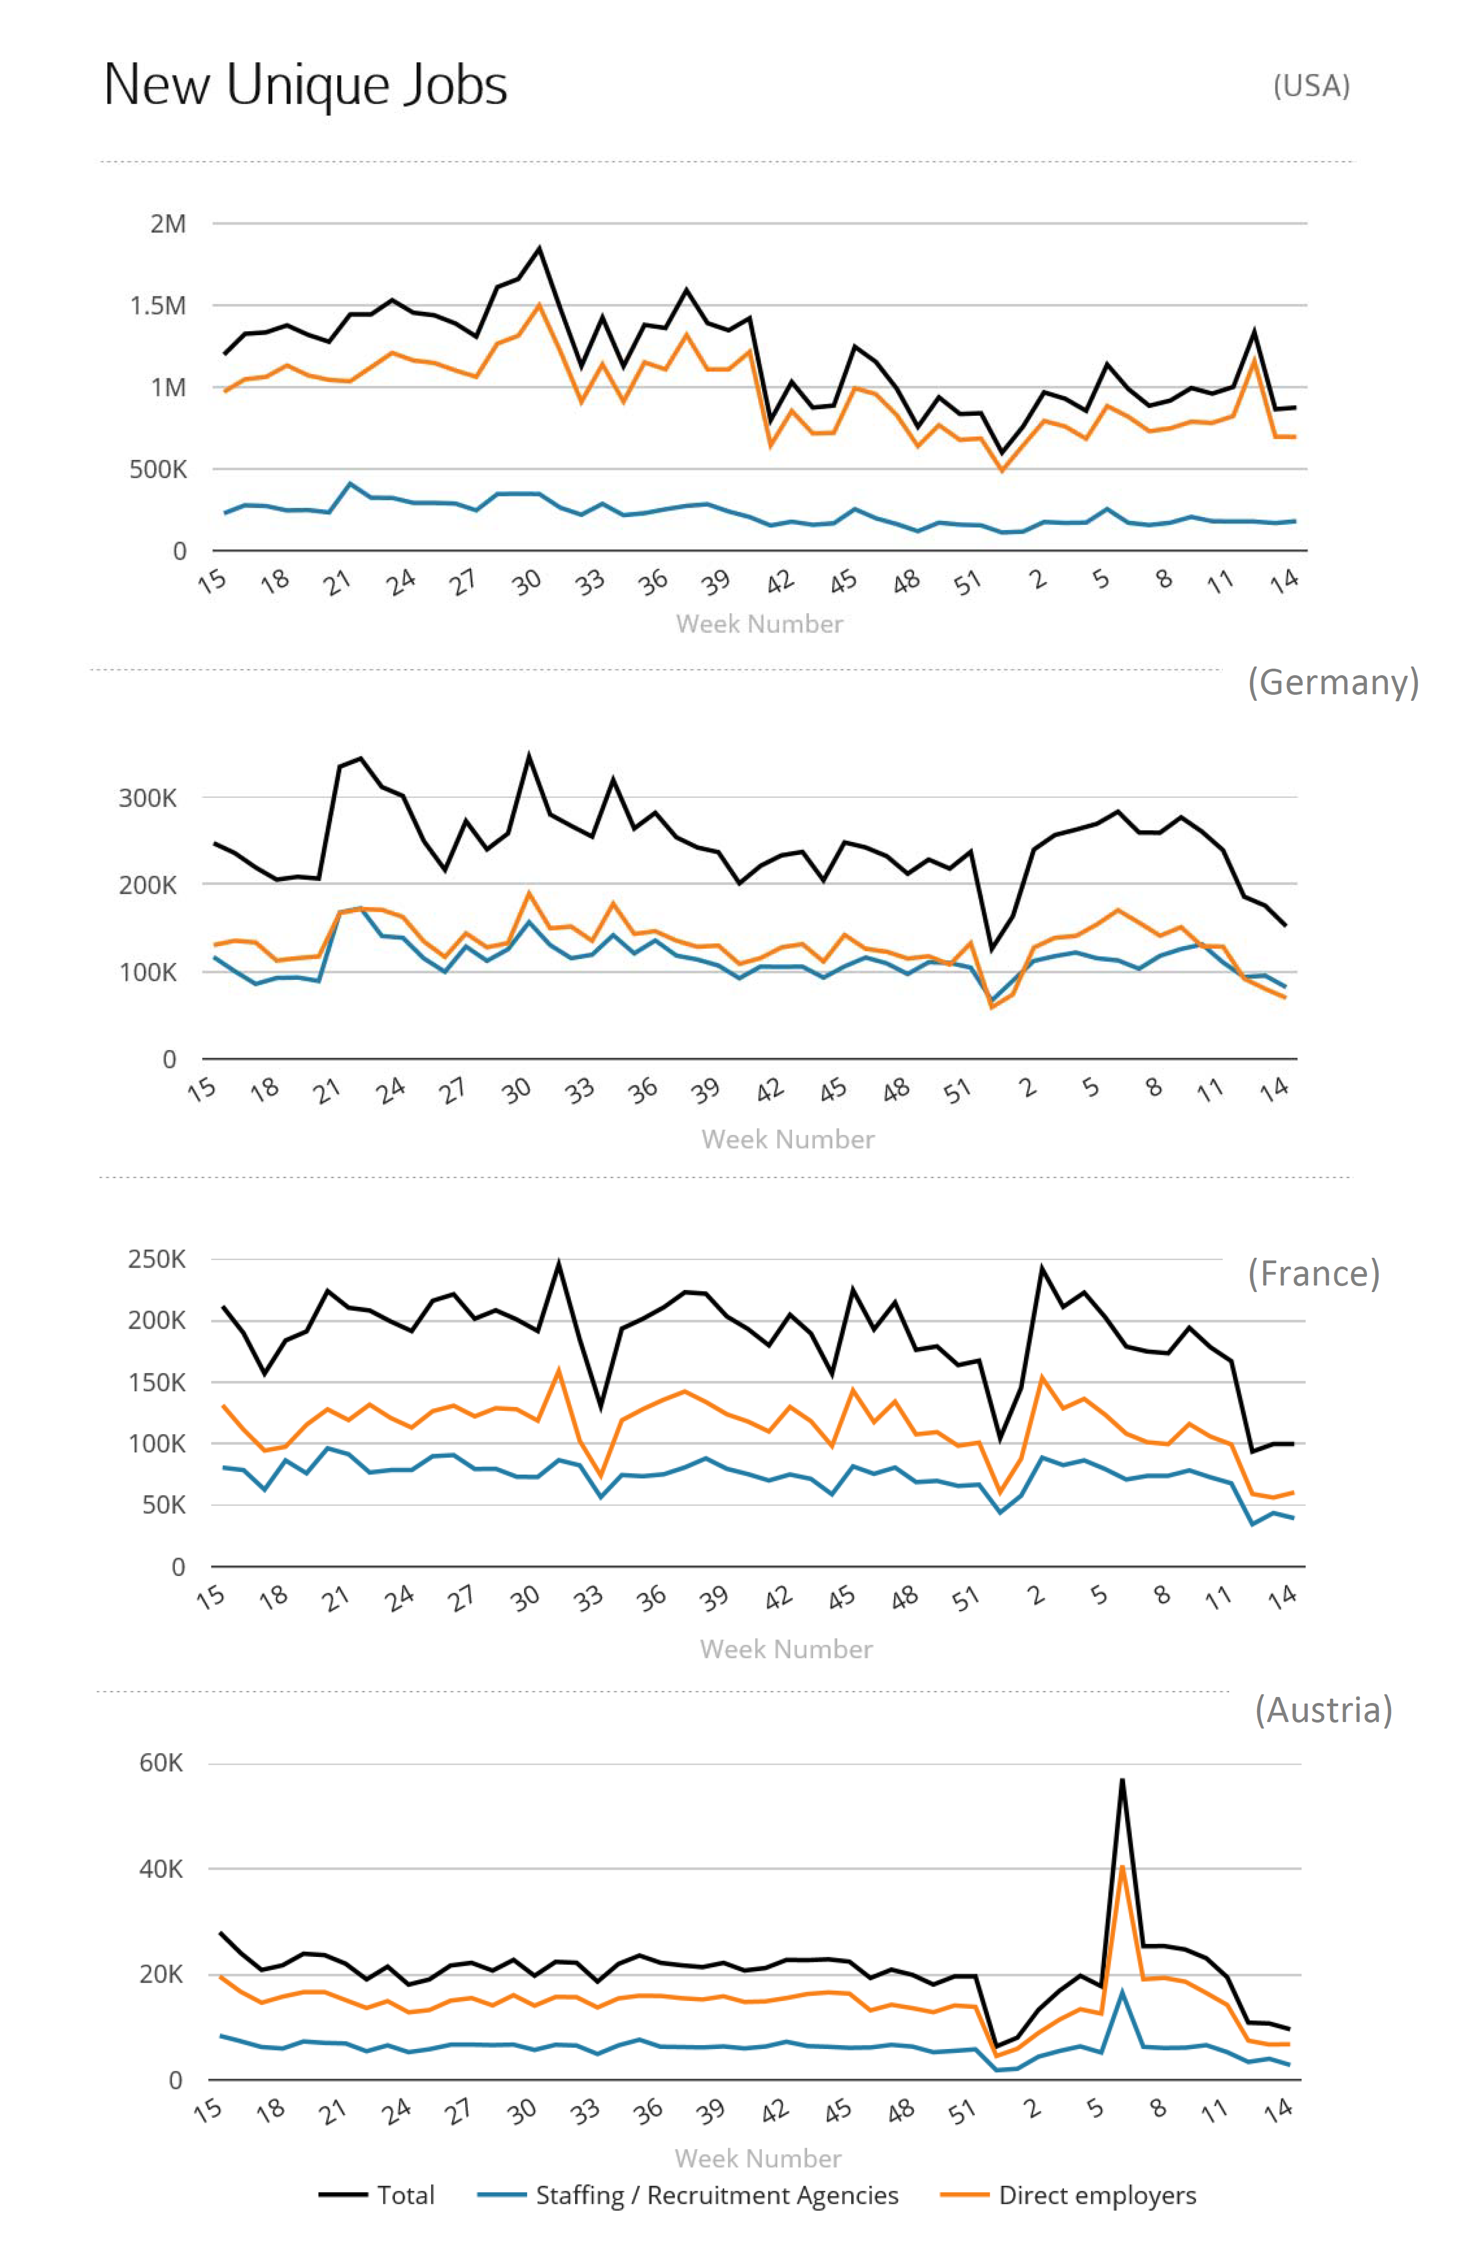

Source: Textkernel, see <https://www.jobfeed.de/home.php>, state of date: 07 April 2020.

Figure 25: Textkernel: Free access to timely graphs in the situation of Covid-19

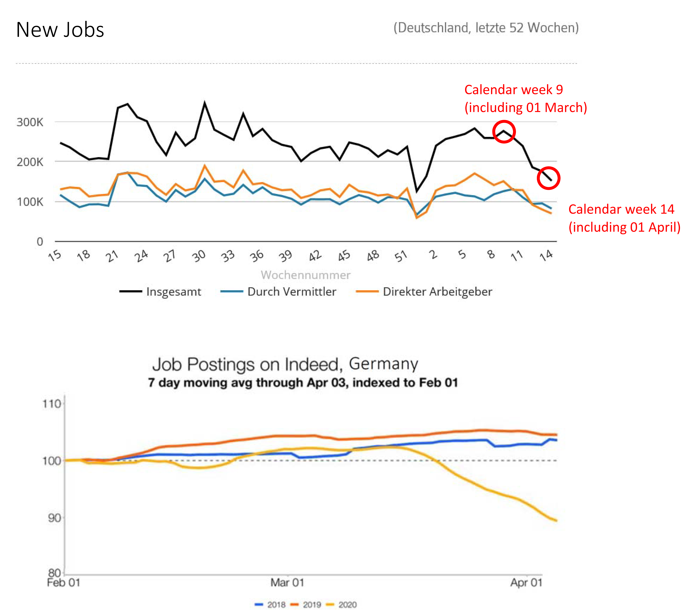

Sources:

First graph from Textkernel, see <https://www.jobfeed.de/home.php>, state of date: 07 April 2020.

Second graph from Indeed, see <https://www.hiringlab.org/de/blog/2020/04/08/coronavirus-arbeitsmarkt-stellenausschreibungen/>, State of date: 09 April 2020.

Figure 26: Germany: how to interpret the different OJA indicators from selected private companies using the example of Covid-19

##### Structural analyses

One of the most popular structural anaylsis is that on jobs and skills requested in online job advertisements. This is what for example CEDEFOP do with Skills-OVATE or Skills Panorama. They provide information on occupations, skills and regions based on international classifications: ISCO-08 for occupations, NUTS-2 for regions, ESCO version 1 for skills and NACE rev. 2 for sectors.

Regarding the Swiss Job Market Monitor there is another structural analysis of interest: the structural changes regarding the importance of different recruiting channels (see Figure 13 in [14]). Among other things, a distinction is made between company websites, online job portals and press. In this context, however, it would also be conceivable to analyse the changing importance of social media over time. However, in order to detect shifts from online job advertisements to social networks, it is necessary to collect not only OJA from job portals but also OJ postings from company websites and (other?) data from social networks.

In an earlier document, Germany has already proposed and described the calculation of a labour market concentration index (LMC) based on OJAs[15]. This is one idea for a more structural analysis. To measure such regional concentration, OJAs are broken down to Functional Urban Areas (FUA). These FUAs consists of city cores and their commuting zones. The LMC index can be published quarterly or yearly and can inform educational, regional and labour market policy.

For a job portal owner there are many other structural analyses possible, as they have access to much more information than only on OJAs. Many job portals have also data from the jobseekers, like information on job wishes or preferences, employment histories or complete resumes (CVs). They can also examine the search behaviour of jobseekers:

* WHAT? - Keywords such as "remote jobs" when entering a search
* Number of hits of job advertisements that meet certain criteria (e.g. "Remote Job")
* HOW? - Search intensity: Number of applications per jobseeker

Furthermore, they have data on submitted applications at least within their own platform and can therefore supply the following indicator as well:

* Number of applications per job/job advertisement

Job portal owner like LinkedIn do all this analyses[16] although they know that their data or not statistically representative[17]. In Germany the Institute for Employment Research (IAB – Institut für Arbeitsmarkt- und Berufsforschung) used those jobseeker information to analyse how the Corona crisis influences search processes on the labour market[18]. Even the ECB economists noted that LinkedIn's insights can provide "more timely information about labour market developments than that derived from more traditional statistical sources” [19].

For more details and detailed analysis of particular cases, see reports provided by DESTATIS [20].

## Labour Market Concentration Indicators using OJA

While market power due to monopolies and monopsonies in product markets is well documented and regulated by antitrust agencies, monopsony power and market concentration in labour markets is rarely in the spotlight. In part because empirical evidence of labour market concentration has historically been scarce due to lack of suitable data. In recent years however, public interest in labour market monopsony power has increased and several studies have shown that labour market concentration is widespread and has significant consequences.[21] Concentrated labour markets allow employers to offer wages below worker’s marginal productivity depress the wage distribution and generate rents just like in concentrated product markets.[22] If, for a given occupation, region and timeframe, few potential employers are offering jobs, they can force workers to accept lower wages since the wage elasticity of labour supply is generally low (at least in the short run).[23]

Concentration in labour markets does not necessarily overlap with concentration in product markets. Labour market competition is measured at the level of worker occupation and is limited by worker mobility. Employees can face a concentrated local labour market even if they work in a sector where products markets are highly competitive nationwide or internationally. On the other hand, product monopolists might compete against employers in other product markets for the same employees.

Against a background of stagnating median real wages and slowly increasing product market power in Germany, the wage effects of labour market monopsony power cannot be taken lightly.[24] Therefore, the topic of market concentration has high policy relevance and German policymakers have shown a willingness to expand the scope of antitrust laws to cover new markets.[25]

Data on online job ads is uniquely suited for detecting and monitoring labour market concentration. Ideally, we would observe the universe of job ads, in order to quantify market shares of all employers in each local labour market. Online job ad data collected by CEDEFOP comes reasonably close to this ideal, with 15,578,258 distinct job ads over three quarters from a wide range of online sources across the entire country and all occupations.[26] CEDEFOP job ad data also contains the necessary information about the location, the company and the occupation of the job.[27]

This data allows us to quantify the share of job offers for each employer by occupation and timeframe in local labour markets. From this data, one can calculate measures of market concentration like market shares or the Herfindahl-Hirschman-Index. Such indices of market concentration can be evaluated by the criteria used by antitrust agencies in order to classify markets as critically concentrated.

We propose a labour market concentration index (LMC) which can be published each quarter and can inform educational, regional and labour market policy.

##### Functional Urban Areas

We define local labour markets in terms of Functional Urban Areas (FUA) as used by Eurostat.[28] A FUA consists of one or more cities and their commuting zone. Commuting zones are based on commuting patterns. If at least 15% of the population of a local administrative unit (sub-region) commute to a city, the unit is classified as part of the commuting zone. If no large numbers of individuals commute from outside the city, the city itself is a FUA (E.g. Tübingen). A FUA represents the area within which the majority of inhabitants would look for jobs. Searching outside their FUA is likely to require moving, which is costly, and would therefore require a high wage premium to be beneficial. The Eurostat definition lists 118 unique FUA codes for Germany.[29] Of these, 11 are missing in our data, meaning that no job ad observations are available. In at least one case this is likely due to geographical miscoding in CEDEFOP data and will need to be resolved in the final index.

##### Construction of the index

Our labour market concentration index (LMC) is based on the considerations by Azar et al. (2018) and employs a similar methodological approach. Relevant labour markets are defined in terms of geography, timeframe and occupation. The geographical unit of choice is the functional urban area (FUA).[30] The principal advantage of FUAs is that they contain both living and working areas within commuting zones and are therefore uniquely suited to define local labour markets. The timeframe for analysis are quarter years. Occupations are classified by the ISCO level 4 scheme.

The actual index is the sum of squared market shares across all employers in a given local labour market in a given quarter. It is calculated for quarter (t) with squared market shares (s) for employers (i) in a given market (j):

$${LMC}_{jt}=\sum_{i}{s_{ijt}^{2}}$$

The index has a range from 0 to 10000, with 0 denoting perfect competition and 10000 denoting a monopoly. The index is the labour market equivalent of the Herfindahl-Hirschmann Index (HHI) for product markets. The HHI is used as a secondary metric for evaluating mergers by the German antitrust agency (Bundeskartellamt), although they primarily rely on the size of market shares by the largest companies. One of the main benefits of these indices is that they can be easily compared across markets and over time.

##### Results and next steps

The LMC is estimated as a labour market concentration index for the timeframe from q3-2018 to q1-2019, for each ISCO-4 occupation and functional urban area in Germany. Table 5 shows summary statistics of the LMC averaged across quarters and regions. The mean LMC across three quarters and all occupation/region cells is 3686 and the median is 2400. In several occupation/region/quarter cells, the LMC reaches a maximum of 10000, indicating a monopoly in the respective occupational local labour market.

In order to interpret these values, consider the following: For merger control at the European level, LMC values between 1000 and 2000 are considered non-critical.[31] In US antitrust proceedings, markets with LMCs below 1500 are considered not concentrated and those above 2500 are considered highly concentrated.[32] A highly concentrated market would have only four active companies, if market shares were evenly distributed. Therefore half of all occupation/region/quarter cells can be considered concentrated because their LMC lies above 2500. And there are even some local occupational labour markets where a single employer has a monopoly on job offers.

|  |  |
| --- | --- |
| Metric | LMC |
| mean | 3686 |
| minimum | 83 |
| 50th percentile (median) | 2400 |
| 48th percentile | 2500 |
| maximum | 10,000 |

Table 3: Summary of concentration index

Figure 27 shows the geographical distribution of average labour market concentration indices by functional urban area, averaged across three quarters. It is apparent that there are substantial differences in the average concentration of labour markets between regions, which suggests that some markets are inherently competitive, while others are not. The regional differences are stable over time and hardly change between quarters. This fact indicates that temporary hiring waves are not a major determinant of labour market concentration. Instead, the structure of employers in each region determines LMC.

Examples of competitive markets are the urban regions of Berlin, Hamburg, Düsseldorf and Stuttgart. Examples of non-competitive markets are rural regions like Mecklenburg-Vorpommern or Niederbayern, but also regions with medium sized cities like Lüneburg, Marburg or Tübingen.

These results show that some labour markets in Germany are highly concentrated. The next step in the analysis would be to establish a link between market concentration and wage levels in local labour markets. The strength of the relation between wages and LMC, while controlling for regional characteristics, would give some indication of the wage impact of labour market concentration. Two data sources, both available from the federal employment agency, might be suitable for this purpose. The best option, the SIAB dataset, containing a 2% sample of all dependent employees with high quality information about wages, occupations and places of work, is not yet available for 2018 and 2019. Once it becomes available, this should be the primary resource for linking wages to LMC. Until then, the plan is to use the statistic of gross employment remuneration, which provides median wages by region and rough occupational classification.[33]

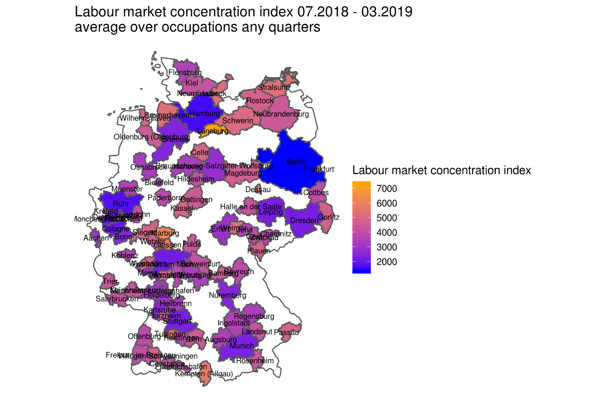

Figure 27: LMC index 072018 - 032019 average over occupations and quarters

For more details and detailed analysis of particular case, see reports provided by DESTATIS [34].

## Supplementary indicators for official statistics from OJAs

OJAs could offer a significant enrichment for the official job vacancy indicator required by EU Regulations, despite their coverage and representativeness limits.

The official statistics on job vacancies as required by the EU Regulations and regularly transmitted to Eurostat by Member States, regards the national job vacancy rate (defined as the ratio between the job vacancies and the sum of vacant and occupied job positions), disaggregated by NACE Rev. 2 economic activity sections and on a quarterly basis.

The official MS job vacancy rates are not required by the Regulations broken down by other characteristics of the vacant job position, such as the geographical area/region where the vacant post is located and the profession required.

However, these kind of characteristics are considered as particularly useful by current and actual stake-holders, and even if the production of job vacancy indicators broken down by these two characteristics is not required as obligatory by the current EU Regulations, Eurostat already invites Member States to disseminate and transmit these data. For some Member States these data are already available in the Eurostat online datawarehouse. Furthermore, the possibility to make obligatory the production of job vacancy statistics broken down by region and profession once a year in one of the survey waves should be discussed by the Task-force on the Review of EU legislation in the field of Business Based Labour Market Indicators (LMI), whose works are currently in progress.

OJAs have the main advantage of providing information high detailed in terms of the characteristics of the job positions.

Moreover, for the production of job vacancy rate the majority of EU Member States use either a representative average of job vacancies collected at specific reference dates during the quarter or a single specific reference date.

The EU Regulations on job vacancy statistics consider the collection on a continuous basis and the average based on specific reference dates as the preferred methods to have an information on the vacant job positions representative for the quarter as a whole: “MS shall provide data on the number of job vacancies and the number of occupied posts that can be considered representative for the reference quarter. The preferred methods to achieve this are data collection on a continuous basis or the calculation of a representative average of data collected for specific reference dates” (EC Reg. No 19/2009 implementing the JV frame Regulation EC No 453/2008).

A continuous collection method implies a significant improvement in the collection costs and in the response burden for the enterprises. From the enterprise side in fact, it would imply having a kind of register in which keeping the account of all vacancies opened and closed during the reference period.

OJAs are available on a daily, weekly and monthly basis, not only at one or at more than one specific reference dates in quarter. They have the advantage of capturing the vacancy flows that is all the vacancies opened and closed during a reference period, instead of only the vacancy stock at specific reference dates.

The vacancy stocks takes only into account the vacancies that survived at a specific date, without reporting the movements of vacancies before that date.

Additional information at higher frequencies than those of the JVS can be derived from the OJAs and gives useful insights into the dynamics within the quarter of the labour demand expressed by the online recruitment process.

This annex includes:

a) An explorative comparison, based on the Italian data, between the OJAs and the JVs by calculating the online job advertisement rate using the same definition of the job vacancy rate.

Furthermore, other preliminary descriptive analysis have been carried out, which exploit the detailed and higher frequency information included in the OJAs and suggest different use in which the OJAs can complement and enrich the current official JV information.

b) Analysis of the daily OJAs data in order to evaluate the representativeness of job vacancies data at specific reference dates;

c) Use of monthly OJAs data to indirect compute a monthly basis JV official indicator from the quarterly ones;

d) Analysis of the daily OJAs broken down by geographical area/region and the profession required data in order to study changes over time over this dimension.

##### OJA rate vs JV rate official indicator: the Italian case

As widely discussed in several reports, job vacancies advertised on job portals by enterprises represent a different concept with respect to EU Regulations definition of job vacancy. They are characterized by different coverage and representativeness limits. They do not represent all existing job vacancies because not all job vacancies are advertised on-line and job portals are not necessarily totally covered. Furthermore, OJAs data might not only miss many jobs, but also not be representative of the overall job vacancies.

Keeping in mind that OJAs are not an exhaustive measure of the labour demand, this section shows a first attempt to compute the OJA rate based on the same definition of the EU Regulation, in order to make an explorative comparison with the quarterly national official JV rate (*JVrq*):

where *JV* and *JP* are, respectively, the estimated number of job vacancies and occupied job position on the basis of the quarterly Istat survey on job vacancies and hours worked (VELA).

The OJA rate (*OJArq*) has been computed on a quarterly basis, from the third quarter 2018 to the fourth quarter 2019, and covering the same NACE Rev. 2 economic activity sections (from B to S, excluding the public sector) as the Italian JV rate.

${OJAr}_{q}=100*\frac{\frac{\sum_{m=1}^{3}{\left({OJA}_{m}\right)}}{3}}{(\frac{\sum_{m=1}^{3}{\left({OJA}_{m}\right)}}{3}+{JP}_{q})}$ [1]

where $\frac{\sum_{m=1}^{3}{\left({OJA}_{m}\right)}}{3}$ is the quarterly average of monthly sum of *OJAs.*

Some preliminary evidence comes out from the analysis broken down by economic activity sector (Figure 1a-1c), such as the quite similar levels of the rates in Industry, with differences between the two rates, which do not exceed 0.5 percentage points. This should partly due to the important role of very big enterprises in the Italian industry sector, which, in general, use advertising on job portals as main recruitment channel. On the other hand, in the services sector higher differences between the two rates are observed. For example, OJA rate is once and a half the JV one in the Q42019. The higher differences in this sector should depend on the relevant role in the Italian service sector of small enterprises, which may prefer to make use of more informal recruitment channels.



Figure 28: OJAs vs JV rates: Italy, Total Economy (NACE Rev. 2 economic activity sections from B to S, excluding O)



Figure 29: OJAs vs JV rates: Italy, Industry (NACE Rev. 2 economic activity sections from B to F)



Figure 30: OJAs vs JV rates: Italy, Industry (NACE Rev. 2 economic activity sections from G to S, excluding O)

Figure 28, Figure 29 and Figure 30 also show the changes with respect to the same quarter of the previous year, even if the period available is too short to make a comparison on the dynamic of the two rates. Taking into account the two sectors separately, it seems that the absolute differences between the year on year changes of the two rates are smaller in the Industry sector than in the Service one.

##### Representativeness of the job vacancy stock at specific reference dates

OJAs daily distribution during the quarter can give useful insights on the representativeness of the vacancy stock at the specific reference dates used in the current job vacancy surveys.

In particular, OJAs can show whether, and to what extent, the single reference date used is representative for the quarter, since the flow of vacancies opened and closed during the quarter cannot be fully captured from a single specific stock. It is especially true during very peculiar period, such as the COVID-19 emergency months, when the single reference dates used in the official surveys fell during the enterprise total lockdown.

Therefore, it is worthwhile analysing the OJAs daily distribution in order to define the best reference dates of the job vacancy official survey collection, or at least, in order to better know the limits of the currently used reference dates.

Figure 31 - Figure 34 shows the Italian daily OJAs distribution during the fourth quarters of 2019. The Italian job vacancy official survey collects vacancies at the last calendar day of the quarter.

There is no a clear evidence of a defined OJAs daily pattern during each month. In addition to this, the “best capturing dates” during the quarter are difficult to be detected and there is not a strong signal supporting a change from the currently used reference date to another single one date for the Italian vacancy survey. It should be better moving from the last calendar day of the quarter to an average over several single dates; but the significant negative impact in the implementation costs for the survey and enterprise response burden need to be take into account.

However, preliminary evidence arises of:

a) Intense flows of vacancies within the month;

b) Different vacancy patterns over each month;

c) Different monthly average numbers of OJAs within the quarter.

These results highlight the need to improve the representativeness of the quarterly JV rate, based on the vacancies stocks collected only at a specific reference date of the quarter.



Figure 31: OJAs daily distribution during the four quarters of 2019: the Italian case, first quarter 2019



Figure 32: OJAs daily distribution during the four quarters of 2019: the Italian case, second quarter 2019



Figure 33: OJAs daily distribution during the four quarters of 2019: the Italian case, third quarter 2019



Figure 34: OJAs daily distribution during the four quarters of 2019: the Italian case, fourth quarter 2019

##### From a quarterly to monthly basis JV indicator

The high frequency detailed information from OJAs can also be used to indirectly extend the frequency of the JV official indicator from a quarterly basis to a monthly one. This is another helpful use of the OJAs, taking into account the difficulties both in implementing a vacancy survey on a continuous basis and in changing the currently used reference date or extending it to more dates.

EU Regulations requires the job vacancy rate on a quarterly basis. In Istat, as already mentioned, for the computation of the vacancy rate, data on job vacancies refer to the last calendar day of the quarter. Daily information on OJAs provides valuable insight into vacancy flows during the quarter. The monthly average number of OJAs could be used to estimate the vacancy rate on a monthly basis (*JVrm* ), as follows:

$${JVr}_{m}={JVr}_{q}*\frac{monthly mean OJAs }{quarterly mean OJAs}$$

Since there is no evidence of a clear daily pattern in the months, we preferred to use the monthly and the quarterly average of OJAs instead of the number of OJAs on a specific day (e.g. last day of the month or the quarter). Job vacancy rate is one of the principal European economic indicators (PEEIs), the primary source of information used to analyse and monitor short-term cyclical economic developments within the EU Member States, the euro area and the individual EU countries (ESSnet Big Data II, Methodological framework for processing online job adverts data for Official Statistics V.2, p. 10). Therefore, a monthly job vacancy rate, indirectly derived from the OJAs, can be used to better understand the dynamics of the economic cycle within the quarter, also in relation to other monthly indicators.

A first attempt of estimating a monthly vacancy rate, only for the Italian case, from the third quarter of 2018 to the fourth quarter of 2019 has been carried out. The exercise has been based on the monthly OJAs data over the months July 2018-December 2019 and on the current not seasonally adjusted job vacancy rate quarterly estimates, derived from the Italian official survey (Figure 35).

Figure 35: From a quarterly to a monthly basis job vacancies rate estimates: the Italian case

Table 4 shows the vacancy rate changes (percentage points differences), calculated comparing the vacancy rates to the same period, month or quarter, of the previous year. It is interesting to note, for example, that the growth in the vacancy rate in the third quarter of 2019 (+0.1) is mainly due to the growth in the vacancy rate in September 2019 with respect to September 2018 (+0.6).

|  |  |  |  |
| --- | --- | --- | --- |
| **Quarter** | **Month** | **Change in monthly JVR** | **Change in quarterly JVR** |
| **Q3-2019** | 7/2019 | 0 | 0.1 |
| **Q3-2019** | 8/2019 | -0.2 | 0.1 |
| **Q3-2019** | 9/2019 | 0.6 | 0.1 |
| **Q4-2019** | 10/2019 | 0.1 | 0 |
| **Q4-2019** | 11/2019 | -0.1 | 0 |
| **Q4-2019** | 12/2019 | 0 | 0 |

Table 4: Year on year change in the job vacancy rate (percentage points difference): the Italian case

##### The quarterly OJAs by profession and geographical area

A possible enrichment of OJAs could be the computation of the online job vacancies rate by professional figure (Isco level 1). It is essential to know the number of jobs positions broken down by professional figure, placed at the denominator of the rate computation. Jobs positions by professional figure are not available in the Italian job vacancy survey (VELA), since it is provides job positions by NACE Rev 2. economic activity sections. Therefore, job positions by profession have been derived from other Istat sources, and extracted from the I.stat database for the quarters of interest. They differs from job positions used for the computation of the official job vacancy rate and for the exercise of computing an OJA rate showed in this annex Job positions by profession available from the other sources also includes jobs in the sectors not observed in the vacancy survey (that covers sections B-S, excluding O) and self-employed workers. For this reason, job positions by professional figure have been recalculated by redistributing the number of job- positions used for the computation of the official vacancy rate derived from the VELA survey, according to the percentage distribution of job positions by professional figure (derived from other sources, Table 5).

|  |  |  |  |  |  |  |
| --- | --- | --- | --- | --- | --- | --- |
| **Isco level 1** | **Q3-2018** | **Q4-2018** | **Q1-2019** | **Q2-2019** | **Q3-2019** | **Q4-2019** |
| Clerical support workers | 11.2 | 11.0 | 11.6 | 11.6 | 11.1 | 11.2 |
| Craft and related trades workers | 14.8 | 14.9 | 14.7 | 14.5 | 14.3 | 14.6 |
| Elementary occupations | 11.1 | 11.3 | 10.8 | 10.7 | 11.2 | 11.1 |
| Managers | 2.7 | 2.8 | 2.6 | 2.6 | 2.7 | 2.6 |
| Plant and machine operators, and assemblers | 8.0 | 8.1 | 8.0 | 8.1 | 8.4 | 8.0 |
| Professionals | 14.3 | 15.0 | 15.2 | 15.2 | 14.6 | 15.3 |
| Service and sales workers | 19.8 | 19.0 | 19.1 | 19.4 | 19.9 | 19.1 |
| Technicians and associate professionals | 18.0 | 17.9 | 18.1 | 18.0 | 17.9 | 18.0 |
| **Total** | **100.0** | **100.0** | **100.0** | **100.0** | **100.0** | **100.0** |

Table 5: Percentage distribution of employees by Isco level 1 and quarter

Indicating with $d_{jq}$ the percentage of job positions in the professional figure *j* in the quarter *q* (values in Table 5) and with $\hat{JP}$ the estimate of the number of job positions obtained from the vacancy survey for the total economy in quarter *q* we compute the number of job positions useful for the computation of the job vacancy rate, as:

$${JP}_{jq}={JP}_{q}*d_{jq}$$

In this way, the vacancy rate by professional figure *j* in quarter *q* can be calculated as follow:

$${OJAr}_{jq}=\frac{{OJA}_{jq}}{{OJA}_{jq}+{JP}_{jq}}$$

where ${OJA}_{jq}$ is the number of online job advertisement for professional figure *j* in quarter *q*.

The resulting *OJA* rates by professional figure are shown in Table 6.

It is interesting to note that the OJA rate for "Managers" is higher than the average of the other professional figures.

|  |  |  |  |  |  |  |
| --- | --- | --- | --- | --- | --- | --- |
| **Isco level 1** | **Q3-2018** | **Q4-2018** | **Q1-2019** | **Q2-2019** | **Q3-2019** | **Q4-2019** |
| Clerical support workers | 1.4 | 1.7 | 2.3 | 1.3 | 1.7 | 2.2 |
| Craft and related trades workers | 1.0 | 1.2 | 2.1 | 1.1 | 1.3 | 1.4 |
| Elementary occupations | 1.4 | 1.3 | 2.8 | 1.6 | 1.7 | 1.7 |
| Managers | 3.2 | 4.4 | 6.0 | 3.7 | 4.8 | 6.5 |
| Plant and machine operators, and assemblers | 1.0 | 1.1 | 1.8 | 1.0 | 1.1 | 1.2 |
| Professionals | 1.7 | 2.2 | 3.2 | 1.9 | 2.9 | 3.7 |
| Service and sales workers | 1.0 | 1.0 | 1.5 | 0.9 | 1.1 | 1.2 |
| Technicians and associate professionals | 1.5 | 2.0 | 2.9 | 1.5 | 2.0 | 2.4 |
| **Total** | **1.3** | **1.6** | **2.5** | **1.4** | **1.8** | **2.2** |

Table 6: Italian OJAs quarterly rate by Isco level 1

Differences in percentage points of the OJA rate by professional figure compared to the same period of the previous year have been calculated, only for the third and fourth quarter of 2019 (Table 7), due to the very short period available. These differences are of particular interest describing changes over time of the characteristic of labour demand in terms of profession required. Both in the third and fourth quarter 2019, online job vacant positions for Managers and Professionals increase significantly.

|  |  |  |
| --- | --- | --- |
| **Isco level 1** | **Q32019 Q32018** | **Q42019 Q42018** |
| Clerical support workers | 0.3 | 0.5 |
| Craft and related trades workers | 0.3 | 0.2 |
| Elementary occupations | 0.3 | 0.4 |
| Managers | 1.6 | 2.1 |
| Plant and machine operators, and assemblers | 0.1 | 0.1 |
| Professionals | 1.2 | 1.5 |
| Service and sales workers | 0.1 | 0.2 |
| Technicians and associate professionals | 0.5 | 0.4 |
| **Total** | **0,5** | **0,6** |

Table 7: Italian OJAr year on year differences, by Isco level 1

Similarly, starting from the distribution of job positions by territorial division, it is possible to calculate the online vacancy rate by geographical area (Table 8 - Table 10). In this case, the online vacancy rate for the total national territory does not correspond to that showed in the first section of this annex, as it was not possible to detect the geographical area for all job advertisements. Both in the third and fourth quarter 2019, online job vacant positions located in North - West and North - East of Italy show an increase higher than the average one.

|  |  |  |  |  |  |  |
| --- | --- | --- | --- | --- | --- | --- |
| **Geographical area** | **Q32018** | **Q42018** | **Q12019** | **Q22019** | **Q32019** | **Q42019** |
| North - West | 30.0 | 30.5 | 30.7 | 30.1 | 29.9 | 30.5 |
|  | 22.7 | 22.5 | 22.7 | 22.6 | 22.5 | 22.6 |
| Centre | 21.3 | 21.4 | 21.4 | 21.2 | 21.4 | 21.0 |
| South | 17.6 | 17.5 | 17.2 | 17.8 | 17.8 | 17.5 |
| Islands | 8.4 | 8.2 | 8.1 | 8.4 | 8.4 | 8.3 |
| **Total** | **100.0** | **100.0** | **100.0** | **100.0** | **100.0** | **100.0** |

Table 8: Percentage distribution of employees by geographical area and quarter

|  |  |  |  |  |  |  |
| --- | --- | --- | --- | --- | --- | --- |
| **Geographical area** | **Q32018** | **Q42018** | **Q12019** | **Q22019** | **Q32019** | **Q42019** |
| North - West | 1.5 | 1.8 | 2.8 | 1.6 | 2.1 | 2.6 |
| North - East | 1.6 | 2.0 | 3.1 | 1.7 | 2.2 | 2.6 |
| Centre | 1.0 | 1.2 | 1.7 | 0.9 | 1.3 | 1.6 |
| South | 0.7 | 0.9 | 1.2 | 0.6 | 0.9 | 1.1 |
| Islands | 0.5 | 0.6 | 0.8 | 0.4 | 0.6 | 0.6 |
| **Total** | **1.2** | **1.4** | **2.2** | **1.2** | **1.6** | **2.0** |

Table 9: Italian OJAs quarterly rate by geographical area and quarter

|  |  |  |  |  |  |  |
| --- | --- | --- | --- | --- | --- | --- |
| **Geographical area** | **Q32018** | **Q42018** | **Q12019** | **Q22019** | **Q32019** | **Q42019** |
| North - West | 1.5 | 1.8 | 2.8 | 1.6 | 2.1 | 2.6 |
| North - East | 1.6 | 2.0 | 3.1 | 1.7 | 2.2 | 2.6 |
| Centre | 1.0 | 1.2 | 1.7 | 0.9 | 1.3 | 1.6 |
| South | 0.7 | 0.9 | 1.2 | 0.6 | 0.9 | 1.1 |
| Islands | 0.5 | 0.6 | 0.8 | 0.4 | 0.6 | 0.6 |
| **Total** | **1.2** | **1.4** | **2.2** | **1.2** | **1.6** | **2.0** |

Table 10: Italian OJAs quarterly rate by geographical area and quarter

For more details and detailed analysis of particular case, see reports provided by ISTAT [35].

## Estimating labour market tightness using OJAs

Since the end of 2017, French NSI’s Labour Department (Dares) and French National Employment Agency (NEA - Pôle emploi) have been working on a new version of the French labour market tightness indicator. Among other changes, new tightness indicators will include online job advertisements (OJAs).

##### Using online data to improve statistical outputs

From 1998 until mid-2017, French quarterly statistics on labour market tightness were published [7]. The main indicator computed was the number of new job offers relayed by the French NEA over the number of new jobseekers registered in the French NEA, broken down by occupation. Historical labour market tightness statistics were then computed using only job offers relayed by NEA. A newer version of this indicator, including online job advertisements (OJAs), is to be published by the end of 2020. It will be an annual statistics provided by region (over 100 French “departements”) and occupation, at a lower level of granularity (186 occupations instead of 77).

The initial purpose of including OJAs was to provide a more robust tightness indicator with a better coverage of job offers. Indeed, as mentioned in the ESSnet Big Data no.1 Final Technical Report [6], “coverage of job ads by Pôle emploi may fluctuate due to changes [...] of online job ads providers.” For example, a website closure or change in its business model (eg. charge per ad) could lead to an increase in the number of job offers reported on the French NEA website [8]. Moreover, a French survey carried out in 2016 [9] showed that NEA’s offers are not representative of job offers. Thus, diversifying sources is a strategy to obtain a more reliable labour demand picture.

##### From raw data to statistical sources

As explained in the ESSnet Big Data no.1 Final Technical Report [6], Dares collected online job offers through scraping from a sample of 14 websites. This includes specialized as well as generalist job boards and one aggregator. These chosen websites were scraped on a daily basis from late 2018 onwards[36]. In 2019, the number of online job offers collected by Dares amounted to more than 8.5 million.

Once collected, online job offers go through the following process:

* fields harmonization across websites
* location recoding using external database of city names and codes
* job offers titles processing and cleaning
* occupation categorization (into the French professions’ nomenclature, ROME) with a SVM model trained on ~1,558,800 annotated job offers titles (see [37]).
* duplicates removal

At the end of this process, resulting job offers are then added to the job offers relayed by NEA. However, due to remaining statistical sources mismatch, OJAs and NEA offers are not yet deduplicated between them. Finally, they are combined to other data sources (number of jobseekers, labour force needs...) to estimate labour tightness broken down by region and/or occupation.

##### First results

Although this new version of the French labour market tightness indicator is not finalised yet[38], some preliminary results are shown below. While tightness is calculated by occupation at the most detailed level, we focus on aggregated results by occupation groups or qualification[39].

When looking at the average tightness by occupation groups (according to French FAP nomenclature occupational classification system), half of them are slightly, or not impacted by the addition of OJAs (+/- 0.1, Figure 28). Only three occupation groups gain at least 0.3 points on the tightness scale: information and communication technologies (+0.30), research (+0.30) and industry executives and engineers (+0.51). A significant reduction of labour tightness (higher than 0.3 on the tightness scale) is noted for only one occupation group: electricity and electronics (-0.37).

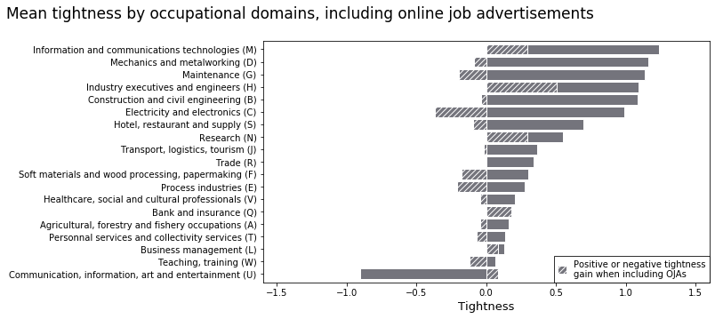

Figure 36: Mean tightness by occupation groups, including OJAs

It appears that most impacted groups are either groups with highly qualified occupations or, on the contrary, relatively lowly qualified occupations. Occupational tightness distribution broken down by qualification corroborates this finding (Figure 29). Overall, labour tightness in upper qualified occupations increases when adding OJAs (+0.28), whereas lower qualified occupations’ tightness decreases (-0.25). Thus, it seems that adding OJAs to NEA’s offers modifies the distribution of labour demand in favour of more qualified occupations, leading as a result to an intensification of labour tightness in these occupations. This result is consistent with that obtained by Dares [11] which shows that 20% of recruitments for executive jobs are advertised online when only 5% of vacancies in elementary occupations are. On the contrary, elementary occupations are over-represented in French national employment agency’s job offers.

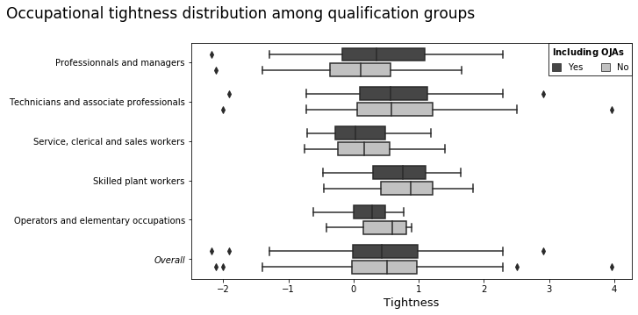

Figure 37: Tightness distribution among qualification groups

##### Possible insights

So far, the main insight remains the consolidation of job offers’ handling process (localisation, classification, company recoding and deduplication). Apart from technical issues, comparison with administrative sources will eventually also give a better understanding on how online job offers reflects labour market demand and possibly helps adjusting OJAs weights in tightness computation.

Finally, although many improvements are to be made, this publication shows the technical feasibility of integrating data from the Internet into statistical indicators computation and paves the way for other experiments using big data and online sources at Dares.

For more details and detailed analysis of particular case, see reports provided by DARES [40].

## Estimation of GDP components using OJA

The following chapter outlines our experiments regarding use of OJAs for economic indicators. Our initial plan was to find a new source to forecast or maybe even nowcast tardy GDP components. OJA seem to correlate well to these data, so we tried to procure earlier indicators using job portals data.

Our data includes around 4 years of weekly scraped job portal data from the two main job portals in Slovenia, with an unfortunate loss of data between the end of 2017 and start of 2018 (as show on the picture below on the left, loss period in pink). In the experiments, they were averaged into monthly periods to be comparable to the indicators.

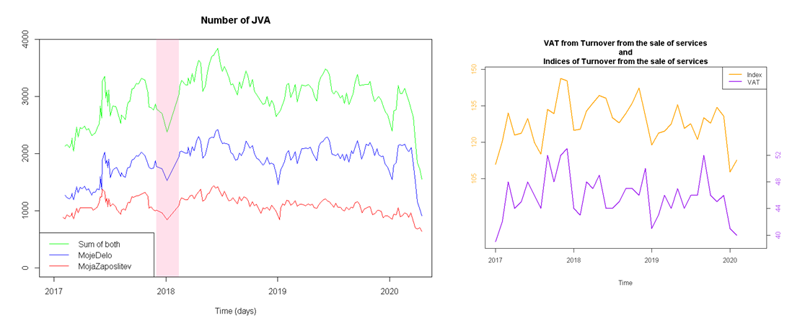

Figure 38: The job portals and economic indicators data

The estimated economic indicators are monthly VAT and indices from turnover from the sale of services (as can also be seen on the figure on the right above), which are used in our calculation of the national GPS. Initial analysis shows that the indices correlate better with job portal data, and as such were more prominent in our experiments. Furthermore, out of each job portal data and the combination of both, the best results were obtained by using data from MojeDelo.si. Only these combinations are shown here.

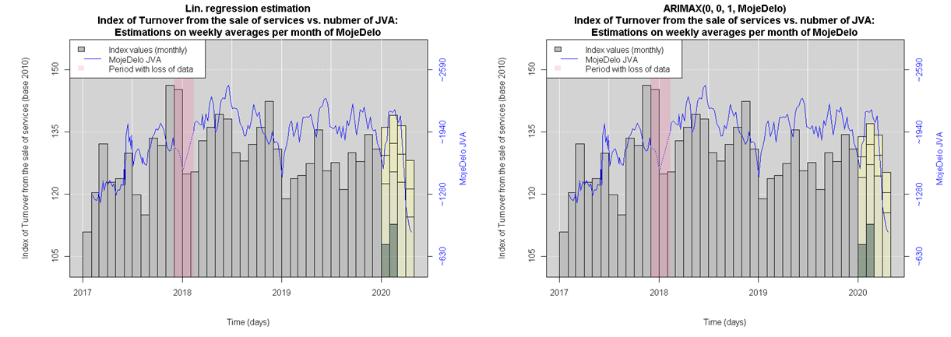

Figure 39: Linear regression and ARIMAX models graphs

Estimating began with a normal linear regression and progressed through ARIMAX (an ARIMA model with an exogenous X variable added as linear argument) to lagged models. The chosen measures for goodness of fit were Log-Likelihood and R2. In the above picture (Figure 31) the visual representation can be seen for the linear regression and ARIMAX models with the best goodnesses of fit.

Our hypothesis for including lagged OJA data was that the job market is affected by the state of the economy after a while, which was established to a 3-period (months) lag on the OJA data by correlation comparisons. Both models were thus adjusted with consideration to the lag period. The results of lagged OJA data are shown below (Figure 32). The results did not confirm our hypothesis; the lagged OJA data do not seem to be a good correlator to the indicators data and performed worse than non-lagged data.

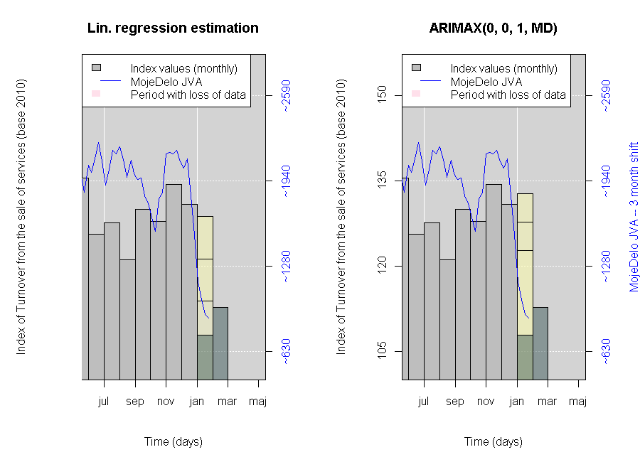

Figure 40: Linear regression and ARIMAX estimations with lagged MD data

However after some more analysis and the inclusion of later data (namely the first quarter of 2020) the picture changes and the lagged data perform much better than non-lagged data with the following results:

$RMSE: 8.047$ $R_{adj}^{2}: 0.037$ $RMSE_{lag}: 7.33$ $R_{adj, lag}^{2}: 0.16$

$\begin{matrix} & Value & t-statistics \\ β_{0} & 133.065 & 3.8∙{10}^{-13} \\ β_{1} & 0.00815 & 0.132\end{matrix}$ $\begin{matrix} & Value & t-statistics \\ β_{0,lag} & 103.536 & 2.7∙{10}^{-13} \\ β_{1, lag} & 0.01330 & 0.00822\end{matrix}.$

This spotlights a considerable issue we are facing:

* the data does not yet include enough periods, to provide a reliable model, we would need at least one more year of scraping,
* OJA data seems to lag too much to be useful for forecasting or nowcasting the chosen economic indicators, even with its timeliness.

Even with these issues, however, it’s reasonable to assume that both variables are linked, which implies a level of connectivity between OJA data and other economic indicators as well.

Our conclusion is that in the future more analyses could determine a better and more advantageous use of OJA data for estimations in other fields. Given the timeliness of OJA data, early estimations could be produced as early as the first week of every month, and subsequent estimations would improve the early values, giving us a dense time series of early estimations of diverse important indicators.

For more details and detailed analysis of particular case, see reports provided by SURS [41].

## Experimental statistics from OJA

### Bulgarian National Statistical Institute

The Bulgarian use-case on web scraping of OJAs for producing experimental statistical outputs is being done as part of an ESSNet on BDII, WPB. This work started in the beginning of 2019 and the BNSI still continue to work on it, even after the end of the ESSnet project. Our ambitions are to improve our initial findings and to produce statistical indicators as such that can serve to enrich the job vacancy statistics or to measure the on-line labour by demand side.

This paper focuses on the OJAs results achieved so far from BNSI team and some main challenges in using OJAs for official statistics purposes from the beginning of the project until August 2020.

In general, BNSI is interested in producing experimental statistics about the OJAs as new statistics derived from the big data sources (job portals) and as complementary statistics for on-line labour market to the regular JVS as well.

In order to be methodologically correct, the following main considerations and assumptions must be taken into account when producing the experimental OJAs statistics:

* The traditional JVS takes account of job vacancies declared by employers at the end of each quarter (according to a European Regulation) i.e. definition of a concept “job vacancy” can be understood as the vacant position within an enterprise that the enterprise is trying to fill. The concept “job vacancy” is different from the concept “job advertisement” and is not possible to produce job vacancy statistics via simple counting the number of job advertisements;
* An “on-line job advertisement” (OJA) is defined as the unstructured text on a job portal, job boards etc. websites consisting information about a given job vacancy. It means that there is a clear distinction between OJV and OJA: an OJA is only indicates the existence of a job vacancy within an enterprise or a recruitment agency. In many cases, an OJA contains more than one job vacancy although there is cases where relationship between OJA and OJV is one-to-one. Vice-versa – a job vacancy could be advertised on a number of different job portals;
* The distribution by characteristics covers only those OJAs, where the relevant characteristics were found during the scraping process;
* The OJAs experimental statistics can not replace the traditional JVS. It still needed and the challenge is how to integrate data from different sources in order to produce statistics that are most useful for labour market policies.

##### Data Sources

Data from OJAs are a very rich data source. They provide almost real-time information on the types of jobs, where jobs are located and some other important characteristics of job vacancy.

BNSI used the extracted OJAs from the two biggest Internet job-portals in Bulgaria: www.jobs.bg and www.zaplata.bg to produce experimental statistical.

These two jobs portals publish daily almost 95% of the total number of OJAs from all job portals in Bulgaria and this makes them sufficiently representative to produce OJAs experimental statistics. Therefore, the BNSI decided not to scrape the other small jobs portals to save effort and resources.

For the purposes of analyzing the COVID-19 lockdawn situation, the administrative daily data on registered unemployment has been received from National Employment Agency.

##### Methodology

The total number of weekly/monthly/quarterly OJAs for the reference period is calculated from the sum of the newly daily published on www.jobs.bg and www.zaplata.bg. Duplicate advertisements on both portals are removed before the OJAs are encoded and classified.

The OJAs indicators do not reflect the total number of job advertisements on the Bulgarian labor market as it does not include jobs advertised through other channels – enterprises websites, social media, newspapers or through informal communications such as word of mouth. In addition, it is possible that some vacant job positions are not advertised at all.

The following experimental indicators for OJAs by weeks/months/quarters for the period were produced:

* Number of OJAs and change (flow)
* Number of OJAs and change by Educational_level (flow)
* Number of OJAs and change by Full_and_part_time_work (flow)
* Number of OJAs and change by Permanent and temporary job (flow)
* Number of OJAs and change by NACE 2.0 Level 1 (flow)
* Number of OJAs by NUTS 3 (flow)
* Number of OJAs by average salary (flow)

BNSI is doing OJAs experimental statistics in four main steps, which are performed in daily, weekly monthly or quarterly basis. The steps are executed automatically with scheduled Python scripts.

Step 1: Scraping

BNSI is doing scraping of OJAs on daily basis. During the scraping, we are saving OJAs that are published only yesterday, i.e. the day before the real scraping. We are using Python’s Scrapy library with custom written spiders. They are using configuration files in JSON format with instructions what to be scraped and from where. A log file is written during the scraping. The spiders are saving the scraped data in CSV files by days. The CSV files have 26 columns of semi-structured information.

Step 2: Validation

BNSI is doing validation step daily on the scraped CSV file with yesterday OJAs data by Python script. The validation step is checking whether the obtained OJAs records are well structured, i.e. dose the column contains expected data or not. In addition, the script is transforming date column in the same pattern. Then the script is saving the OJA records without errors in CSV files by days.

Step 3: Encoding

BNSI is doing encoding step daily on the all validated CSV files with OJAs data by Python script. First, the script de duplicates all records by all columns and keeps only the first record. Then the script de duplicates all records by date, OJA publisher (employer), populated place, country and OJA title and keeps only the first record. Then the script encodes the OJA by the following characteristics:

* Educational levels;
* Permanent or temporary work;
* Full or part time work;
* Country codes;
* Min. and Max. Salary
* NUTS 3 levels – from populated places classification and OJA populated place;
* Enterprise’s ID code (Statistical Business Register code) – full string comparison of OJA publisher and SBR enterprise name;
* NACE 2 codes – from enterprise’s identification code and SBR NACE information.
* The script is saving the encoded OJAs data in two CSV files:
* All OJAs records;
* OJAs records placed in Bulgaria.

The NACE code has been assigned only for employers who encoded from SBR with ID code. The sub-population of OJAs encoded to NACE is around 45% of the total number of OJAs population.

Step 4: Experimental statistics and statistical indicators

BNSI is calculating experimental OJAs statistics according to the list of indicators, mentioned above.

##### Results

The experimental data for OJAs are available on the Intranet site of BNSI, under the dedicated Experimental statistics section and on the WPB wiki page:

https://webgate.ec.europa.eu/fpfis/mwikis/essnetbigdata/index.php/WPB_Experimental_statistics

Most interesting is the indicator - OJAs offered per 1000 unemployed people under NUTS3 for the period May-July 2019. For example, there are 1768 OJVs offered to 1000 unemployed people in Sofia – the capital. The high number of job vacancies shows that employers are looking for skilled workers for their businesses. For the other larger districts the same data are as follows per 1000 unemployed: Sofia district - 967; Burgas - 468; Varna - 677; Plovdiv - 496. In regions, where the population is relatively smaller, OJVs per 1 000 unemployed are: Veliko Tarnovo - 223; Gabrovo - 254; Dobrich - 105; Kardzhali - 119; Kyustendil - 191; Pazardzhik - 182; Pernik - 123; Pleven - 114; Haskovo - 227. In the smallest districts, OJVs per 1000 people unemployed are as follows: Shumen - 77; Yambol - 100; Vidin 27; Vratsa - 68; Lovech - 71; Montana - 33; Silistra - 40; Sliven - 63; Smolyan - 30; Targovishte - 49. It should be noted that the population factor (total, working age, employed and unemployed), as a whole, is important, but it is also ranked by a number of other factors and reasons characterizing each of the 28 areas of the country. This means that the geographical position of the district, the communications that have been built, as well as a number of socio-demographic and economic factors that determine the employment potential of the population, respectively for the offered number of online vacancies, are important for the dimension of each indicator.

Another interesting indicator from Table 11 is the ratio of OJVs offered per 1,000 employees. In the districts with the largest cities of the country there is also an increase in the available vacancies per 1000 people employed. For Sofia - the capital these are 37, Plovdiv - 19, Burgas - 26 and Varna - 31 offered OJVs. In other areas of the country, this indicator has relatively lower values. For the period considered, there are few online jobs available per 1000 people employed, which can be explained by the increased demand and job finding, which is the result of the favorable for work summer season. These two indicators are directly relevant to the labor market. In this sense, they characterize and focus on the aggregates of the population that are directly related to OJAs for searcing of labour force.

The data on other ratios between the number of OJVs and the population, respectively relative to the working population in the districts of the country, show smaller values. They reflect in a more generalized way the processes of the labor market, as they are tailored to the size of the districts, and especially to the size of the district cities. This makes them fairly comparable, but with relatively less relevant information on the current situation on the labor market and its changes.

The main conclusion from the data is that, under other things being equal, the demand and supply of job vacancies in the labor market strive for balance. In the larger areas of the country more jobs are offered online. Obviously, the demand and supply are the highest there, but the requirements of the employers are also higher in terms of the skills of workers (see Table 12).

Table 11: Number of OJVs and main proportions (in ‰) for the period May - July 2019

|  |  |  |  |  |  |
| --- | --- | --- | --- | --- | --- |
|  | | | | | |
| NUTS 3 | Monthly Mean | Population to Mountly mean | Workforce to Mountly mean | Employed to Mountly mean | Unemployed to Mountly mean |
| Blagoevgrad | 1134 | 4 | 6 | 8 | 155 |
| Burgas | 4727 | 12 | 19 | 26 | 468 |
| Dobrich | 726 | 4 | 7 | 10 | 105 |
| Gabrovo | 534 | 5 | 9 | 12 | 254 |
| Haskovo | 682 | 3 | 5 | 7 | 227 |
| Kardzhali | 249 | 2 | 3 | 4 | 119 |
| Kyustendil | 343 | 3 | 5 | 7 | 191 |
| Lovech | 353 | 3 | 5 | 8 | 71 |
| Montana | 251 | 2 | 3 | 6 | 33 |
| Pazardzhik | 948 | 4 | 6 | 9 | 182 |
| Pernik | 503 | 4 | 7 | 10 | 123 |
| Pleven | 949 | 4 | 7 | 10 | 114 |
| Plovdiv | 5654 | 8 | 14 | 19 | 496 |
| Razgrad | 260 | 2 | 4 | 6 | 50 |
| Ruse | 1540 | 7 | 12 | 16 | 291 |
| Shumen | 752 | 4 | 7 | 10 | 77 |
| Silistra | 207 | 2 | 3 | 5 | 40 |
| Sliven | 492 | 3 | 5 | 7 | 63 |
| Smolyan | 164 | 2 | 3 | 3 | 30 |
| Sofia | 677 | 3 | 5 | 6 | 967 |
| Sofia (stolitsa) | 25462 | 19 | 30 | 37 | 1768 |
| Stara Zagora | 1577 | 5 | 9 | 11 | 464 |
| Targovishte | 281 | 3 | 4 | 6 | 49 |
| Varna | 6434 | 14 | 22 | 31 | 677 |
| Veliko Tarnovo | 1293 | 5 | 9 | 13 | 223 |
| Vidin | 199 | 2 | 4 | 7 | 27 |
| Vratsa | 429 | 3 | 5 | 8 | 68 |
| Yambol | 421 | 4 | 6 | 9 | 100 |

Table 11: Number of OJVs and main proportions (in ‰) for the period May - July 2019

|  |  |  |  |
| --- | --- | --- | --- |
|  | | | |
| Educational level | Higher | Primary | Secondary |
| NUTS 3 |  |  |  |
| Blagoevgrad | 117 | 1 | 61 |
| Burgas | 246 | 17 | 217 |
| Dobrich | 41 | 0 | 55 |
| Gabrovo | 56 | 0 | 54 |
| Haskovo | 54 | 1 | 44 |
| Kardzhali | 28 | 0 | 19 |
| Kyustendil | 25 | 0 | 27 |
| Lovech | 46 | 1 | 32 |
| Montana | 29 | 0 | 15 |
| Pazardzhik | 87 | 1 | 80 |
| Pernik | 35 | 2 | 49 |
| Pleven | 80 | 2 | 68 |
| Plovdiv | 493 | 11 | 453 |
| Razgrad | 30 | 0 | 21 |
| Ruse | 144 | 2 | 116 |
| Shumen | 84 | 0 | 59 |
| Silistra | 19 | 0 | 18 |
| Sliven | 43 | 1 | 29 |
| Smolyan | 15 | 0 | 11 |
| Sofia | 63 | 1 | 94 |
| Sofia (stolitsa) | 2259 | 87 | 1662 |
| Stara Zagora | 133 | 2 | 99 |
| Targovishte | 31 | 0 | 18 |
| Varna | 458 | 6 | 368 |
| Veliko Tarnovo | 121 | 1 | 115 |
| Vidin | 13 | 0 | 9 |
| Vratsa | 32 | 0 | 24 |
| Yambol | 37 | 0 | 34 |

Table 12: Distribution of OJAs by Educational level and NUTS 3

Another feature of OJVs is the type of working time, with 95% of all advertisements being offered at the national level for the May-July 2019 period are for full time jobs.

From the total number of OJAs for the period May-July 2019, for only 70 937 OJAs (or 40% of all) we have found the economic sector of employers offering online job vacancies according to the NACE Rev. 2. This is done by comparing the name of the employer from the advertisement in the job portals to the company name from the statistical business register. In this way, the economic activity from the register was joined to a job advertisement (Table 13).

|  |  |  |  |  |  |  |  |  |  |  |  |  |
| --- | --- | --- | --- | --- | --- | --- | --- | --- | --- | --- | --- | --- |
| NACE Level 1 | C | D | E | F | G | H | I | J | L | M | N | S |
| NUTS 3 |  |  |  |  |  |  |  |  |  |  |  |  |
| Blagoevgrad | 94 | 6 | 1 | 25 | 196 | 30 | 147 | 14 | 25 | 28 | 19 | 0 |
| Burgas | 169 | 6 | 3 | 123 | 587 | 70 | 672 | 31 | 92 | 76 | 139 | 2 |
| Dobrich | 86 | 5 | 1 | 15 | 107 | 21 | 72 | 4 | 9 | 11 | 14 | 0 |
| Gabrovo | 88 | 5 | 0 | 8 | 79 | 16 | 17 | 1 | 6 | 2 | 12 | 0 |
| Haskovo | 73 | 2 | 3 | 10 | 110 | 17 | 47 | 1 | 1 | 11 | 14 | 0 |
| Kardzhali | 26 | 2 | 1 | 7 | 24 | 6 | 32 | 2 | 1 | 10 | 5 | 0 |
| Kyustendil | 20 | 3 | 0 | 9 | 39 | 16 | 22 | 2 | 0 | 24 | 9 | 0 |
| Lovech | 65 | 1 | 2 | 3 | 40 | 10 | 20 | 7 | 4 | 3 | 3 | 0 |
| Montana | 27 | 2 | 0 | 5 | 43 | 8 | 34 | 2 | 1 | 7 | 7 | 0 |
| Pazardzhik | 119 | 2 | 6 | 43 | 99 | 46 | 54 | 6 | 6 | 12 | 24 | 0 |
| Pernik | 44 | 7 | 1 | 20 | 65 | 28 | 26 | 5 | 7 | 5 | 24 | 0 |
| Pleven | 143 | 8 | 0 | 30 | 131 | 32 | 49 | 4 | 5 | 12 | 24 | 0 |
| Plovdiv | 538 | 8 | 8 | 136 | 707 | 160 | 312 | 57 | 60 | 131 | 302 | 0 |
| Razgrad | 23 | 4 | 0 | 6 | 35 | 13 | 11 | 5 | 1 | 2 | 3 | 0 |
| Ruse | 219 | 7 | 0 | 17 | 209 | 58 | 84 | 24 | 7 | 18 | 52 | 2 |
| Shumen | 104 | 7 | 2 | 34 | 119 | 22 | 20 | 4 | 6 | 7 | 31 | 1 |
| Silistra | 15 | 2 | 0 | 3 | 49 | 5 | 20 | 5 | 0 | 2 | 1 | 0 |
| Sliven | 54 | 2 | 0 | 10 | 73 | 12 | 41 | 0 | 2 | 6 | 26 | 0 |
| Smolyan | 36 | 0 | 0 | 3 | 22 | 9 | 15 | 3 | 0 | 4 | 5 | 0 |
| Sofia | 124 | 6 | 0 | 9 | 86 | 13 | 14 | 2 | 2 | 7 | 28 | 0 |
| Sofia (stolitsa) | 978 | 47 | 52 | 546 | 2586 | 499 | 1086 | 738 | 243 | 784 | 1069 | 11 |
| Stara Zagora | 139 | 5 | 1 | 59 | 213 | 52 | 109 | 23 | 12 | 21 | 48 | 2 |
| Targovishte | 16 | 4 | 0 | 5 | 43 | 12 | 8 | 4 | 2 | 5 | 4 | 0 |
| Varna | 331 | 20 | 11 | 145 | 886 | 137 | 839 | 80 | 100 | 166 | 206 | 1 |
| Veliko Tarnovo | 165 | 9 | 0 | 17 | 191 | 34 | 110 | 14 | 13 | 22 | 18 | 0 |
| Vidin | 9 | 2 | 0 | 5 | 33 | 9 | 19 | 1 | 0 | 5 | 3 | 0 |
| Vratsa | 43 | 4 | 0 | 32 | 48 | 26 | 10 | 5 | 4 | 10 | 10 | 0 |
| Yambol | 37 | 2 | 0 | 8 | 64 | 10 | 20 | 4 | 2 | 4 | 3 | 0 |

Table 13: Distribution of OJAs by NUTS 3 and NACE Level 1 for the period May-July 2019

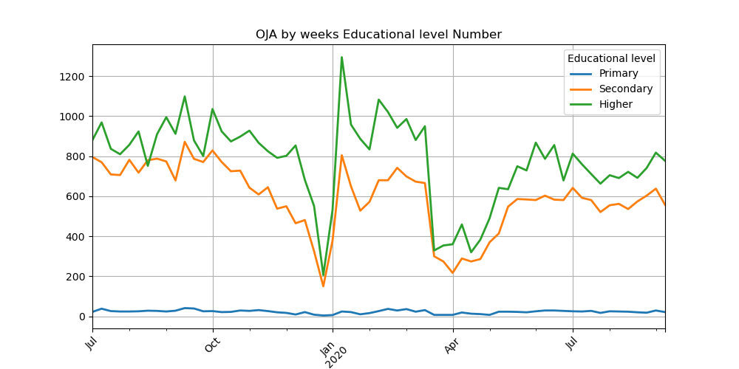

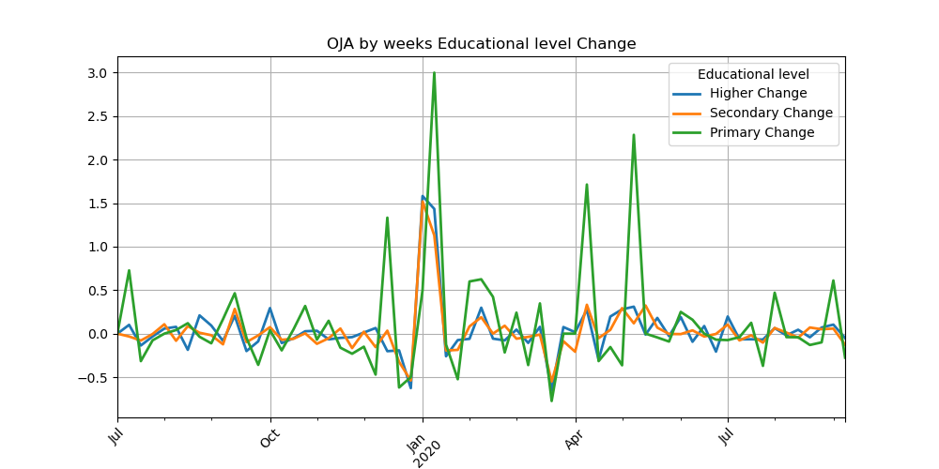

Figure 41: Number of OJAs and change by Educational level (flow)

##### COVID OJAs statistics

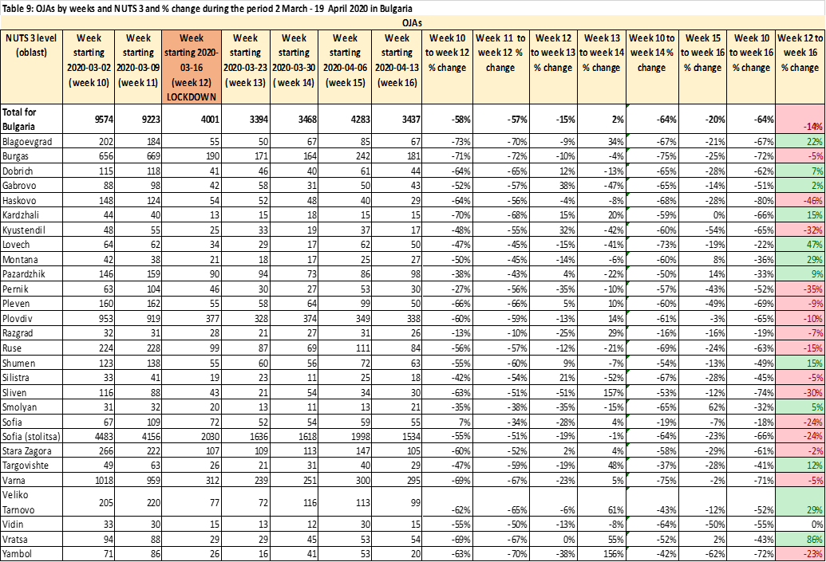

Table 14: OJA by weeks and NUTS3 and % change during the COVID period in Bulgaria

The Table above shows certain aspects of employers' newly published OJAs by weeks (for the period 3rd February 2020 to 19th April 2020 for 28 regions in Bulgaria by NUTS). The surveyed period includes the week of March related to the government's announcement of a lockdown in connection with COVID-19. Data on the number of jobs announced in week 12 (starting 16 March 2020) was considered as a baseline in calculating a series of ratios showing the effect of lockdown on of employers' decisions to publish OJAs.

Data show that after the critical week, the number of OJAs declined dramatically from the previous two weeks in March. The decrease is relatively lower in Sofia compared to other regional cities in the country. Four weeks after quarantine, there was a slight downward trend in tension. This means that OJAs are gradually increasing, but they still cannot reach supply levels in the pre-quarantine period and the change is still negative. It can be concluded that the labor market is currently tight and job vacancies in job platforms remain weak.

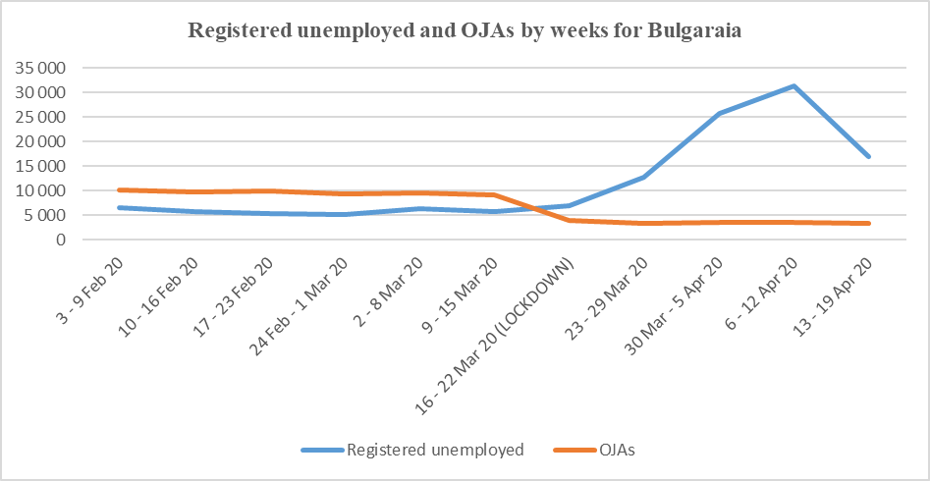

Figure 42: Registered unemployed and OJAs during COVID outbreak

Figure 42 show clearly the trend that before the lockdown the ratio between the unemployed registered at the Employment Agency and the offered online job vacancies is in favour of the offered jobs at the labour market. During the critical week of March (lockdown) a sharp change is noticed whereby the number of the registered unemployed increases drastically and the ratio between them and the supply of job vacancies is negative. The curve of the unemployed is steep upwards during the first two weeks after announcing the lockdown and starts descending downwards during the first two weeks of April. This shows that the gap between the labour supply and demand decreases but still has not reached its normal levels before the lockdown period.

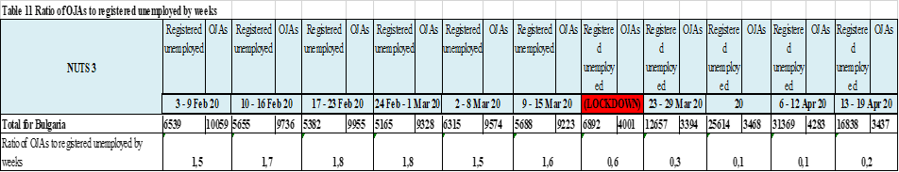

Table 15: Ratio of OJAs to registered unemployed by weeks

The data of the Table 15 show that before the lockdown period more than one job advertisement corresponded per each registered unemployed. After the critical moment this trend changed – less than one job advertisement corresponds per each unemployed. This change in the labour market situation by equal other conditions illustrates a characteristic period when only within approximately four months of 2020 the demand and supply of labour force change their directions. Thus for example after a process of increased demand of labour force by 20th March 2020 a comparatively drastic change followed and the supply of labour force increased at the labour market.

##### Conclusions

The results from OJAs home data raise some important questions about the OJVs data and whether and how it should be used for official statistics. While in this report (BNSI results) has shown that it is feasible to produce experimental estimates of OJAs, there is a still conceptual difference between them and the official JV estimates. It is therefore clear that experimental OJAs data could not be replace the official statistical indicators for JV. Unfortunately, OJAs experimental data give only a partial “picture” of overall labour market demand. It therefore seems that the role of OJAs data within official statistics is more likely to be as the basis for producing supplementary indicators. These could include indicators of local labour market demand (as shown above) and/or indicators of occupations and skills. It would be better not to measuring only absolute numbers of OJAs, but also would be more useful for measuring their change over time.

To conclude, it is important to have in mind the significant differences between ESS countries in terms of the OJVs landscape. Thus, what is feasible in one country may not necessarily be reproducible in others.

For more details and detailed analysis of particular case, see reports provided by BNSI [42].

### Romanian National Institute of Statistics

Here we present the results for computation of potential indicators of Online Job Vacancies from the web scraped site of the National Employment Agency from Romania, www.anofm.ro. Romanian law requires employers to declare jobs vacant.

“To communicate to the county agency for employment, all vacancies, within 5 working days from their vacancy, by completing and submitting Annex 1A of the Methodological Norms for the application of Law no. 76/2002 on the unemployment insurance system and employment stimulation. They also have the obligation to communicate the filling of vacancies that were communicated, within one day from the date of their occupation, in accordance with the law, by completing and submitting Annex 1B of the Methodological Norms for the application of Law no. 76/2002 on the unemployment insurance system and employment stimulation.

Through vacancies, according to Law no. 76/2002, are the jobs that became available as a result of the termination of the employment or service relations, as well as the newly created jobs.

Employers who have employed, according to the law, persons among the beneficiaries of unemployment benefits have the obligation to notify within 3 days the employment agencies at which they were registered.”

##### Web scraper

The web scraper was build in R software and it is available online on GitHub.

https://github.com/OnlineJobVacanciesESSnetBigData/romScrappers/blob/master/anofm.R

##### Data availability

The results presented in this material are calculated on the data collected on reference day of the Job Vacancies Survey, the last working day of the second month of the quarter. Therefore, the months in which the data were collected were Nov 2019, March 2020 (not Feb 2020, because on some technical issue) and May 2020.

The collected OJV were validated in order to be still available in the reference day.

##### Methodological considerations

ESSNet II WPB OJV Methodological framework V1 [43]

##### Potential indicators from OJVs - Methodological framework V1

Number of available on-line job vacancies in a reference day

Number of OJAs web scraped in a reference day by COR/ESCO level 2

Number of OJVs web scraped in a reference day by required educational level

Number of OJAs web scraped in a reference day by CAEN/NACE

Number of OJAs web scraped in a reference day by Working Time

Number of OJAs web scraped in a reference day by Experience Years

Number of OJAs web scraped in a reference day by County

Number of OJAs web scraped in a reference day by Region Code

Number of OJAs web scraped in a reference day by Organization

##### Results for Potential indicators from OJVs - Q2 2020

##### Number of available on-line job vacancies in a reference day

Data collected from National Employment Agency from Romania refers to all observations webscraped in the reference day of JVS from website www.anofm.ro, the last day of the second month of a quarter (May 2020). In the National Employment Agency database there are 4058 observations in the reference day. Of these, the total number of unique OJV is 4058. The total number of JVs posted in the National Employment Agency is 11130. The number of employers who posted the OJV is 2011.

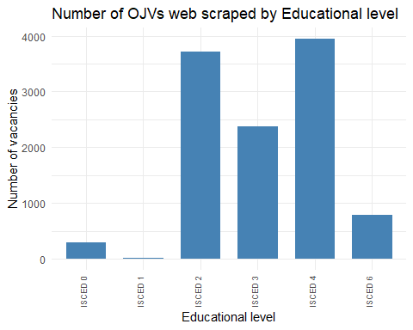

Figure 43: Number of OJA by educational level

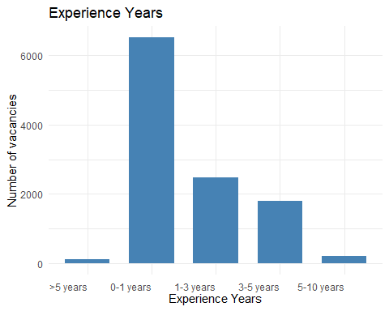

Figure 44: Number of OJA by experience years

For more details and detailed analysis of particular case, see reports provided by Romanian statistics[44].

### Statistics Poland

##### General overview of home data

The data for Poland are scrapped every day from largest Job Offers Portals, and occasionally (for a specific publication) from additional data sources. It includes (number of job offers for 2017):

* Commercial data sources (Internet portals)
  + money.pl – 140 thous.
  + gowork.pl – 124 thous.
  + jobs.pl – 46 thous.
  + pracuj.pl – 39 thous.
  + praca.trojmiasto.pl – 9,9 thous.
* Dedicated data sources (organizations and institutions):
  + www.bazaogloszen.nauka.gov.pl – 1248
  + nabory.kprm.gov.pl – 375
  + BIP – depending on organization

The main conclusion from the analysis of time series is that the fluctuation of job offers among the commercial data sources is high. The differences between 2017 and 2018 are shown in Table 16.

|  |  |  |  |
| --- | --- | --- | --- |
| **Type** | **No.** | **In Q3 (average)** | |
| 2018 | 2017 |
| **Commercial** | 1 | 64 | 140 |
| 2 | 19 | 124 |
| 3 | 86 | 46 |
| 4 | 54 | 39 |
| **Dedicated** | 1 | 0,6 | 1,2 |
| 2 | 0,8 | 0,4 |
| **Regional** | 1 | 8,5 | 9,9 |

Table 16: Year-by-year comparison in the number of job offers among different data sources

It means that concentration on one data source to acquire and estimate data for the country is not possible. Another issue is that there are many duplicates of job offers when taking data from different data sources. Therefore, the goal is to select only representative data sources and use the methodological framework to prepare and analyse the data.

The home data were mostly used to prepare the analysis, such as:

* job advertisements by occupation,
* job advertisements by localization,
* job advertisements by occupation and level of education (ISCED),
* trends in job advertisements (by day, by day of week).

The analysis shows that the data from job offers portals are a bit shaky but the scale of different job advertisement in contrast to official job vacancies data is comparable. Such comparison was shown in Table 17.

|  |  |  |
| --- | --- | --- |
| **SPECIFICATION** | **Data source** | |
| **Official statistics on job vacancies** | **Big Data  (job advertisments)** |
| TOTAL | 122,0 thous. (II quarter 2017)  164,7 thous. (II quarter 2018) | 110,0 thous. (II quarter 2017)  131,0 thous. (II quarter 2018) |
| Mazowieckie voivodship (region) | 27,9 thous. (II quarter 2017) | 23,2 thous. (II quarter 2017) |
| Sales industry | 14,5 thous. (II quarter 2017) | 15,3 thous. (II quarter 2017) |

Table 17: The comparison between official statistics and Big Data sources

As shown in Table 17, the differences between official statistics and Big Data for selected data is not a key issue. It means that Big Data source can be used to show the scale of the data, probably not in absolute numbers (due to the existing differences), but rather relative data.

##### Methodology of data processing and analysis for home data

The preliminary processing of the web scrapped data was as follows:

* de-duplication of data, i.e. removal of the same job offers, repeated many times,
* manual mapping of the ISCO classification or using machine learning for this purpose,
* matching localities to voivodships in accordance with the TERYT register.

The biggest challenge related to the analysis of job offers is to properly classify the data. Unfortunately, the owners of websites that post job offers allow employers to enter any information in the job offer description. Thus, it is necessary to use text mining methods to verify and assign a job offer to the correct category, expressed by the codes of the Classification of Occupations and Specialties or the International Standard Classification of Occupation (ISCO) codes. Methods supporting the proper mapping of a job offer in the classification include supervised machine learning, which is also not a perfect tool due to the disproportions in the training set in terms of recognized job offers. This means that some job offers may have a greater chance of being properly classified in relation to those less frequent in the training sets. Hence, the experience of the author of the article, as well as other significant centres dealing with this issue, prompts the use of deterministic methods based on regular expressions in the area of text mining, rather than machine learning. Figure 45 shows the differences between the number of job offers before and after the text mining methods mentioned above (orange – before text mining use, yellow – after the use of text mining).

Figure 45: Results of the text mining use for occupation classification

In this case study, for comparison, the training set was prepared manually, i.e. by assigning the name of the job offer to the appropriate code from the Classification of Occupations and Specialties. The methods of analysis used led to the conclusion that it is not possible to obtain the precision of classifying job offers at a level higher than 90%. Hence, the assignment of job offers to occupations on the basis of text mining methods was adopted.

##### Main differences between CEDEFOP and home data

The main difference between CEDEFOP and home data analysis is that CEDEFOP data set is collected from various websites, including organizations data, while home data for Poland concentrates on the most representativeness few data sources. One of the most important indicator is how many job offers were scrapped by these two different data sources. It was shown in Table 18.

|  |  |  |  |  |  |
| --- | --- | --- | --- | --- | --- |
|  | **COUNTRY** | **year_grab_date** | **month_grab_date** | **num_job_vacancy** | **Home Big Data (one source)** |
| **0** | POLSKA | 2018 | 7 | 100710 | n/a |
| **1** | POLSKA | 2018 | 8 | 65142 | n/a |
| **2** | POLSKA | 2018 | 9 | 147135 | 55821 |
| **3** | POLSKA | 2018 | 10 | 105275 | 55880 |
| **4** | POLSKA | 2018 | 11 | 82683 | 48637 |
| **5** | POLSKA | 2018 | 12 | 62666 | 50251 |
| **6** | POLSKA | 2019 | 1 | 158613 | 44101 |
| **7** | POLSKA | 2019 | 2 | 140211 | 55015 |
| **8** | POLSKA | 2019 | 3 | 112435 | 54241 |
| **9** | POLSKA | 2019 | 4 | 126429 | 52053 |
| **10** | POLSKA | 2019 | 5 | 101187 | 50586 |
| **11** | POLSKA | 2019 | 6 | 106462 | 56843 |
| **12** | POLSKA | 2019 | 7 | 152239 | 54810 |
| **13** | POLSKA | 2019 | 8 | 112736 | 53045 |
| **14** | POLSKA | 2019 | 9 | 170446 | 56002 |
| **15** | POLSKA | 2019 | 10 | 187011 | 57019 |
| **16** | POLSKA | 2019 | 11 | 125873 | 57339 |
| **17** | POLSKA | 2019 | 12 | 99134 | 69515 |

Table 18: Comparison between CEDEFOP and home data (Big Data - one source)

According to the data shown in Table 3, the number of job vacancies based on CEDEFOP is significantly larger than the data based on one data source. Please note that the data from Home Big Data is rather stable, concentrating between 44-69 thous. job advertisements. The data source used for the Home Big Data is one of the most popular and the largest job offer portals in Poland.

In selected months we can observe a weak correlation between data from CEDEFOP and home data. However most of the CEDEFOP data is not correlated with home data sources.

##### Main conclusions and future work

The concentration on one data source to acquire and estimate data for the country is not possible as there are huge differences between different job offer portals. The suggestions is to limit number of data sources to the most reliable. For instance, most of the job offers comes from few Internet portals. Webscraping job offers directly from companies websites provides unnecessary redundance and duplicates in the data.

The future work is undergoing in investigations of monitor social skills vs. educational attainment. The preliminary research shows that there is a huge difference between official statistics data and CEDEFOP data. The problem cannot be avoided as there are several mistakes in job offer description – for example, looking for a cleaning personnel is one of the job offers that has high expectations of the skills, for example computer skills and higher education diploma, which is probably a mistake.

### Swedish case: Experimental Online Job Vacancy index

Statistics Sweden (SCB) has explored possibilities to use online job vacancy data from different sources (including CEDEFOP) and came to a conclusion that, at this moment, the most reliable and the most useful source is the Swedish Employment Service (SES). According to an agreement between the SES and SCB, the online data from an API of the SES has been frequently downloaded as daily online advertisements, and hence become available to further exploration in almost real time. See Figure 46 for illustration of the whole process.

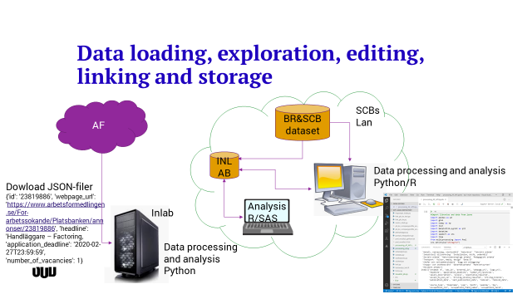

Figure 46. Processing online job advertisements from Swedish Employment Service to Statistics Sweden

In the short term, SCB has an intention to publish an experimental index based on the online job advertisements (in Swedish: *Index Online Lediga Tjänster I-OLT*) on monthly basis. This index is neither a replacement nor a monthly flash estimate for corresponding quarterly estimates but more like a complement in order to get a quick insight into the job market fluctuations. This index is similar to the previously mentioned *Internet Vacancy Index* published by the Australian government. Figure 47 presents this index in terms of original index values (January 2008 = 100) and the corresponding seasonally adjusted (and trend) figures. The index reveals a sharp downward movement from April 2020 to May 2020 with modest recovery in June 2020 (the last observation in this example) due to Corona crisis. This kind of movement was impossible to identify with quarterly survey data so clearly. (*We have also noticed a sharp downward movement in index values from June 2020 to July 2020 but these results are not included since the data from July was not fully edited at the moment of writing this text*).

In Table 19 there are some key numbers for the total index I-OLT. In seasonally adjusted figures, the I-OLT has decreased by 54% from March to April 2020, which was the start of the decline due to Covid-19 in the Swedish online vacancy data. From April to May the decline was about 4% while the upward movement slightly changed the situation from May to June (+11%). The seasonally adjusted index value in March 2020 is 196 while the corresponding value in June is about 96. The I-OLT for almost all industrial groups showed strong decline in April 2020 with slight recovery in June 2020, as shown in Table 20.

The index figures will be prepared for the most important industrial classifications (according to NACE business activity classification) in the private sector and some of the classifications in the public sector. Hence, it will be easy to understand which of the industries that are most influential in creating the downward movement. This issue may be important in understanding the job market tendencies in terms of vulnerability to some external shocks such as the Covid-19 crisis. There are also some tentative plans to develop corresponding index figures based on the regional divisions in Sweden and, more importantly, the index figures based on professional acitivities (occupational categories).



Figure 47. SCB:s Experimental Index Online Job Vacancies (I-OLT): Seasonally adjusted, trend- and unadjusted index values (Jan 2008= 100) ; Data from Jan 2008 to June 2020.

Table 19. SCB:s Experimental Index Online Job Vacancies (I-OLT)- total: Seasonally adjusted, trend- and unadjusted index values (Jan 2008= 100) ; Data from Feb 2020 to June 2020. Levels vs percentage changes (original values 12 months’ perc.change; trend- and seasonally adjusted figures- 1 month perc. change)



Table 20. SCB:s Experimental Index Online Job Vacancies (I-OLT)- total and by industrial classifications; Seasonally adjusted figures- percentage change from previous month (index values (Jan 2008= 100) ; Data from April 2020 to June 2020.)



In the long term, SCB will continue to explore possibilities to use the SES data, the CEDEFOP data and the data from some other online sources, for different purposes.

One of the purposes is to evaluate quality and precision of the Job Vacancy Survey estimates. Another alternative is to create monthly flash estimates by using the calibration techniques, combining the survey and online data. The final alternative is investigate about possibilities to replace survey estimates by the model-based estimates, primarily based on online data, for at least some of the survey occasions. In this way, the response burden could be reasonably reduced but this final option is to be examined very carefully.

At this point in time, the use of CEDEFOP data is limited to simple comparisons and evaluations since the analytical work requires time series of monthly data over several years in order to be fully useful. Also, certain important quality issues concerning CEDEFOP data are still questionable which is one of the main reasons why the analysis about CEDEFOP is not the SCB’s primary activity in the context of exploring OJA.

Worth to mention is the fact that there is an ongoing work att SES concerning linking different classifications on professional and educational activities, which is of interest for the users of SCB’s statistics, and this issue will probably be explored in the near future, depending on the progress in this area.

### Quality template ESQRS V 2.0 for OJAs outputs

ESQRS 2.0 template for OJAs is based on Deliverable K6 (see on the following link: https://webgate.ec.europa.eu/fpfis/mwikis/essnetbigdata/images/8/87/WPK_Deliverable_K6_Quality_report_template_2020_02_28.pdf). This template is derived from SIMS 2.0 for big data sources and comprises only concepts for the respective quality aspects for the experimental statistics on different big data sources, in this case for OJAs experimental statistics. The definitions and guidelines are based on the recently published and updated version of the EHQMR (ESS handbook for quality and metadata reports). The new subconcepts for Big data are indicated by an "A" for "additional". The template ESQRS for OBECs will be also as a C5 deliverable.

The main idea is that each country which is to produce and publish experimental statistics for OJAs, should fill in this ESQRS template and disseminate together with experimental statistics.

ESQRS 2.0 template is available at https://github.com/OnlineJobVacanciesESSnetBigData/Reports/blob/master/BG/WPB_ESQRS_Quality%20template%20for%20statistical%20outputs.xlsx.

# Conclusions and recommendations for future developments

The OJA cannot be considered similar to the job vacancies as defined in the EU Regulations. The online job vacancies cover only those job vacancies, as defined by EU Regulation, for which the active steps carried out by the employers to find a suitable candidate include also the advertising on internet job portals, only if all job portals used by the employers are covered by the web scraping and other data ingestion activities. However, even if all the job portals were considered, it is not clear if all the job advertisements posted on all job portals refer to total job vacancies that still exist at a specific reference date.

The CEDEFOP data collected as the European scale seem to offer a promising basis for developing pertinent statistics and economic indicators. A preliminary analysis shows that should be explored existing relationship between OJAs, national and regional population sizes, and national economic activity expressed as GDP.

Therefore, model predictions can be drawn, which could be compared to actual observations for the other European countries for which no CEDEFOP data are available. On the same basis, OJVs could offer a tool for developing flash estimates of GDP among EU countries, since OJAs are potentially real-time available. The models and choice of variables should be evaluated in more detail and improved, by each country, according also with the OJA representativity among the sector activities of the economy.

## Major goals of collecting OJA in future years

Integrating OJA in the production of JVS and replacing JVS by OJA may be major goals of collecting OJA in future years. Such an approach would significantly alleviate the survey burden on enterprises and would have important consequences on survey designs, with classical sampling surveys being replaced by censuses. In this section, we try to:

* Propose tentative sketches of integrating OJA in the process of JVS production
* Identify necessary requirements needed to assure standards of quality
* Identify pitfalls to avoid and issues to address

Possible levels of integration of OJA in the process of JVS production

Three levels of integration are considered here:

* Use OJA as a complementary data source to help filling non-response items
* Replace the classical data collection using OJA in a classical sampling approach
* Replace both the survey data collection and the sampling approach by a census approach

##### Collect OJA as an additional data source to help filling non-response items in a classical JVS approach

Collecting OJA from the web as a complementary data source in order to help filling non-response items in a classical JVS approach is a goal which is easy to achieve and easy to implement in practice. Effects of non-response items can be corrected in two ways, i.e. by imputations or adjustment of survey weights. However, imputation of missing values for job vacancies is not an easy task because auxiliary variables for job vacancies are usually no available and because of the peculiar frequency distribution of job vacancies among enterprises. In addition, adjustment of sampling weights does not apply to very large enterprises which are often so dominant in their strata that they may be exhaustively sampled (treated as a census) in many surveys. Using alternative data such as OJA is therefore particularly valuable in these circumstances.

Achieving excellent levels of quality is a key issue while mixing different data sources. One should evaluate on common grounds how data from two sources may diverge from each other. Depending on the circumstances, correction factors for over- or under-estimation could be computed from paired observations from the two data sources. Evaluating the range of the discrepancies between JVS survey data and OJA, as well as understanding the causes of the differences is essential in such an approach. The more likely causes of differences are errors in reporting job vacancies, differences in the perimeters of the reporting units (especially likely in large enterprises or groups of enterprises controlling many establishments) and matching errors.

##### Replace the survey data collection using OJA as a substitution data source for the sampling units

Such an approach could be used in order to alleviate the survey burden on enterprises, a valuable goal when alternative data are available. A peculiar care should be put in the matching; otherwise, estimates could largely diverge from those of a classical survey. A transition period using simultaneously both approaches should be planned in order to secure the quality of the results produced as well as the continuity of the time series.

##### Replace the sampling approach by an OJA census

This approach is similar to the precedent, except for the fact that OJA from all enterprises should be crawled. Here again correct matching is a critical issue in order to properly establish the boundaries of the relevant information. The following sketch is suggested:

* Define the data that should be acquired, their metadata and the quality standards to achieve
* Develop a crawling project or secure a sustainable contract of data acquisition
* Plan a transition period to assess and reach the required quality standards of an OJA approach
* Conduct simultaneously both approaches (classical survey and OJA) during the transition period
* Match enterprises with units of the register (enterprises and local units)
* Evaluate the quality of matching by simultaneously recording JV from the enterprises during the transition period
* Dispatch OJA among local units (establishments)
* Produce and assess estimates at all levels of aggregation between the two approaches during the transition period
* Move to the OJA census once all quality criteria are satisfied.
* Carefully secure the transition by assessing the possible gaps between the two approaches in order to assure the continuity of time series

##### Pitfalls to avoid and issues to address

##### Secure data matching quality

Data matching between web data and statistical units is the most challenging issue to solve. Only a good matching will enable to move from classical data collection to online information in the production of JVS. Record Linkage is a promising and complete tool to address the question of matching units. It is available in R and Python and offers a large set of comparison tools including a machine learning approach. It results from a lifetime work of specialists from the US Census Bureau developed during the last decades while trying to link records of persons and enterprises in large datasets, particularly in the fields of health and demographic studies. Among the many possible string comparisons, the package concentrates on Levensthein and Jarowinkler scores, the second having been found to be the most effective to link addresses, because of its capacity to handle misspellings.

##### Data matching and deduplication: two facets of a comparison problem

Interestingly, the function “compare” of the LinkageRecord package handles matching and deduplication as two different options of the same issue, with “compare.linkage” resulting in joining cases from two datasets on the basis of similarities of comparison variables, and “compare.dedup” resulting in the exclusion of duplicates identified on the same grounds. Therefore all the methods described in the process of deduplication may potentially apply to matching issues.

##### Secure long term data acquisition

Secure long term data acquisition is a crucial issue, since public statistics must offer grounds on which to compare changes over time using comparable data. Since Job portals are usually privately developed and are not designed to produce reliable statistics, they are therefore susceptible to significant changes. One must therefore secure a long-term availability of the data, as well as control quality standards over time.

## Opportunities for further collaborative development

Starting from the interests and building strengths of all parties (Member States and Eurostat), there is a ground for collaborative development of a shared system for producing official from OJA. Such a system should cover the need of all Member States and all official languages gather OJA data from wide range of preselected websites and portals, cover all stages of data processing.

There are various possibilities for NSIs to combine their efforts, working together on a joint solution. The easiest solution is to share code and replicate application services. Another possibility is to share infrastructure and in specific occasions data sources. For successful sharing and reusing gradual approach is needed. Countries and Eurostat should proactively participate in the development processes also by providing-specific data, methodologies and experts in order to secure sustainable technical solution for the production of OJA data. An important aspect of this collaboration is also organisation of work, including possible roles and responsibilities of each party as well as governance structure to ensures that the new developments are made in a modular way in line with the Trusted Smart Statistics principles following the hourglass model and the layered architecture.

Eurostat has undertaken further initiatives like the development and maintenance of a flexible software solution freely available and identification of best practice for Data access Arrangements (DA), the use of Web Scraping (WS), Data from the IoT/Smart devices (DI), Natural Language Processing (NLP), Machine Learning (ML) and Production process Automation (PA) to produce Official Statistics. Web Intelligence is an important element of the Smart Trust Statistics that will play a pivotal role in the new official statistics business architecture[45].

The member states should consider an active role and bring their experience in the joint development of common solutions; further exploration of the potential of new types of OJA sources, assessment of quality of the data collected and perform methodological developments.

# References

[1] Cedefop (2019). The online job vacancy market in the EU: driving forces and emerging trends. Luxembourg: Publications Office. Cedefop research paper; No 72., http://data.europa.eu/doi/10.2801/16675

[2] Francis Saucy, Sophie Schmassmann, Alberto Columbano, (oct. 2019), Analyses of 1st CEDEFOP DATA (July-Oct. 2019), https://github.com/OnlineJobVacanciesESSnetBigData/Reports/blob/master/CH/ESSnet_WPB_OJV_CEDEFOP_data_analyses_20190729CH(6).docx

[3] CEDEFOP data analysis: Bulgaria, September 2019, https://github.com/OnlineJobVacanciesESSnetBigData/Reports/blob/master/BG/ExpOJVs_BNSI_B4.doc

[4] Maślankowski J., Pozyskiwanie i analiza danych na temat ofert pracy z wykorzystaniem big data, Wiadomości Statystyczne. The Polish Statistician, vol. 64, 2019, 9, pp. 60-74, DOI 10.5604/01.3001.0013.7590.

[5] Web scraping / Job vacancies Deliverable 1.1, Strategy for ongoing engagement (SGA-2), Last accessed August 2019 at: https://webgate.ec.europa.eu/fpfis/mwikis/essnetbigdata/images/e/e0/WP1_SGA2_Deliverable_1_1_1.0docx.pdf

[6] Web scraping / Job vacancies Deliverable 2.2 Final Technical Report (SGA-2), Last accessed August 2019 at: https://webgate.ec.europa.eu/fpfis/mwikis/essnetbigdata/images/5/5e/SGA2_WP1_Deliverable_2_2_main_report_with_annexes_final.pdf

[7] Bergeat M. (2017), “Les tensions sur le marché du travail au 2e trimestre 2017”, Dares indicateurs n°056/2017, Dares.

[8] Niang, M. (2020, forthcoming), “Comment mesurer les tensions sur le marché du travail en France ?”, Document d’études, Dares.

[9] Bergeat M., Rémy V. (2017), “Comment les employeurs recrutent-ils leurs salariés ?”, Dares analyses n° 064/2017, Dares.

[10] Australian Government (2020), Vacancy Report June 2020, Release date: 22 July 2020. Available at https://lmip.gov.au/PortalFile.axd?FieldID=2790176&.pdf (state of date: 19th August 2020).

[11] Bauer, Anja / Keveloh, Kristin / Mamertino, Mariano / Weber, Enzo (2020), Wie die Corona-Krise die Suchprozesse am Arbeitsmarkt beeinflusst, IAB-Forum 6 August 2020, available at: https://www.iab-forum.de/wie-die-corona-krise-die-suchprozesse-am-arbeitsmarkt-beeinflusst/?pdf=17548 (state of date: 22 August 2020)

[12] BLS (2020), Labor Force Statistics from the Current Population Survey, available at U.S. Bureau of Labor Statistics on https://www.bls.gov/cps/cps_over.htm#faq (state of date: 16th April 2020).

[13] CEDEFOP (2019), Online job vacancies and skills analysis: a Cedefop pan-European approach, Luxembourg: Publications Office. Available at: https://www.cedefop.europa.eu/files/4172_en.pdf (state of date: 19th August 2020).

[14] CEDEFOP (2018a). Real-time labour market information on skill requirements:setting up the EU system for online vacancy analysis. Global report. Available at: https://www.cedefop.europa.eu/files/rlmi_-_skill_requirements_global_report.pdf (state of date: 19th August 2020).

[15] CEDEFOP (2018b), Mapping the landscape of online job vacancies. Background country report: Germany. Available at: https://www.cedefop.europa.eu/files/rlmi_-_mapping_online_vacancies_germany.pdf (state of date: 19th August 2020).

[16] Descy, Pascaline / Kvetan, Vladimir / Zukersteinova, Alena / Wirthmann, Albrecht / Reis, Fernando (2018), Towards a Common Infrastructure for Online Job Vacancy Data, paper presented at DGINS Conference "The European path towards Trusted Smart Statistics" in Bucharest 2018. Available at https://dgins2018.statisticsevents.ro/wp-content/uploads/2018/10/16-online-job-vacancies-v5-1.pdf (state of date: 19th August 2020).

[17] Chetty, Raj / Friedman, John N. / Hendren, Nathaniel / Stepner, Michael / The Opportunity Insights Team (2020), How Did COVID-19 and Stabilization Policies Affect Spending and Employment? A New Real-Time Economic Tracker Based on Private Sector Data NBER Working Paper No. 27431, June 2020 http://www.nber.org/papers/w27431

[18] Conference Board (2020), News release #7015 Tuesday August 11, 2020, Online Labor Demand Rises in July, https://conference-board.org/pdf_free/press/7015%20-%20HWOL%20July%202020.pdf (state of date: 18 August 2020)

[19] Conference Board (2018), The Conference Board Help Wanted OnLine® Technical Note, available at: https://conference-board.org/pdf_free/press/2020%20HWOL%20Technical%20Note.pdf (state of date: 18th August 2020).

[20] De Lazzer, Jakob (2020), Labour Market Concentration Indicators using Online Job Ad Data, document prepared for Workpackage WPB “Implementation – Online Job Vacancies” of the ESSnet on Big Data. ESSnet internal document

[21] ECB (2020), High-frequency data developments in the euro area labour market, Prepared by Nicola Benatti, Vasco Botelho, Agostino Consolo, António Dias da Silva and Malgorzata Osiewicz, Published as part of the ECB Economic Bulletin, Issue 5/2020. The latter is available at https://www.ecb.europa.eu/pub/pdf/ecbu/eb202005.en.pdf (state of date: 18th August 2020).

[22] Ifo Institute (2020), ifo Institute: Help Wanted – IT Service Providers and the Health Sector Need Employees in Germany, Press release June 16th 2020, available at https://www.ifo.de/en/node/56091 (state of date: 18th August 2020).

[23] LinkedIn Economic Graph (2019), AI Talent in the European Labour Market, available at: https://economicgraph.linkedin.com/content/dam/me/economicgraph/en-us/reference-cards/research/2019/LinkedIn-AI-Talent-in-the-European-Labour-Market.pdf.

[24] Rengers, Martina (2018), Internetgestützte Erfassung offener Stellen – Machbarkeitsstudie im Rahmen eines ESSnet-Projekts zu Big Data, in WiSta 5/2018 S. 11ff. Available at https://www.destatis.de/DE/Methoden/WISTA-Wirtschaft-und-Statistik/2018/05/internetgestuetzte-erfassung-052018.pdf?__blob=publicationFile&v=4 (state of date: 16th April 2020).

[25] Sacchi (2014), Lange Messreihen zur Entwicklung des Stellenangebots der Schweizer Wirtschaft: Kombinierter Presse-Online-Index, SMM Working Paper 2014-1, Zürich. Available at https://www.stellenmarktmonitor.uzh.ch/dam/jcr:00000000-4c97-2c4b-ffff-ffff9ef38383/SMM-WP-Sacchi_lange_Reihen_def.pdf (state of date: 19th August 2020).

[26] Sacchi, Stefan (2008), Adecco Swiss Job Market Index – Stellenmarktmonitor Schweiz, Methodische Grundlagen, Zürich. Available at https://www.stellenmarktmonitor.uzh.ch/dam/jcr:ffffffff-ab27-3e8e-ffff-ffff98f1c6d9/ASJMI_Methoden.pdf (state of date: 19th August 2020).

# Annex

ESQRS 2.0 for Experimental OJAs statistics 2020 – Bulgarian National Statistical Institute

|  |  |  |  |  |
| --- | --- | --- | --- | --- |
| **1** | **Contact** | Individual or organisational contact points for the data or metadata, including information on how to reach the contact points. | (Information relating to this concept is provided by reporting on its sub-concepts.) |  |
| 1.1 | Contact organisation | The name of the organisation of the contact points for the data or metadata. | Provide the full name (not just code name). of organisation responsible for the process and outputs (data and metadata) that are the subject of the report. | Bulgarian National Statistical Institute (BNSI) |
| 1.6 | Contact email address | E-mail address of the contact points for the data or metadata. | Provide the email address(es) of the person(s) indicated as contacts. The address can be an individual e-mail address or a mailbox for the organisation to which the person has access. | [gstateva@nsi.bg](mailto:gstateva@nsi.bg)  [kgeorgiev@nsi.bg](mailto:kgeorgiev@nsi.bg) |
| 1.7 | Contact phone number | The telephone number of the contact points for the data or metadata. | Provide the telephone number(s) of the person(s) indicated as contacts. | +359 2 9857773 |
| 2 | **Statistical presentation** | Description of the statistical output. | (Information relating to this concept is provided by reporting on its sub-concepts.) |  |
| 2.1 | Data description | Main characteristics of the data set, referring to the statistical output. | Describe briefly the main characteristics of the data in an easily and quickly understandable manner, referring to the main variables. More detailed descriptions of the variables and how they were derived  in sub-concept 2.4. | On-line Job Advertisements (OJAs) characteristics by:   * Educational level * Full and part time work * NACE rev 2.0 level 1 * NUTS 3 level |
| 2.4 | Statistical concepts and definitions | Statistical characteristics of statistical observations. | Define and describe briefly the main statistical variables that have been observed or derived. Indicate their types. Note that any difference between these variables and the variables desired by users is a relevance issue and is discussed in concept 5. Indicate discrepancies, if any, from variables which were previously collected in a different way (e.g. via surveys). | The main statistical concepts are the following:   * OJAs * Full time and part time * Salary * Education * Economic sector/economic activity * Region   The main statistical indicators produced are:   1. Number of OJAs and change by weeks; 2. Number of OJAs by educational level of and change by weeks; 3. Number of OJAs by full and part time work and change by weeks; 4. Number of OJAs by NACE Level 1 and change by weeks; 5. Number of OJAs by NUTS 3 and change by weeks; 6. Number of OJAs and change by months; 7. Number of OJAs by educational level and change by months; 8. Number of OJAs by full and part time work and change by months; 9. Number of OJAs by NACE Level 1 and change by months; 10. Number of OJAs by NUTS 3 and change by months; 11. OJAs by average salary and by weeks/months/quarters 12. Ratio of OJAs to registered unemployed by weeks |
| 2.5 | Statistical unit | Entity for which information is sought and for which statistics are ultimately compiled. | Define the type of statistical unit about which data are available, e.g. enterprise, local unit, private household, person. If there is more than one type of unit, define each type. Summarize, if possible, the differences to units in traditional ways to collect data. | On-line job advertisement. |
| 2.6 | Statistical population | The total membership or population or "universe" of a defined class of people, objects or events. | Define the target population of the statistical units for which information is sought. Note that a difference between the target population and the population desired by users is a relevance issue and is discussed in concept 5; and the difference between target population and the actual (frame) population is a coverage issue and is discussed in sub-concept 6.3.  If there is more than one type of population, define each type. Describe if there are any differences to the populations in the traditional surveys. | The source population are two biggest job portals in Bulgaria: [www.jobs.bg](http://www.jobs.bg) and www.zaplata.bg . |
| 2.7 | Reference area | The country or geographic area to which the measured statistical phenomenon relates. | Describe the country, the regions, the districts, or the other geographical aggregates, to which the data refer. Identify any specific exclusions in the statistical data. | Bulgaria and Bulgarian NUTS 3 level. |
| 2.8 | Time coverage | The length of time for which data are available. | State the time period(s) covered by the data, e.g. first quarter 2018, or quarters 2015-2018, or year 2018, or years 1985-2018. Note that any issues concerning comparability over time are discussed in concept 8. | Year 2020, time series for the period 2019-2020. |
| 3 | **Statistical processing** | (Defined by its sub-concepts) | (Information relating to this concept is provided by reporting on its sub-concepts.) |  |
| 3.1 | Source data | Characteristics and components of the raw statistical data used for compiling statistical aggregates. | Indicate if the data are based on a survey, an administrative data source, multiple data sources, big data source (machine generated, human sourced, process mediated), e.g., web data, and/or macro-aggregates.  Refer to the accreditation document of the data source, if applies. In the event of multiple data sources or macro-aggregates, reference each source and indicate how they are combined. For each survey source, summarise the sample design, cross referencing the descriptions of the target and survey populations, presented in sub-concept 2.6. For each administrative data source, summarise the source, its primary purpose, and the most important data items acquired. Information in which form the metadata for the new data source is available, where it can be found, and if it is updated on a regular basis.  **European level**  Provide an overview of the sources used across countries. | BNSI used the following data sources to produce experimental OJAs statistics:   * Job portal [www.jobs.bg](http://www.jobs.bg) * Job portal [www.zaplata.bg](http://www.zaplata.bg) * Statistical Business Register (SBR) information for employers: * Enterprise ID * Enterprise Name * Enterprise NUTS 3 level * Enterprise NACE information |
| 3.2 | Frequency of data collection | Frequency with which the source data are collected. | Indicate the frequency of data collection (e.g. monthly, quarterly, annually, or continuous). | Quarterly, Monthly, Weekly. |
| 3.3 | Data collection | Systematic process of gathering data for official statistics. | For each survey data source: • describe the method(s) used to gather data from respondents;  • annex or hyperlink the questionnaires(s). For each administrative data source  • describe the acquisition process and how it was tested.  For all sources  • describe the types of checks applied at the time of data entry.  For big data sources describe the methods used to collect the data; add hyperlink if it is web data or name of the API used to collect the data.  **European level**  Provide a summary of the commonalities and differences in the collection methods, questionnaires and checks used in different countries. | The BNSI is doing scraping of OJAs on daily basis. During the scraping, we are saving OJAs that are newly published only yesterday, i.e. the day before the real scraping. We are using Python’s Scrapy library with custom written spiders. They are using configuration files in JSON format with instructions what to be scraped and from where. A log file is written during the scraping. The spiders are saving the scraped data in CSV files by days. The CSV files have 26 columns of semi-structured information. |
| 3.4 | Data validation | Process of monitoring the results of data compilation and ensuring the quality of statistical results. | Describe the procedures for checking and validating the source data and how the results are monitored and used. Describe the procedures for validating the aggregate output data (statistics) after compilation, including checking coverage and response rates, and comparing with data for previous cycles and with expectations. List other output datasets to which the data relate and outline the procedures for identifying inconsistencies between the output data and these other datasets. Define the linkage method for big data sources and other data sources used for validation. **European level**  Provide a summary of the commonalities and differences in the validation methods used by countries. | BNSI is doing validation step daily on the scraped CSV file with yesterday OJAs data by Python script. The validation step is checking whether the obtained OJAs records are well structured, i.e. dose the column contains expected data or not. In addition, the script is transforming date column in the same pattern. Then the script is saving the OJA records without errors in CSV files by days. |
| 3.5 | Data compilation | Operations performed on data to derive new information according to a given set of rules. | If there is missing data, give detailed description of the methods used for imputation. For big data sources, e.g., web data, indicate the reason why data were not collected (technical issues etc.).  Describe the procedures for imputation, the most common reasons for imputation and imputation rates within each of the main strata.  Describe the likely impact of imputation. Describe the procedures for adjustment for non-response and the corrections to the design weights to account for differences in response rates. Describe the calculation of design weights, including calibration (if used).  Describe the procedures for combining input data from different sources. | Some web data are not collected because of the Internet connection problems categorized as follows:   * HTTP error; * Time out accurred; * To many re-directs; * Request exceptions; * General exception.   No blocking from the source websites was detected during the webscraping process. |
| 4 | **Quality management** | Systems and frameworks in place within an organisation to manage the quality of statistical products and processes. | (Information relating to this concept is provided by reporting on its sub-concepts.) |  |
| 4.1 | Quality assurance | All systematic activities implemented that can be demonstrated to provide confidence that the processes will fulfil the requirements for the statistical output. | Describe the quality assurance procedures specifically applied to the statistical process for which the report is being prepared, for example agreements with the big data providers, benchmarking, assessments, and use of best practices. Include descriptions of all forms of quality assessment procedures (self-assessment, peer review, compliance monitoring, audit) and when they most recently took place. Summarise the results of the most recent quality assessments and cross reference to the chapters in the report where the results are presented in more detail. Describe any ongoing or planned improvements in quality assurance procedures. | The main activities implemented to assure the quality of experimental data are the following:   * Standarizing the variables from both job portals; * De-duplication of all records by all variables and keeps only the first record; * Second de-duplication of all records by date, OJA publisher (employer), populated place, country and OJA title and keeps only the first record; * Automated messages to the subject-matter statisticians for every step of data processing. |
| 4.2 | Quality assessment | Overall assessment of data quality, based on standard quality criteria. | Summarise the results of the most recent quality assessments and cross reference to the chapters in the report where the results are presented in more detail. | All quality aspects and consideration are described in details on the [Deliverable B2](https://webgate.ec.europa.eu/fpfis/mwikis/essnetbigdata/images/8/8f/WPB_Deliverable_B2_Methodological_framework_V1_2020_03_18.pdf) and [Deliverable B4](https://webgate.ec.europa.eu/fpfis/mwikis/essnetbigdata/index.php/WPB_Milestones_and_deliverables). |
| 5 | **Relevance** | The degree to which statistical information meet current and potential needs of the users. | (Information relating to this concept is provided by reporting on its sub-concepts.) |  |
| 5.1 | User needs | Description of users and their respective needs with respect to the statistical data. | Provide: • a classification of users, also indicating their relative importance;  • an indication of the uses for which users want the statistical outputs;  • an assessment of the key outputs desired by different categories of users and any shortcomings in outputs for important users;  • information on unmet user needs and any plans to satisfy them in the future; and  •details regarding those quality components which do not meet user requirements. | The main users are subject matter exsperts from JV survey. They could use the experimental OJAs data as a complementary source to enrich the job vacancy statistics.  The general users who have an interest for OJAs data. |
| 5.3 | Completeness | The extent to which all statistics that are needed are available. | Provide qualitative information on the extent to which content requirements in relevant legislation, regulations and guidelines are met. Provide information on the extent to which user needs related to content are satisfied. Provide values of indicator R1 Data completeness rate, for each required data item for each relevant regulation/ guideline at producer/user level of detail as appropriate. In the case where the indicator refers to data sent to Eurostat, this indicator can be compiled by Eurostat.  **European level**  Summarise across countries the extent to which ESS requirements for data items are met | The potential indicators for OJAs indicators (defined in the Deliverable B2) which are not produced are as follows:   * Number and change of OJAs by occupations; * Number and change of OJAs by skills; |
| 5.A | Added Value through new data source | The potential added value of a new data source to an existing statistical product. | Describe if and how the usage of a new data source provides an added value to an already existing statistical product.  E.g., this could be more detailed data on particular subgroups, or information on grid level instead of district level or the potential replacement of questions of a survey through information of the new data source. | The outputs could be distributed by NUTS 3, education, occupations and skills. The complementary statistics about salary, full and part time work, permanent or temporary work could be produced also.  The data can also be produced almost in a real time.  The results are not the time and cost consuming. |
| 6 | **Accuracy and reliability** | Closeness of computations or estimates to the exact or true values that the statistics were intended to measure. Reliability of the data, defined as the closeness of the initial estimated value to the subsequent estimated value. | (Information relating to accuracy is provided by reporting on 6 sub-concepts. Information on Reliability is reported in sub-concept 6.5 Data Revision-policy). |  |
| 6.1 | Overall accuracy | Assessment of accuracy, linked to a certain data set or domain, which is summarising the various components. | Describe the main sources of random and systematic errors in the statistical outputs and provide a summary assessment of all errors with special focus on the impact on key estimates. The bias assessment can be in quantitative or qualitative terms, or both, and may be expressed as bias risk. It should reflect the producer’s best current understanding (sign and order of magnitude) and include actions taken to reduce bias.  **European level**  Provide a summary picture of accuracy across countries. The emphasis placed on various types of errors should depend upon the error profile of the respective process. For repetitive processes, describe how accuracy is developing over time and what efforts are underway to improve accuracy from an ESS perspective.  There is a tendency to focus on the micro-level here. please include in this and subsequent sections that reporting at the group or aggregated level can/should be done when the units can not be identified. In general, one should be able to repport any quality issues when working with event-based Big Data sources!!! | The main sources for errors are the following:   * Changes in the job portals’ structures of pages; * Internet connection problems; * The misleading content of job advertisements portals; * Missclassifications; * Blocking from the job portal’s owner; * Changes in the job portals popularity; |
| 6.2 | Sampling error | That part of the difference between a population value and an estimate thereof, derived from a random sample, which is due to the fact that only a subset of the population is enumerated. | State whether sampling error is relevant. If probability sampling is used: • for user reports, provide the range of variation of the A1 indicator among key variables at user report level of detail; • for producer reports, provide the range of variation of the A1 indicator among key variables at producer report level of detail;  • indicate the impact of sampling error on the overall accuracy of the results; • state how the calculation of sampling error is affected by imputation for nonresponse, misclassifications and other sources of uncertainty, such as outlier treatment.  If non-probability sampling is used, provide an assessment of representativity and risk of sampling bias.  **ESS level**  If probability sampling is used: • present sampling errors for key estimates across countries;  • indicate which country to country differences are significant and which are not;  • for a repetitive survey, describe at least broadly the trends in sampling error over time;  • provide sampling errors for ESS level estimates. | There is not a a sample design. The source population are two biggest job portals in Bulgaria. |
| 6.3 | Non-sampling error | Error in estimates which cannot be attributed to sampling fluctuations | Summarise the most important aspects of coverage, measurement, non-response, processing and model assumption errors. Discuss the corresponding bias risks and actions undertaken to reduce them. | The owners of job portals could block or restrict the scraper.  Deduplication is done by days and therefore the same OJA can be found on different days or portals. |
|  | A4. Unit non-response - rate (U) | The ratio of the number of units with no information or not usable information to the total number of in-scope (eligible) units, at a level of detail appropriate for a user report. |  | The response date is 100% from both portals. There is no missing data. |
|  | A5. Item non-response - rate (U) | The ratio of the in-scope (eligible) units that have not provided a particular item and the in-scope units that are expected to provide that particular item, at a level of detail appropriate for a user report. |  | Not relevant. |
| 6.3.1 | Coverage error | Divergence between the population of the Big Data source and the target population. | Provide information on the frame and its sources and actions performed to gather the population impacting on coverage (e.g. webscraping). Provide an assessment, whenever possible quantitative, of overcoverage and undercoverage, including an evaluation of the bias risks associated with the latter. Describe actions taken for reduction of undercoverage and associated bias risks. | The experimental OJAs data covers only the two biggest job portals in BG domain.  Other smaller job portals in BG, enterprise’s websites, job agency portals, social media or other Internet domains are not covered. There is under coverage of OJAs data. |
| 6.3.1.1 | A2. Overcoverage – rate (P) | The proportion of units accessible via the frame that do not belong to the target population. | Report A2, Overcoverage - rate | Not relevant. |
| 6.3.2 | Measurement error | Measurement errors are errors that occur during data capture and cause recorded values of variables to be different from the true ones | The main sources of measurement error should be reported and assessed. Their description should be accompanied by any available analysis, otherwise by the producer’s best knowledge. Where available and relevant describe:  • identification and general assessment of the main sources of measurement error, including errors arising from data acquisition; • efforts made in questionnaire design and testing, information on interviewer training and other work on error prevention;  • errors in measurement instruments (meters, satellites,...);  • results of assessments based on comparisons with external data, re-interviews or experiments;  • results of indirect analysis, for example, of the editing phase; and  • actions taken to correct measurement errors. | The various ways to scrape and extract the content of OJAs from job portals could be source for measurement errors.  The capture of variables from unstructured text is not always precise. |
| 6.3.3 | Non response error | Nonresponse errors occur when the Big Data source fails to collect one or all the variables for units belonging to the domain covered by the source | Provide qualitative/quantitative assessments of unit nonresponse and highlight the units that are most subject to nonresponse.  Highlight the variables that are most subject to item nonresponse. Provide a qualitative/quantitative assessments of the bias associated with nonresponse, comparing response rate for different sub-groups or distribution of auxiliary variables known for respondents and non-respondets (etc.). Provide a breakdown of nonrespondents according to cause for nonresponse mainly focusing on unit dependent cause and data collection tools cause. Define a stategy for reducing nonresponse during data collection and follow-up. Implement an estimator adjusted for nonresponse.  **European level:**  Provide a qualitative/quantitative assessments of unit and item nonresponse across countries. | There could be some cases in which the job portals is not responding, blocking robots or they are in maintenance mode which can cause non response errors (Till now, the non response rate for Bulgarian OJAs data is 0%). |
| 6.3.3.1 | A4. Unit nonresponse - rate (P) | The ratio of the number of units with no information or not usable information to the total number of in-scope (eligible) units, at a level of detail appropriate for a producer report. | Report A4: Unit nonresponse rate overall and at a level of detail appropriate for a producer report. | Till now, the non response rate for Bulgarian OJAs data is 0%. |
| 6.3.4 | Processing error | The error in final data collection process results arising from the faulty implementation of correctly planned implementation methods, e.g., algorithms used to transform the data or extract information from raw data. | If processing errors are significant, identify the main issues regarding them. Present an analysis of processing errors, where available, otherwise a qualitative assessment.  Report their extent, and impact on the outputs, of the most significant types of error.  Include descriptions of linking and coding errors, if applicable. Where mistakes relating to programming or publishing have occurred, corrective measures taken as well as actions for avoiding them in the future should be reported.  Example: For web data sources: Setting up a pipeline assures processing is comparable over time. Because texts were processed, the final results were highly affected by the various choices of text processing made. | BNSI is doing encoding of unstructured text daily on the all validated CSV files with OJAs data by Python script. The script encodes the OJAs by the following characteristics with success rates:   * NUTS 3 levels – 98%; * NACE Rev. 2 (from enterprise’s identification code and SBR NACE information) – 37%; * Permanent or temporary work – 97%; * Full or part time work – 97%; * Educational level (not all advirtisements clearly state the information and no ML approach is used) – 17%; |
| 6.3.4.1 | A7. Imputation – rate | The ratio of the number of replaced values to the total number of values for a given variable. | Provide values of indicator A7 Imputation – rate. | Not applicable. |
| 6.3.5 | Model assumption error | Error due to models used in the statistical production. | Describe process specific models, for example, as needed to define the target of estimation itself and models used for transformation of data into statistical data. Provide an assessment of the validity of each model. Descriptions of models used in treatment of specific sources of error should be presented in the section dealing with those errors. The assessment of the models used in treatment of specific sources of error should be presented in this section.  Discuss the trade off between the need to use proper model that can change over time (accuracy) and the use a constant model in order to ensure comparability over time | Not relevant since no model is used for producing OJAs experimental data. |
| 6.5 | Data revision - policy | Policy aimed at ensuring the transparency of disseminated data, whereby preliminary data are compiled that are later revised. | Describe the data revision policy applicable to data output from the statistical process being reported. In so far as they are relevant to the process being reported, summarise the general procedures for treatment of planned revisions, benchmark revisions, unplanned revisions, and revisions due to conceptual and/or methodological changes.  **European level**  Describe the data revision policy and procedures at European level. | Not relevant. |
| 7 | **Timeliness and punctuality** | (Defined by its sub-concepts) | (Information relating to this concept is provided by reporting on its sub-concepts.) |  |
| 7.1 | Timeliness | Length of time between data availability and the event or phenomenon the data describe. | Outline the reasons for the time lag. Outline efforts to reduce time lag in future. Describe the envisioned time lag for producing statistical output from/with the help of a new data source. Describe if the use of the new data source has the potential to decrease the time lag as it exists at the moment for already existing statistical products. | The results are avaialble after web scraping and processing information - it means that there is significant reduce in time needed to deliver the results (almost in real time).  For the Bulgarian OJAs experimental statistics it takes 12 hours after the end of reference period (week, month, quarter). |
| 8 | **Coherence and comparability** | Adequacy of statistics to be reliably combined in different ways and for various uses and the extent to which differences between statistics can be attributed to differences between the true values of the statistical characteristics. | (Information relating to this concept is provided by reporting on its sub-concepts.) |  |
| 8.1 | Comparability - geographical | The extent to which statistics are comparable between geographical areas. | Describe any problems of comparability between regions of the country. The reasons for the problems should be described and as well an assessment (preferably quantitative) of the possible effect on the output values. Give information on discrepancies from the ESS/ international concepts, definitions, with reference to other chapters for more details. | 98% of OJAs are mapped to NUTS 3 classification. |
| 8.2 | Comparability - over time | The extent to which statistics are comparable or reconcilable over time. | Provide information on possible limitations in the use of data for comparisons over time. Distinguish three broad possibilities:  1. There have been no changes, in which case this should be reported.  2. There have been some changes but not enough to warrant the designation of a break in series.  3. There have been sufficient changes to warrant the designation of a break in series.  Additionally, provide information about the comparability over time of the technological processes which produce the data, of the data access and changes in the covered population over time.  Give also an assessment how the the comparison over time will develop in the future. | No any limitations in the use of OJAs data for comparisons over time. |
| 8.3 | Coherence - cross domain | The extent to which statistics are reconcilable with those obtained through other data sources or statistical domains. | An analysis of incoherence should be provided, where this is an issue of importance. | Not relevant. |
| 8.4 | Coherence - internal | The extent to which statistics are consistent within a given data set. | Each set of outputs should be internally consistent. If statistical outputs within the data set in question are not consistent, any resulting lack of coherence in the output of the statistical process itself should be stated as well as a brief explanation of the reasons for publishing such results. | Not applicable. |
| 8.A.1 | Coherence - with existing information/ Official Statistics | The extent to which information / statistical output from new data sources is consistent with information /statistical output from traditional data sources. | Provide information if it is meaningful to compare the information gained from new data sources with information from traditional data sources and if so, how consistent the information /statistical output gained from new data sources is with the one from traditional data sources. | The OJAs experimental indicators cannot be directly compared with results from JVS, because of different concepts, scope, statistical units and etc. |
| 8.A.2 | Comparability - between information from several distinct new data sources | The extent to which information from several distinct new data sources is comparable among one another. | If you have raw data from several distinct new data sources, provide information how comparable the respective raw data sets and the information derived from them are among one other. Examples: MNO data from several mobile operators, smart meter data from several electricity providers. | Only two biggest job portals were analyzed. |
| 9 | **Accessibility and clarity** | The conditions and modalities by which users can access, use and interpret data. | (Information relating to this concept is provided by reporting on its sub-concepts.) |  |
| 9.6 | Documentation on methodology | Descriptive text and references to methodological documents available. | List national reference metadata files, methodological papers, summary documents and handbooks relevant to the statistical process.  For each item provide the title, publisher, year and link to on-line version (if any). List deliverables, reference metadata files, methodological papers, summary documents etc relevant to the process of deriving statistical data from raw data and - if already available - for producing statistical output using the statistical data. | Reference Methodological Framework, ver. 2.0, available on the following link: [RMF 2.0](https://webgate.ec.europa.eu/fpfis/mwikis/essnetbigdata/index.php/WPC_Milestones_and_deliverables). |
| 9.7 | Quality documentation | Documentation on procedures applied for quality management and quality assessment. | List relevant quality related documents, for example, other quality reports, studies. Cross reference to descriptions of quality procedures in other chapters, especially concept 6. List also the deliverables, in which quality related issues are described. | [Deliverable B2](https://webgate.ec.europa.eu/fpfis/mwikis/essnetbigdata/images/8/8f/WPB_Deliverable_B2_Methodological_framework_V1_2020_03_18.pdf) and [Deliverable B4](https://webgate.ec.europa.eu/fpfis/mwikis/essnetbigdata/index.php/WPB_Milestones_and_deliverables);  [Methodological notes for OJAs experimental statistics](https://webgate.ec.europa.eu/fpfis/mwikis/essnetbigdata/images/3/37/OJAs_Experimental_statistics_BG_Methodology_overview.pdf) |
| 10 | **Cost and burden** | Cost associated with the collection and production of a statistical product and burden on respondents. | Cost Provide annual operational costs of the process, with breakdown by major cost component. Describe recent efforts to improve efficiency and comment on the extent to which information and communication technology is used. European level Describe recent initiatives and efforts to improve efficiency at the European level. Burden Provide an estimate of the respondent burden imposed by the process. Describe all the means taken to minimise burden.  **European level**  Describe recent initiatives and efforts to minimise burden at the European level. | The search engine is queried every 7 seconds and enerprise’s websites every 0,5 seconds to not overload webservers. The time consuming of the experts can be consider. |
| 10.A | Potential savings in cost and burden | Description how the new data source might influence cost and burden in the future | Provide an overview how the new data source could be deployed in the future to save the NSIs cost and/or decrease the respondent burden. Provide a qualitative description of the additional efforts for the NSI and the data owners. | The complementary indicators for OJAs, not covered in traditional survey can be provided. |
| 11 | **Confidentiality** | A property of data indicating the extent to which their unauthorised disclosure could be prejudicial or harmful to the interest of the source or other relevant parties. | (Information relating to this concept is provided by reporting on its sub-concepts.) |  |
| 11.1 | Confidentiality - policy | Legislative measures or other formal procedures which prevent unauthorised disclosure of data that identify a person or economic entity either directly or indirectly. | Describe all European or national legislation, or other formal requirements, that relate to confidentiality. Describe relevant policy (if any). Note that the existence of legislation and/or policy provides some assurance that methods necessary to assure confidentiality have been applied to the data. European level  Summarise the commonalties and differences in national approaches to confidentiality policy. | The job portals have public access so no restrictions regarding confidentiality are applied.  The ESS web-scraping policy template ([Deliverable C1](https://webgate.ec.europa.eu/fpfis/mwikis/essnetbigdata/images/6/65/WPC_Deliverable_C1_ESS_webscraping_policy_template_2019_07_15.pdf)) was followed. |
| 11.2 | Confidentiality - data treatment | Rules applied for treating the datasets to ensure statistical confidentiality and prevent unauthorised disclosure. | For aggregate outputs  • Provide the rules that define a confidential cell.  • Describe the procedures for detecting confidential cells, including checking for residual disclosure.  •Describe the procedures for eliminating confidential cells, for example by controlled rounding, cell suppression, or cell aggregation.  For micro-level outputs:  • Describe the procedures that are used in protecting confidentiality. | Not applicable. |
| 11.A1 | Privacy | How privacy sensitive is the information coming from external data holders? | State which treatments are prescribed to satisfy privacy concerns | Not applicable. |
| 11.A2 | Privacy - protecting treatments | Treatment applied to ensure privacy - sensitive information from external data holders | State any treatments prescribed to satisfy privacy concerns. | Not applicable. |
| 12 | **Comment** | Supplementary descriptive text which can be attached to data or metadata. | Provide any information that is pertinent to the report but does not fit under any of the other concepts, or to repeat key issues, or to make reference to annexes that might be attached to the report. |  |

1. Additionally, OJA data might allow for the provision of completely new (to official statistics) labour market insights: for instance, indicators of labour market power by employers, which can be measured by Herfindahl Hirschman Indices (HHIs) for labour markets. Azar et al (2018) calculate such a measure of labour market concentration using HHIs for labour markets at the occupation (6-digit SOC, Standard Occupational Classification), commuting zone and quarterly level based on the market share of firm j in market m. “The market share of a firm in a given market and time is defined as the sum of vacancies posted by a given firm in a given market and time divided by total vacancies posted in that market and time.” [Azar et al (2018) p. 6]
2. EUROSTAT Call for proposals. ESTAT-2020-PA11-PA13-B-SmartStat Trusted Smart Statistics – Web Intelligence Network (B5461-B5472-2020-SmartStat)
3. https://github.com/OnlineJobVacanciesESSnetBigData/Reports/blob/master/CH/ESSnet_WPB_OJV_CEDEFOP_data_analyses_20190729CH(6).docx
4. From 25th of March 2020 a 3rd version of the CEDEFOP dataset is apparently online, with dramatically less OJA than in the second dataset, i.e. 85 instead of 108 millions and 67.5 instead of 92.4 millions of unique records (-25 millions). In all countries the global number of OJA is drastically lower. Moreover, the remaining data are dispatched over 18 months (July 2018 Dec. to 2019) instead of 15. Which means that data of the 3rd dataset cover 6 quarters, instead of 5. The analysis showed a large heterogeneity of OJA fluctuations among countries and months. These patterns as well as the differences between the 2nd and 3rd datasets need to be explained and further investigate.
5. Web Scraping for Job Vacancy Statistics in the SGA-2 (that ran from August 2017 to the end of May 2018) and in the SGA-1 (February 2016 to July 2017).
6. Job vacancy statistics (JVS) are collected under the [framework regulation](https://eur-lex.europa.eu/LexUriServ/LexUriServ.do?uri=OJ:L:2008:145:0234:0237:EN:PDF) and two implementing regulations: the Regulation (EC) No 453/2008 of the European Parliament and of the Council of the 23 April 2008 [11] on quarterly statistics on Community job vacancies; the Commission Regulation (EC) No 1062/2008 of 28 October 2008 implementing Regulation (EC) n. 453/2008 of the European Parliament and of the Council on quarterly statistics on Community job vacancies, as regards [seasonal adjustment procedures and quality reports](https://eur-lex.europa.eu/LexUriServ/LexUriServ.do?uri=OJ:L:2008:285:0003:0008:EN:PDF); and the Commission Regulation (EC) No 19/2009 of 13 January 2009 Implementing Regulation (EC) n. 453/2008 of the European Parliament and of the Council on quarterly statistics on Community job vacancies, as regards the [definition of a job vacancy, the reference dates for data collection, data transmission specifications and feasibility studies](https://eur-lex.europa.eu/LexUriServ/LexUriServ.do?uri=OJ:L:2009:009:0003:0006:EN:PDF).
7. https://github.com/OnlineJobVacanciesESSnetBigData/Reports/tree/master/CH.
8. As shown in Figure 10, we also perform the same analysis with validity periods of 20 days and 40 days, in order to ensure robustness of the chosen timeframe. The results scale almost linearly with the length of the validity period. See also ESSnet WP 1.
9. Compare Sacchi, S. 2008, Methodische Grundlagen Stellenmarkt-Monitor Schweiz, Universität Zürich.
10. https://github.com/OnlineJobVacanciesESSnetBigData/Reports/tree/master/DE.
11. See Conference Board (2018) p. 3 and BLS (2020).
12. See Chetty et al. (2020) p. 1; words in the original are not printed in bold.
13. <https://www.x28.ch/jobradar/>.
14. https://github.com/OnlineJobVacanciesESSnetBigData/Reports/blob/master/DE/DE_OJA-meaningful-indicators_2020_08_24.docx.
15. See de Lazzer (2020).
16. Publications on different analyses of LinkedIN can be found on <http://linkedin-deutschland.mynewsdesk.com/documents> (state of date: 22.08.2020).
17. LinkeIn mention the lack of representativity for example in one of their publications: “This analysis represents the world seen through the lens of LinkedIn data […] Although LinkedIn’s membership covers around 50 percent of Europe’s active labour force, its members are not evenly distributed across the EU. While the results are therefore not statistically representative, the digital and tech workforce tends to be well represented within our membership, even in countries where LinkedIn’s overall market share is smaller.” Methodology notes in LinkeIn Economic Graph (2919) p. 3
18. See Bauer et al. (2020).
19. ECB (2020) p. 56.
20. https://github.com/OnlineJobVacanciesESSnetBigData/Reports/blob/master/DE/DE_OJA-meaningful-indicators_2020_08_24.docx.
21. Azar et al. (2018), Staiger and Spetz (2010), Falch (2010).
22. Compare Manning (2011).
23. Compare Ashenfelter et al. (2010).
24. Compare Dustmann (2009), Card (2013) and Biewen (2018) and Monopolkommission (2018).
25. Compare GWB (2017).
26. The companion report to this article, Destatis (2019), “CEDEFOP exploratory analysis”, documents gaps and inconsistencies in the current version of CEDEFOP OJA data. The documented issues are not detrimental to the quality of the concentration index. Particularly, the problem of possible duplicate observations has no impact on the concentration index, as long as the frequency of duplicates is not correlated with employer market shares. Of more pressing concern is the under-representation of the construction sector in OJA data. However, when performing the analysis omitting the construction sector, the results are almost identical. Furthermore, considering the continuing efforts by CEDEFOP to improve their data collection and preparation procedures, I expect these issues to be resolved in the medium term.
27. For a fraction of observations information about the company is missing. These observations are treated as belonging to synthetic employers, each of which offers the median number of job, in order to not distort the concentration index.
28. Eurostat Glossary:Functional urban area, accessed 10.02.2020, https://ec.europa.eu/eurostat/statistics-explained/index.php/Glossary:Functional_urban_area
29. Because CEDEFOP data does not contain geographical identifiers for FUAs, we merge FUAs by NUTS 3 level.
30.
31. Leitlinien zur Bewertung horizontaler Zusammenschlüsse gemäß der Ratsverordnung über die Kontrolle von Unternehmenszusammenschlüssen (2004/C 31/03).
32. DOJ/FTC, Horizontal Merger Guidelines, 19. August 2010.
33. „Statistik der Bruttoarbeitsentgelte“.
34. https://github.com/OnlineJobVacanciesESSnetBigData/Reports/blob/master/DE/DE_Labour%20market%20concentration%20Index_2020_02_06.docx.
35. https://github.com/OnlineJobVacanciesESSnetBigData/Reports/blob/master/IT/ESSNet%20II%20WPB%20Report%20on%20Output_%20IT.docx.
36. For some websites, however, data collection by scraping only began in 2019.
37. Https://github.com/OnlineJobVacanciesESSnetBigData/Reports/blob/master/DARES/WPB2020report_Classification_Sweden_France_UPDATE.docx
38. The publication of this new indicator of labour market tightness is due on September 2020.
39. Due to this report format, detailed results are not presented but will be published by Dares in the incoming months.
40. https://github.com/OnlineJobVacanciesESSnetBigData/Reports/blob/master/DARES/20200911_Statistical_output_Tightness_FR_Final.docx.
41. https://github.com/OnlineJobVacanciesESSnetBigData/Reports/blob/master/SI/JVA_to_economic_SI.docx.
42. https://github.com/OnlineJobVacanciesESSnetBigData/Reports/blob/master/BG/ExpOJVs_BNSI_B4.doc.
43. https://webgate.ec.europa.eu/fpfis/wikis/download/attachments/440405614/ESSNet%20II%20WPB%20OJV%20Methodological%20framework%20V1%2018032020_4.docx?version=1&modificationDate=1590989511103&api=v2
44. https://github.com/OnlineJobVacanciesESSnetBigData/Reports/blob/master/RO/OJVs%20Web%20scraped%20from%20National%20Employment%20Agency%20Romania%20(RO).docx.
45. EUROSTAT Call for proposals. ESTAT-2020-PA11-PA13-B-SmartStat Trusted Smart Statistics – Web Intelligence Network (B5461-B5472-2020-SmartStat)